Please distribute this alert to any users within your agency who are responsible for accessing the Electronic Official Personnel File (e-OPF) in SAP.

Updated Location of Services for Object Icon in SAP

- Information regarding the updated location of the Services for Object icon in SAP.

An SAP GUI upgrade to Version 7.70 is being implemented for all commonwealth SAP users. Version 7.70 changes the location of the ‘Services for Object’ icon that is utilized to access an employee’s electronic official personnel file (e-OPF).

The ‘Services for Object’ icon will now be located on the right-hand side of the tool bar to the left of the word “Exit” for users who have received the upgraded version. The new location of the icon is for both PA20 (Display HR Master Data) and PA30 (Maintain HR Master Data) transactions.

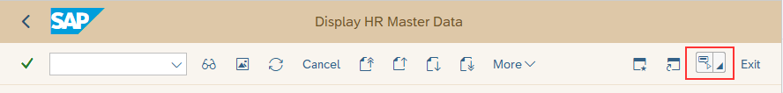

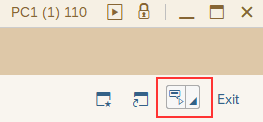

As a reminder, users who have the necessary permissions can access an employee’s e-OPF via transaction PA20 or PA30 then selecting the arrow in the bottom-right corner of the Services for Object icon > DocFinity Attachment > View Attachment (DocFinity). A pop-up box will then then appear for the user to access and view the e-OPF documents.

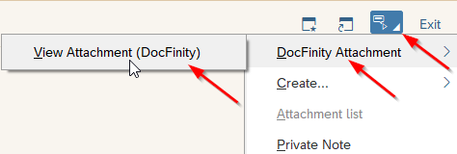

Questions?
If you have any questions regarding Updated Location of Services for Object Icon in SAP, please submit an HR help desk ticket in the personnel administration category. You may also call the HR Service Center, Agency Services & Operations Division at 877.242.6007.

