Please distribute this alert to any users within your agency who are responsible for personnel administration, organization management and processing human resource transactions in SAP.

Telework System Enhancements

- Information regarding enhancements to SAP and Employee Self Service (ESS) to support agency telework programs.
- Revised Alert (06.07.2021): This revision includes a change to the selections for the Telework Eligibility position indicator. The “Required” status has been replaced with a “Preferred” status. The revision also includes additional information regarding the possible rejection reasons for the Employee Telework Request (Infotype 9015).

Effective Monday, September 28, 2020, enhancements will be deployed to SAP and ESS to support agency telework programs. The enhancement release includes SAP position and employee telework indicators and ESS telework coordinator transactions. This will facilitate training for Agency Telework Coordinators who are responsible for the day to day management of the agency teleworking program and allows Telework Coordinators to prepare the system for implementation.

Further information on the telework program and request process will be distributed when a go-live date has been established.

Position Indicator
A new field ‘Telework Eligibility’ will display on Infotype 1013 (Employee Group/Subgroup). The field indicates if the position qualifies for telework and provides the current status of telework eligibility for that position. The ‘Telework Eligibility’ field will have three options and defines the position as required, eligible or ineligible. Please refer to the following table for a detailed description of each telework status:

Status | Description
Preferred (PF) | Indicates the position is best suited for telework. Employees who occupy these positions will telework on a full-time basis when approved by the supervisor and agency telework coordinator
Eligible (EG) | Indicates the position is eligible for telework. Employees who occupy these positions may telework on a full-time, part-time or ad hoc basis if approved by the supervisor and agency telework coordinator
No Status (i.e. blank) | Indicates the position is ineligible for telework. Employees who occupy these positions do not have the option to telework

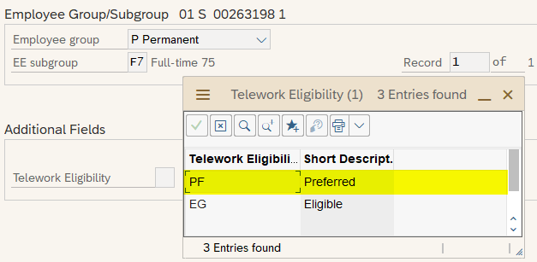

Agency Telework Coordinators are solely responsible for managing the ‘Telework Eligibility’ field for positions within their assigned agency. Updates to the telework status will only occur after discussions with the supervisor and consensus is reached regarding a position’s suitability for telework.

Telework Coordinators will set the status for each position as needed via a new mass transaction in ESS that enables Telework Coordinators to select positions using a variety of criteria (e.g. Personnel Area, Organization, Job, etc.) and perform updates to one or more positions at a time.

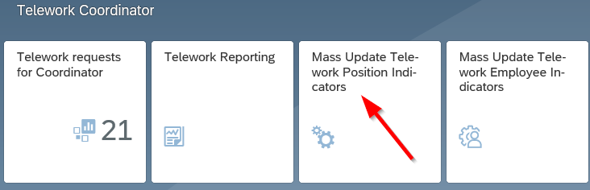

HR Service Center and agency/delivery center HR staff who perform organization management transactions should leave the ‘Telework Eligibility’ field blank when creating a new position and should not modify the assigned status when reclassifying a position.

Agency Telework Coordinators are responsible for setting the initial status on each position and can update the status provided that the incumbent of a filled position has not submitted a telework request. Changes cannot be made to filled positions where the employee has an active or completed telework request. Telework Coordinators must coordinate with their HR office in these situations for the updates to be performed directly in SAP.

Employee Indicator
A new Infotype 9015 (Employee Telework Request) will be available for employees whose positions are deemed suitable for telework. The new infotype will display the employee’s current telework status and associated action date(s). Please refer to the following table for a detailed description of each infotype field:

Field Name | Description
Telework Status | Indicates current telework status:  - Pre-Checked (01) – Telework coordinator and supervisor determined employee is suitable for telework  - Requested (02) – Employee submitted request to telework  - Eligible (03) – Employee deemed tentatively eligible for telework  - Denied (04) – Employee request to telework has been denied  - Opted Out (05) – Employee declined to telework  - Ready (06) – Employee completed telework training  - Negotiated (07) – Telework start date established  - Completed (08) – Telework request fully approved by supervisor and telework coordinator
Telework Type | Defines the telework type requested by the employee:  - Full Time (FT)  - Part Time (PT)  - No Type (i.e. Blank)
Date Requested | Date employee submitted request to telework
Date Deemed Eligible | Date the request to telework was tentatively approved
Date Denied | Date the request to telework was denied by the telework coordinator
Rejection Reason | Indicates the reason the request to telework was denied as entered by the telework coordinator:  - Conduct  - Time and Attendance  - Training Requirements  - Work Performance  - Other
Date Opted Out | Date the employee chose to decline telework if in a telework eligible position
Date Ready to TW | Date automated system program ran to add telework qualification on IT0024 indicating employee has completed telework training
Date Negotiation Done | Date supervisor entered employee telework start date
Date Completed | Date telework coordinator completed final approval after start date entered by supervisor
Telework Start Date | Date employee will begin to telework as entered by the supervisor

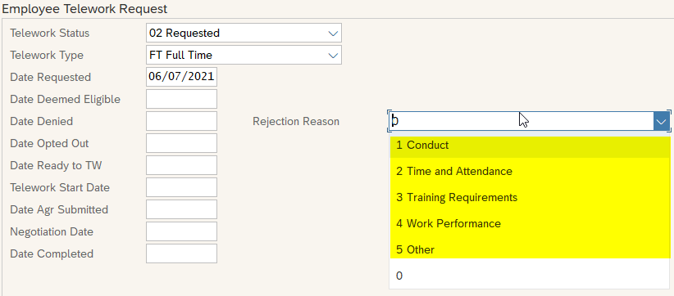

This infotype will only be present if both the position and employee have been deemed suitable for telework and each has been updated accordingly in the system. The Agency Telework Coordinator will update the employee to a ‘Pre-Checked’ status after receiving agreement from the Supervisor that the employee is suitable for telework.

Agency Telework Coordinators will set the status for each employee as needed via a new mass transaction in ESS that enables Telework Coordinators to select employees using a variety of criteria (e.g. Personnel Number, Position number, Organization, etc.) and perform updates to one or more employees at a time.

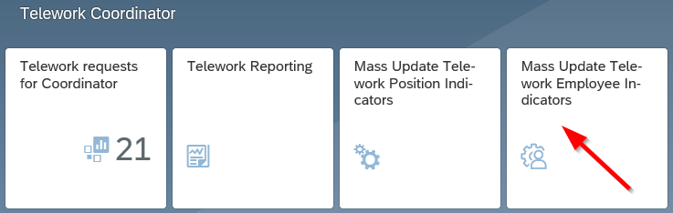

Changes to the telework status and action dates will automatically occur as an employee’s telework request advances through the approval process. Telework Coordinators must coordinate with their HR office to edit or delete this infotype as any direct changes in SAP must be performed by HR staff.

Roles
Several SAP roles have been developed to control system access for Agency Telework Coordinators. The roles will provide Telework Coordinators access to the new ESS telework transactions and authorization to positions and employees within their assigned agency. Please refer to the below table for brief description of each role:

Role | Description
YPC>TELEWORK_COORD_BUSAREA_COPA | Provides access to the Agency Telework Coordinator’s home business area
YPC>TELEWORK_COORD_OA_COPA | Provides access to the Office of Administration (Organizations 00811000 through 00813999)
YPC>TELEWORK_COORD_OB_COPA | Provides access to the Office of the Budget (Organizations 00814000 through 00815999)
YPC>TELEWORK_COORD_OIG_COPA | Provides access to the Office of State Inspector General (Organizations 00816000 through 00816199)
YPC>TELEWORK_COORD_PCOA_COPA | Provides access to the PA Council on the Arts (Organizations 00816900 through 00816999)
YPC>TELEWORK_COORD_PCCD_COPA | Provides access to the PA Commission on Crime and Delinquency (Organizations 00817000 through 00817999)
YPC>TELEWORK_COORD_OGC_COPA | Provides access to the Office of General Counsel within Executive Offices (Organizations 00818300 through 00818399) and agency chief counsel offices under the purview of OGC
YPC>TELEWORK_COORD_JCJC_COPA | Provides access to the Juvenile Court Judges Commission (Organizations 00818400 through 00818499)
YPC>TELEWORK_COORD_PHRC_COPA | Provides access to the PA Human Relations Commission (Organizations 00819000 through 00819999)

Questions?
Any policy related questions regarding telework should be sent to the OA, Employee Relations and Workforce Support Office at ra-oaleave@pa.gov. If you have any questions regarding the Telework System Enhancements, please submit an HR help desk ticket in the Personnel Administration category.

