***Please distribute this alert to any users within your agency who are responsible for personnel administration and processing human resource transactions.***

**Infotype 0014 (Recurring Payments/Deductions) Enhancement for AFSCME Political and Legislative Contributions (PAC/PAL)**

* Information regarding an infotype 0014 (Recurring Payments/Deductions) enhancement for AFSCME PAC/PAL contributions

Effective April 27, 2020, users are restricted from creating a PAC/PAL deduction on the infotype 0014 (Recurring Payments/Deductions) for American Federation of State, County and Municipal Employees (AFSCME) employees who have a non-union member record. This enhancement is for AFSCME non-member employees **ONLY**. Users will still have the ability to create PAC/PAL deductions for AFSCME union members and represented employees in other applicable unions.

Union membership records are located on the infotype 0057 (Membership Fees) in SAP. Below is a screenshot of an AFSCME non-member record appearing on the infotype 0057 (Membership Fees).

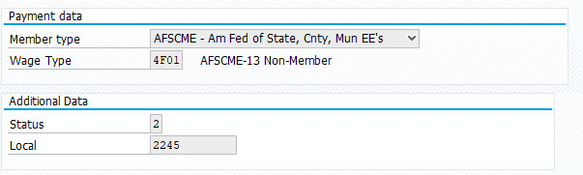

Users who attempt to create a PAC/PAL deduction in SAP for an AFSCME non-member employee will be prevented from performing the transaction and receive an error message at the bottom of the infotype 0014 (Recurring Payments/Deductions) record as shown in the following screenshot.

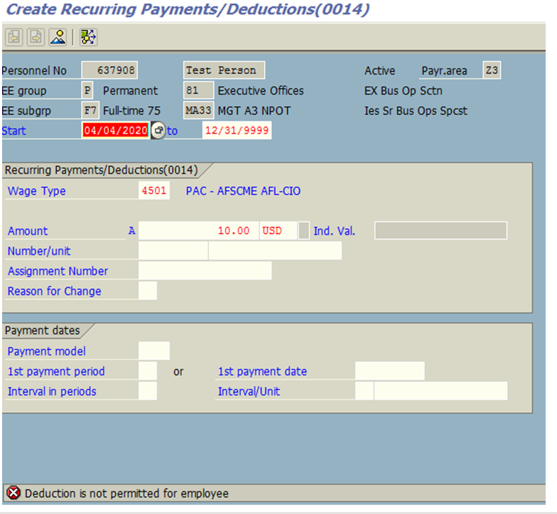

**Questions?**   
If you have any questions regarding Infotype 0014 (Recurring Payments/Deductions) Enhancement for AFSCME Political and Legislative Contributions (PAC/PAL), please submit an [**HR help desk ticket**](http://oaiss.state.pa.us/HR-Pay_Help_Desk/) using the “personnel administration” category.