Military Service Report Instructions
Issued 07.31.2019

Military Service Report (transaction Y_A1D_14000634) features both period and selection options to help you identify employees who have military service and those who are eligible to receive a military service recognition pin, among other important information.

If you have additional questions regarding either the military service report transaction, its recognition report, or custom report variants, please submit an HR/Pay Help Desk ticket under the “Personnel Administration” category.

Contents
Using Military Service Transaction Y_A1D_14000634 2
1. Accessing the Transaction 2
2. Entering a Time Period 3
3. Choosing the Selection Criteria 5
4. Entering Multiple Selections 6
5. Navigating the Report Section 7
6. Exporting the Results 8
7. Creating and Saving a Report Variant 10
Identify Eligible Employees for Recognition Campaign 11
1. Accessing the Transaction 11
2. Entering a Time Period 12
3. Choosing the Selection Criteria 13
4. Entering Multiple Selections 14
5. Navigating the Report Section 15
6. Exporting the Results 16
7. Creating and Saving a Report Variant 18
Customizing Report Variants 19
1. Creating a Variant 19
2. Accessing the Variant 20

Military Service Report Transaction Y_A1D_14000634
Issued 07.31.2019

Military service report transaction Y_A1D_14000634 is available in SAP for agencies looking to identify employees with confirmed or self-disclosed military service or who are looking to run various ad hoc reports regarding those with military service.

Please note that the report will only generate results for employees who have had “Military Service” (IT9014) created on their record.

1. Accessing the Transaction

In the SAP navigation bar in the top-left corner, enter code “Y_A1D_14000634.” See Figure 1 for more details.

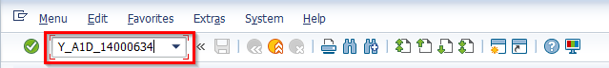
Figure 1

After you enter the code, hit the “Enter” button on your keyboard or click the green checkmark located to the left of the navigation bar. This code will take you to the “Military Service Report” screen, as shown in Figure 2.

Helpful Hint: Save the military service report transaction to your SAP favorites list for easier future access. To save a transaction to your list of favorites, navigate to the “Favorites” tab in the menu across the top of the screen. Click on the “Favorites” tab, then the “Insert Transaction” option. A box will then pop up on the screen prompting you to enter in a transaction code. Type in the code “Y_A1D_14000634” and click on the green check mark to add the transaction to your list of favorites.
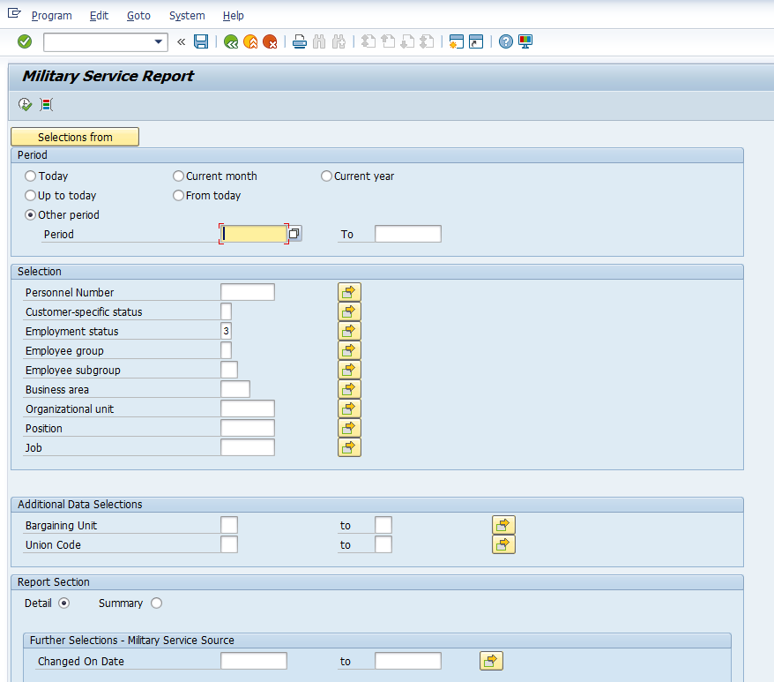
Figure 2

2. Entering a Time Period

Within the transaction, users can select different criteria to filter the results of the report. The first criteria, as highlighted in Figure 3, is “Period.”

With the settings displayed in the “Period” section, users can filter their results based on a range of desired dates. As shown in Figure 3, users have the option to select from six different time periods.

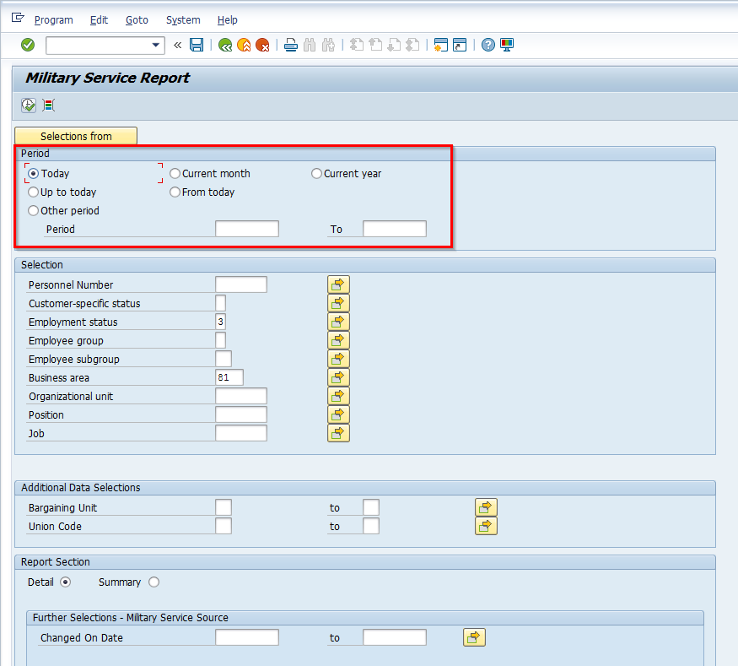
Figure 3

For reference, each time period and its corresponding definition are listed as follows:
- Today—Employees with a military indicator who are currently active

- Current month—Employees with a military indicator who are/have been active
within the current month

- Current year—Employees with a military indicator who are/have been active
within the current year

- Up to today—Employees with a military indicator who are/have been active from
the beginning of the records until today

- From today—Employees with a military indicator who are/have been active from
today and any future days
- Other period—Employees with a military indicator who are/have been active
within the specified dates

Please note: Choosing some of these reporting periods may populate duplicate records in your results. An example of this would be an employee with a military indicator who had a record delimited and a new record created within the same time period.

3. Choosing the Selection Criteria

After the user selects a time period, the user then has the option to enter additional criteria in the “Selection” and “Additional Data Selections” fields. As shown in Figure 4, users can enter single or multiple selections into the following categories:

- Personnel Number
- Customer-specific Status
- Employee Group
- Employee Subgroup
- Business Area
- Organizational Unit
- Position
- Job
- Bargaining Unit
- Union Code
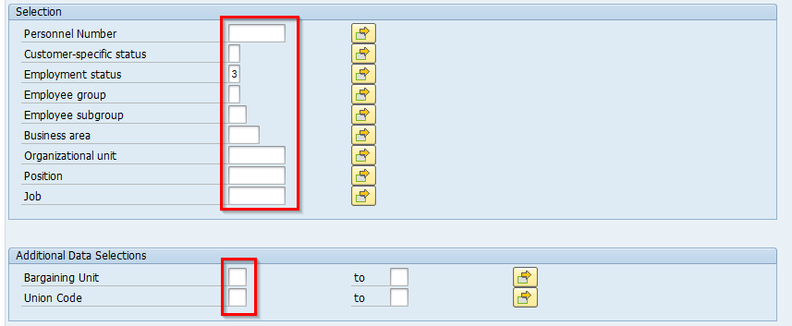
Figure 4

Please note: The Employment Status criteria is pre-populated to include only active employees.

For additional information on selection definitions and codes, please visit this website.

4. Entering Multiple Selections

Within the “Selection” and “Additional Data Selection” fields mentioned above, users can enter either single or multiple selection criteria into the categories to refine their results.

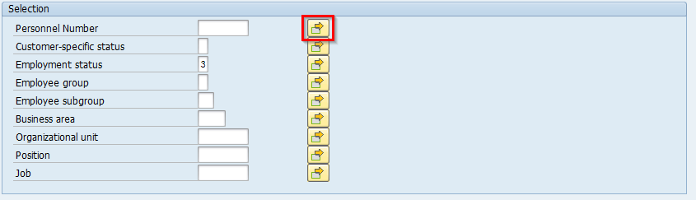
To enter multiple values into a category, start by clicking on the yellow button (with the green box and orange arrow located inside of it) next to the desired category. See Figure 5 for more details.
Figure 5

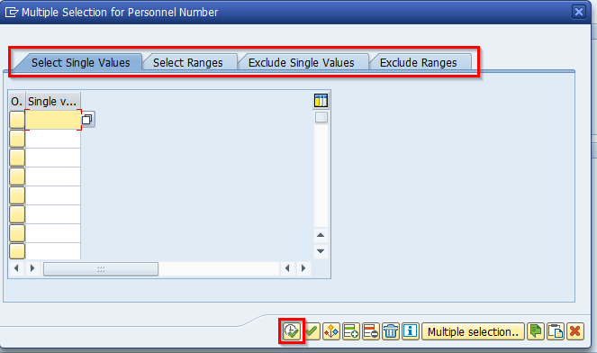
After the user clicks on the yellow button, a pop-up screen will appear, like the screen highlighted in Figure 6.
Figure 6

As shown in Figure 6, users have the option to enter single values and value ranges in the “Select Single Values” and “Select Ranges” tabs. Additionally, users may exclude any parameters they do not want to include in the report using the “Exclude Single Values” and “Exclude Ranges” tabs.

Once the included or excluded parameters are typed into the corresponding tabs, click on the clock with the green check mark to execute the multiple selections into the report.

Please note: There is no limit to how many categories can have multiple selections at a time. Entering multiple selections for the categories listed in the military service transaction is optional, and multiple report criteria can simultaneously have multiple selections.

5. Navigating the Report Section

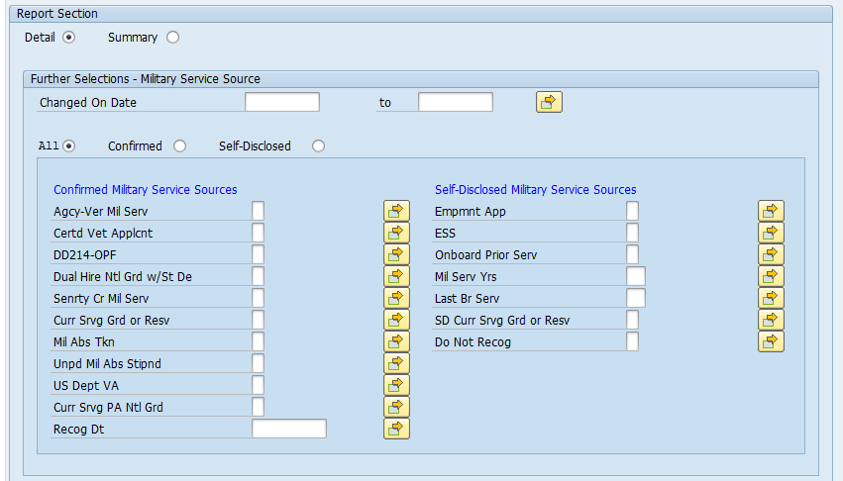
The final section of selection criteria, “Report Section,” gives users the ability to filter their results based on information provided by the military service infotype in SAP. As shown in Figure 7, users have the option of selecting and entering values to tailor the report to an agency’s requests and needs.
Figure 7

First, users must choose between the “Detail” or the “Summary” report. A detailed report will list every individual record produced, while a summary report will only list one record of averaged results.

Please note: The Summary Report can only be executed for a single date period.
Users may then enter a “Changed On Date,” although it is not required to successfully run the report. Additionally, users have the option to choose from the “All,” “Confirmed,” and “Self-Disclosed” buttons, which refer to employees’ military service status in SAP.

For more refined results, users may select criteria throughout the “Confirmed Military Service Sources” and “Self-Disclosed Military Service Sources” highlighted in Figure 8.

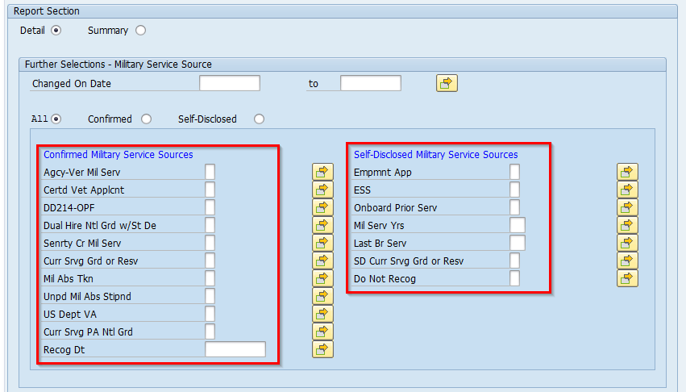
Figure 8

Please note: All the fields (except for “Recog Dt,” “Mil Serv Yrs,” and “Last Br Serv”), are coded with an “X” for Yes and blank for No. “Recog Dt” requires a date value, “Mil Serv Yrs” requires a value between 0 and 99, and “Last Br Serv” requires a military branch code.

6. Exporting the Results

Once you have a time period selected and your criteria entered, you can now run the report. To execute the military service transaction, click on the clock with the green check mark in the upper left-hand corner of the screen. See Figure 9 for more details.

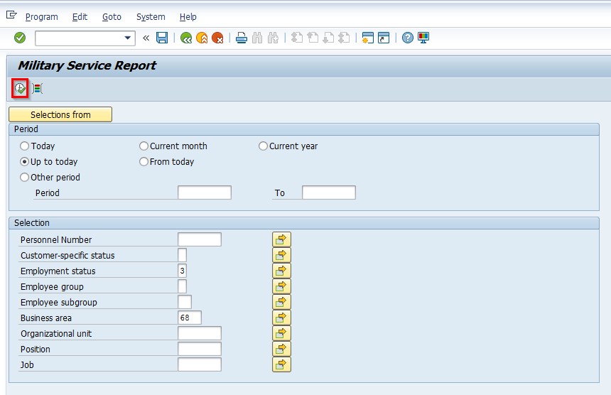
Figure 9

Once your results appear, you can then export them into an excel file for future reference. To export your results, navigate to the top-left corner of the screen and click on the “List” menu option. From there, select “Export” and then “Spreadsheet.” See Figure 10.
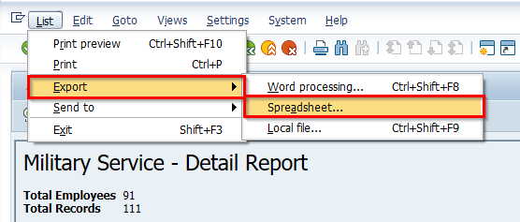

Figure 10

Once you click on “Spreadsheet,” a series of boxes will pop up onto the report screen. In the first box, click the green check mark. In the second box, choose the “Table” option and then click the green check mark. And in the third box, click the green check mark. See Figures 11, 12, and 13 for more details.

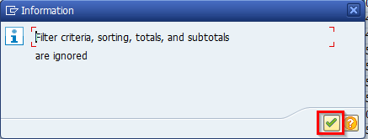

Figure 11

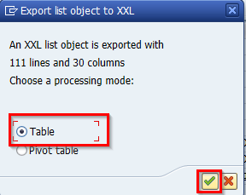

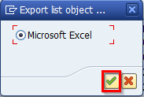

Figure 12 Figure 13

After clicking on the third green check mark, an excel file will pop up on your screen. Format and save the file accordingly.

7. Creating and Saving a Report Variant

Create and save a variant of your customized report for easier reporting in the future. Please reference the “Customizing Report Variants” section for more information.

Identify Eligible Employees for Recognition Campaign
Issued 07.31.2019

For all agencies participating in the Governor’s Military Service Recognition Campaign, the military service report transaction Y_A1D_14000634 can be tailored to help determine which employees in an agency (or agencies) qualify to be recognized for their military service.
Please note that this transaction will only generate results for employees who have had “Military Service” (IT9014) created on their record.

1. Accessing the Transaction

To access the military service transaction, log onto SAP through the “HR/Payroll” selection. In the navigation bar in the top-left corner, search for the code “Y_A1D_14000634.” See Figure 1 for more details.

Figure 1

After you enter the code, hit the “Enter” button on your keyboard or click the green checkmark located to the left of the navigation bar. This code will take you to the “Military Service Report” screen, as shown in Figure 2.

Helpful Hint: Save the military service report transaction to your SAP favorites list for easier future access. To save a transaction to your list of favorites, navigate to the “Favorites” tab in the menu across the top of the screen. Click on the “Favorites” tab, then the “Insert Transaction” option. A box will then pop up on the screen prompting you to enter in a transaction code. Type in the code “Y_A1D_14000634” and click on the green check mark to add the transaction to your list of favorites.

Figure 2

2. Entering a Time Period

Within the transaction, users can select different criteria to filter the results of the report. The first criteria, as highlighted in Figure 3, is “Period.”

In order to acquire a list of eligible employees to be recognized for the Governor’s Recognition Campaign, users must select the “Today” option as shown in Figure 3.

Figure 3

3. Choosing the Selection Criteria

In conjunction with the Governor’s Recognition Campaign, users can enter single or multiple selections into the “Business Area” or “Organizational Unit” criteria for more specific results. Users also have the option to enter additional criteria in the other “Selection” and “Additional Data Selections” fields, but only if it is necessary. See Figure 4 for more details.
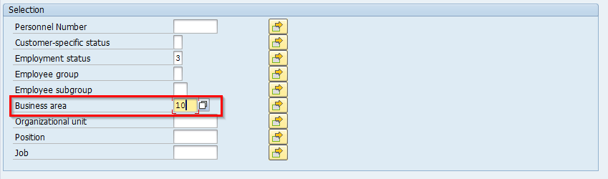
Figure 4

Please note: The Employment Status criteria is pre-populated to include only active employees.

For additional information on selection definitions and codes, please visit this website.

4. Entering Multiple Selections

Within the “Business Area” and “Organizational Unit” criteria mentioned above, users can enter either single or multiple selection criteria into the categories to refine their results.

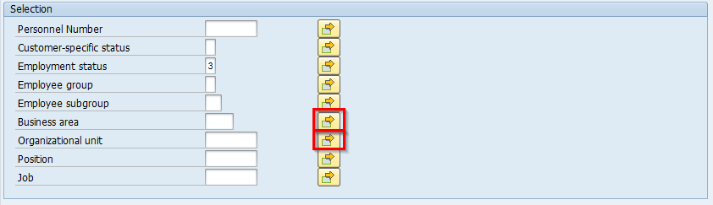
To enter multiple values into a category, start by clicking on the yellow button (with the green box and orange arrow located inside of it) next to the desired category. See Figure 5.
Figure 5
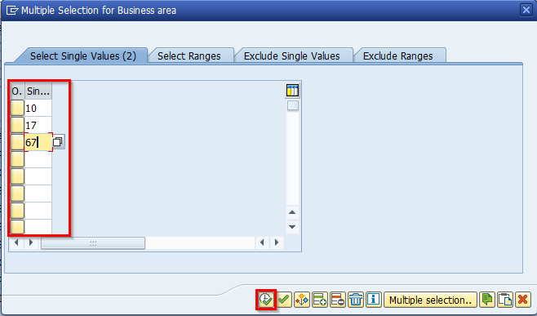
After the user clicks on the yellow button, a pop-up screen will appear, like the screen highlighted in Figure 6.
Figure 6

Users have the option to enter single values and value ranges in the “Select Single Values” and “Select Ranges” tabs. Additionally, users may exclude any parameters they do not want to include in the report using the “Exclude Single Values” and “Exclude Ranges” tabs. As shown in Figure 6, three different business areas have been entered into the “Select Single Values” tab to refine the military service report’s results.

Once the included or excluded parameters are typed into the corresponding tabs, click on the clock with the green check mark to execute the multiple selections into the military service report transaction.

Please note: Entering multiple selections for the categories listed within the transaction is optional, and multiple report criteria can simultaneously have multiple selections.

5. Navigating the Report Section

In order to tailor the military service report transaction to find the employees eligible to be recognized for the annual Governor’s Military Service Recognition Campaign, the following criteria must be entered in the “Report Section”:
- The “Military Service Indicator” must be Confirmed
- The “Do Not Recog” option must be blank
- The “Recog Dt” must be reflective of the October Quarterly Update date (or left blank for a current count of eligible employees)

Please note: The “Recog Dt” field should be populated with the date of the October quarterly update, i.e. “10/05/2019”. This date does not indicate that the employee was recognized, but rather that the employee is eligible for formal recognition. Each year thereafter, an alert will be issued to notify agencies which “Recognition Date” will be used to populate and generate lists of employees to be recognized for that year.
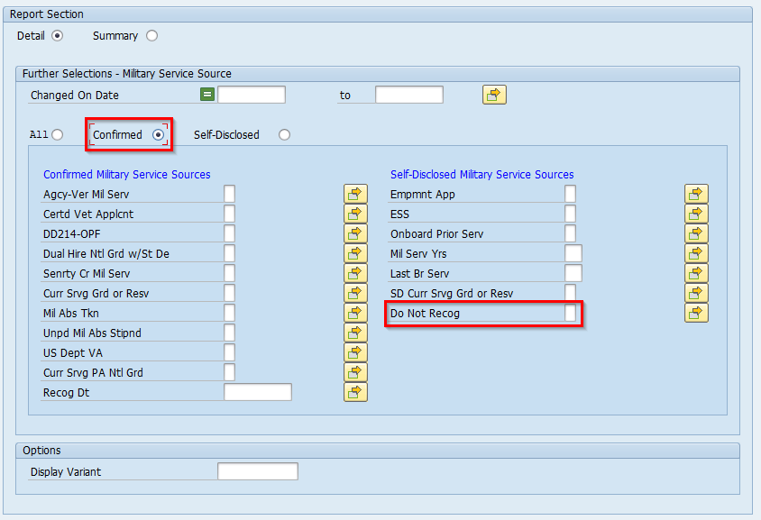
See Figure 7 for more details.
Figure 7

6. Exporting the Results

Once you have the “Today” time period selected and your criteria entered, you can now run the report. To execute the transaction, click on the clock with the green check mark in the upper left-hand corner of the screen. See Figure 8 for more details.
Figure 8

After your results appear, you can then export them into an excel file for future reference. To export your results, navigate to the top-left corner of the screen and click on the “List” menu option. From there, select “Export” and then “Spreadsheet.” See Figure 9.

Figure 9

Once you click on “Spreadsheet,” a series of boxes will pop up onto the report screen. In the first box, click the green check mark. In the second box, choose the “Table” option and then click the green check mark. And in the third box, click the green check mark. See Figures 10, 11, and 12 for more details.

Figure 10

Figure 11 Figure 12

After clicking on the third green check mark, an excel file will pop up on your screen. Format and save the file accordingly.

7. Creating and Saving a Report Variant

Create and save a variant of your customized report for easier reporting in the future. Please refer to the “Customizing Report Variants” instructions for more information.

Create and Save Report Variants
Issued 07.31.2019

A report variant is an alternate version of any report that is customized and saved for later access and simpler, future reporting. With reports that feature various selection options, creating and saving a custom variant will save users time within the reporting process and will ensure consistent reporting.

This set of instructions will walk through the following steps on how to create, access, and save a variant of the military service transaction Y_A1D_14000634:
- Creating a Variant
- Accessing the Variant

If you have any additional questions regarding creating a report variant, please submit an HR/Pay Help Desk ticket under the “Personnel Administration” category.

1. Creating a Variant

Please note: Users who are saving variants of reports should already have created and executed a full report. For more information on how to run the military service report transaction, please refer to the “Military Service Report Transaction Y_A1D_14000634” instructions. For more information on how to run the military service report transaction with regard to the Governor’s Recognition Campaign, please refer to the “Identify Eligible Employees for Recognition Campaign” instructions.

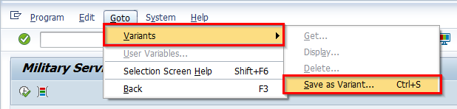
To create a variant of the military service report transaction, navigate to the “Go To” menu option at the top of the screen. Within the drop-down menu, click the “Variants” button and then click “Save as Variant…,” as shown in Figure 1.
Figure 1

Once the user clicks on the “Save as Variant…” button, the user will then be transferred to the Variant Attributes screen. Within this window, users can name their variants, describe their variants, and configure additional settings to their report variants.

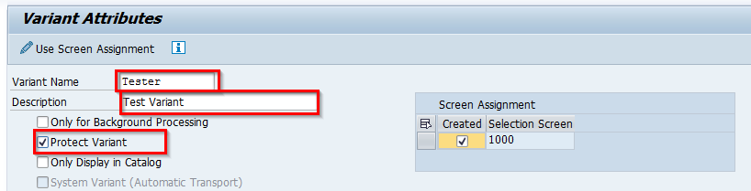
First, the user must name the variant and provide a brief description of its actions. Then, the user should select the “Protect Variant” option located under the Description box. See Figure 2 for more details.
Figure 2

Please note: Selecting the “Protect Variant” option ensures that the variant you are creating can only be changed or modified by you. It limits others from going into your variant and making selection or layout changes without your knowledge.

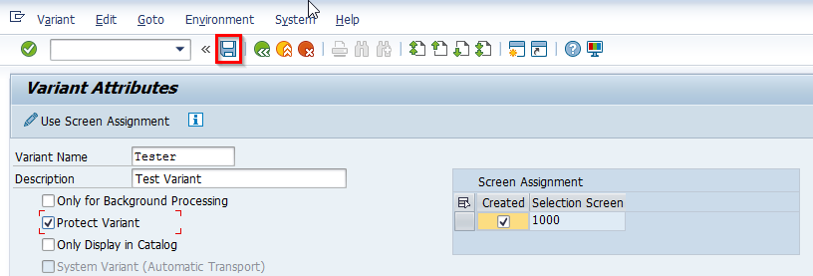
To save the variant, click on the save icon at the top of the screen. See Figure 3.
Figure 3

Once the variant is saved, the user will be successfully directed back to the “Military Service Report” screen.

2. Accessing the Variant

To run this report using a saved variant, first access the military service transaction Y_A1D_14000634 in SAP.

For additional instructions on logging into SAP or accessing the military service transaction, please refer to 1. Accessing the Report of the “Using Military Service Transaction Y_A1D_14000634” instructions.

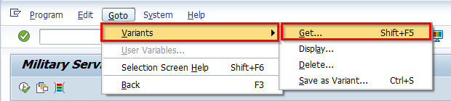
Then, navigate to the “Go To” menu option at the top of the screen. Within the drop-down menu, click the “Variants” button and then click “Get…,” as shown in Figure 4.
Figure 4

After the user clicks on “Get…,” a box will pop up on the screen with a list of variant names and their corresponding descriptions. Click on the name of the variant you wish to execute, and then click on the green check mark located in the bottom right-hand corner of the box. See Figure 5 for more details.
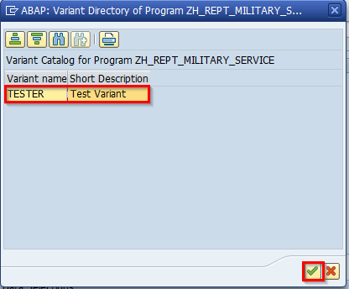

Figure 5

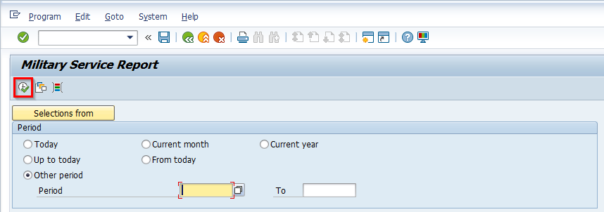
After the user clicks on the green check mark, the “Military Service Report” screen will reappear will all the saved conditions and selection criteria of the variant. Users can then execute the transaction by clicking on the clock with the green check mark in the upper left-hand corner of the screen. See Figure 6.
Figure 6

For additional instructions on exporting your military service report results, please refer to 6. Exporting the Results of the “Using Military Service Transaction Y_A1D_14000634” instructions.

