Please distribute this alert to any users within your agency who are responsible for maintaining and monitoring financial data infotypes.

Fiscal Year Changes to SAP Funds and Cost Infotypes

- Information regarding changes to the Fiscal Year within SAP Funds and implementation of a new Budget Period data field

Budget Period Implementation
The use of the Budget Period is standard SAP functionality utilized by Public Sector entities. The changes to the fiscal year within SAP funds and the creation of a new budget period will bring the commonwealth into compliance for future SAP enhancements that rely on the new attribute. The implementation will run concurrently with the Department of Treasury’s modernization project, which will also require use of a budget period.

In addition, the implementation will result in several key benefits for the commonwealth, including:
- Improved business processes for managing and controlling budgetary functions

- Simplified reconciliation process

- Accelerated fiscal year end process

- Reduction in master data maintenance

SAP Overview
Effective July 1, 2014, the fiscal year within SAP Funds will be removed and replaced with a new Budget Period data field. These changes will impact IT0027 (Cost Distribution), IT1018 (Cost Distribution) and IT9104 (Complement Control). Other cost objects such as the cost center, fund center, internal order number and WBS element will not be affected.

The new Budget Period data field will be available in SAP as of June 1, 2014. For records prior to July 1, 2014, the Budget Period field will remain blank and the 6th and 7th digit of the SAP Fund will still reflect the fiscal year on the impacted infotypes. The Budget Period will be a required field for records effective on or after July 1, 2014.

This change will affect the HR Service Center, agencies serviced by the HR Service Center who manage vacant positions and Independent Agencies not serviced by the HR Service Center.

Cost Object Changes
Funds will be amended as follows:
- Funds beginning with 1, 2, 3, 7, and 8; the fiscal year in the 6th and 7th digit will be removed and replaced with zeros (00). (e.g. Fund 1006713000 to 1006700000).

- Funds beginning with 30002, 30003 and 30166; the fiscal year will remain as the 6th and 7th digit of the fund. (e.g. 3000210134).

- Funds beginning with 5 and 6; no changes will occur as the fiscal year is not associated with these funds. The 6th and 7th digit will remain as 00. (e.g. 5000200000).

The new Budget Period field will reflect as follows:
- Funds beginning with 1, 2, 3, 7, and 8; the Budget Period will equal the current fiscal year. (e.g. Fund 1006700000 equals Budget Period 2014).

- Funds beginning with 30002, 30003 and 30166; the Budget Period will equal the fiscal year present in the fund. (e.g. 3000210134 equals Budget Period 2010).

- Funds beginning with 5 and 6; the Budget Period will equal 0000, since the fiscal year is not associated with these funds. (e.g. 5000200000 equals Budget Period 0000).

SAP Transaction Processing Prior to July 1, 2014

IT0027/IT1018 (Cost Distribution)
When a PA40 transaction is processed with an effective date prior to 07/01/2014:
- IT0027 will appear in the foreground during the transaction after IT0001 (Organizational Assignment) is presented and saved.

- IT0027 will present with a blank Budget Period field.

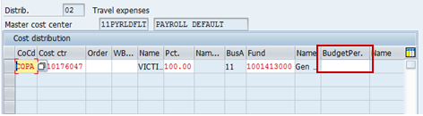

- Select the green check. A default pop-up box will appear with a standard SAP message, “Default budget period 20XX entered for fund XXXXXXXXXX”.

- Simply select the green check on the pop-up box and save the infotype.

- The Budget Period field cannot be saved with a value for records prior to 07/01/2014. Even though the budget period populates during the action, the value will be deleted when the infotype is saved.
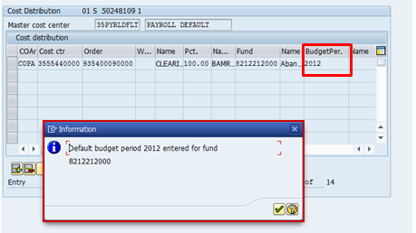

The above pop-up box and message will also appear when:
- IT0027 records are changed or created via PA30 with an effective date before 07/01/2014.

- IT1018 records are changed or created via PO13 or ZPQ13 with an effective date before 07/01/2014.

- Please follow the same procedures by selecting the green check on the pop-up box and saving the infotype. The Budget Period will be removed from the data field.

IT9104 (Complement Control)
When a record is changed or created on IT9104 with an effective date before 07/01/2014:

- The Budget Period field should remain blank.

- If a fiscal year is entered, a hard error message will prompt removal of the value within the data field
.
- At the bottom of the screen you will see an error message, “Delete Budget Period value. Budget Period not effective until 07/01/2014.”.

- Remove the value in the data field. This will allow the infotype to be saved.
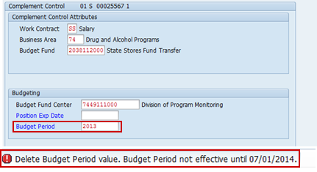

SAP Transaction Processing After July 1, 2014

IT0027/IT1018 (Cost Distribution)
When a PA40 transaction is processed on or after 07/01/2014 standard SAP functionality will apply. IT0027 will create and save in the background.

When an IT0027 or IT1018 record is changed or created with an effective date on or after 07/01/2014:

- A valid fiscal year or value must always be entered manually in the Budget Period field for the infotype to be saved.

- If the Budget Period field is left blank:
  - A warning message, “Fund entered without budget period” will appear when saving the infotype.

  - The Budget Period field will populate with the first line on the budget period table for that fund, which is the first year the fund was created in SAP.

  - The standard SAP pop-up box and message “Default budget period 20XX entered for fund XXXXXXXXXX” will simultaneously appear when the data field is populated.

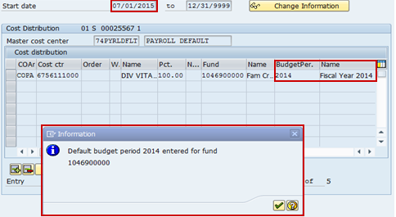

  - Select the green check on the pop-up box. A hard error message, “Invalid Fund/Budget Period for fiscal year of the Begin Date in line 1” will be displayed at the bottom of the infotype. All values on the infotype are now grayed out and cannot be changed. At this point, the user will need to exit the infotype and reprocess the entry.

- If an incorrect fiscal year or value is initially entered:
  - The above error message, “Invalid Fund/Budget Period for fiscal year of the Begin Date in line 1” will be received when the infotype is saved.

  - As above, the validity dates will gray out and the user will need to exit the infotype and reprocess.

IT9104 (Complement Control)
When an IT9104 record is changed or created with an effective date on or after 07/01/2014:

- No value will need to be entered in the Budget Period field. Based on the start date and the fund that is entered, the correct budget period value will default when the infotype is saved.

- If an invalid value is entered into the Budget Period field an error message, “Budget Period not valid with Fund”, will be received.

- Update the field with a valid budget period for the infotype to be saved.

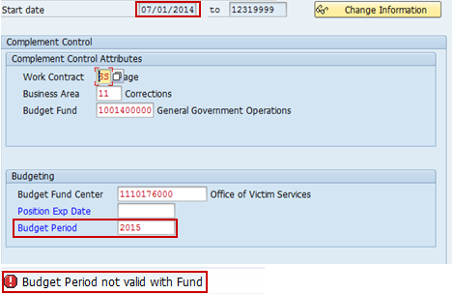

Fiscal Year Funds Update Program
The Fiscal Year Funds Update Program commences in mid-June and runs through early July each year. This year the program will take all applicable IT0027, IT1018 and IT9104 records and change the 6th and 7th digit of the fund to reflect 00. The program will also populate the budget period field to the current fiscal year. For example, if a position or employee had a fund of 1006713000, the program would create a new record effective 7/1/14 with fund 1006700000 and budget period 2014.

A separate program will also be run this year to populate the budget period value of 0000 for Funds beginning with 5 and 6. It is only necessary to run this program for the upcoming fiscal year, July 2014, in order to update the budget period value on all infotypes.

The removal of the fiscal year from applicable SAP Funds will not affect fiscal year end processing. This program will continue to be processed at the end of each fiscal year. In future years the Budget Period field will be rolled to the next fiscal year in lieu of the 6th and 7th digit of the SAP Fund. For example, if the current fiscal year is 2014, the program will create a new record effective 7/1/15 with Budget Period 2015.

Once program processing is complete, retroactive changes or transactions (i.e. New Hire, Promotion, Reassignment) that affect funding in a previous fiscal year will require manual updates by the user. For example, if you create a position after 7/1/14 retroactive to 5/1/14, you will need to create an additional IT1018 and IT9104 record from 7/1/14 to 12/31/9999. Thus, when the position is finished being created it should have one record from 5/1/14 to 6/30/14 for fiscal year 2013 and a second from 7/1/14 to 12/31/9999 for fiscal year 2014. Please keep in mind that for records prior to 7/1/14 the fund will still reflect the fiscal year and for records on or after 7/1/14 the Budget Period field will be required.

Questions?
If you have any questions regarding Fiscal Year Changes to SAP Funds and Cost Infotypes, please submit an HR help desk ticket in the personnel administration category. You may also call the HR Service Center, Agency Services & Operations Division at 877.242.6007.

