**Public School Employees’ Retirement System (PSERS) Act 2017-5 Pension Reform SAP Benefit Configuration Changes**

PSERS Act 2017-5 Pension Reform Retirement Enrollment 2

PSERS Act 2017-5 Pension Reform Infotype 169 – Savings Plan Enrollment Configuration 3

• Class T-G Defined Benefit/Defined Contribution enrollment 3

• Class T-H Defined Benefit/Defined Contribution enrollment 3

• PS 401(a) Defined Contribution enrollment 3

Benefits Confirmation Page Text for Act 2017-5 PSERS Retirement Plan Enrollment 4

• Class T-G Defined Benefit/Defined Contribution enrollment 4

• Class T-H Defined Benefit/Defined Contribution enrollment 4

• PS 401(a) Defined Contribution enrollment 4

Creation of A5/A6/401a Ineligible Indicators 5

• Infotype 9106 – Detail Job Attribute Tab – Job Indicators Section 5

• Infotype 9105 – Detail Position Attributes Tab – Indicators Section 5

Creation of Infotype 9013 – Inelig A5/A6/401a & OT Cap 6

# PSERS Act 2017-5 Pension Reform Retirement Enrollment

Below are the three new retirement pension plans that are being offered to eligible Education employees hired on or after July 1, 2019 with no prior service.

* Class T-G– Defined Benefit/Defined Contribution Plan
* Class T-H – Defined Benefit/Defined Contribution Plan
* PS 401(a) DC – Defined Contribution Plan

Below is a screen shot of how these new retirement plan options will appear on the HRBEN0001 – Enrollment transaction. All retirement plan enrollments should be processed through the HRBEN0001(Enrollment) transaction due to dynamic creation of retirement plan records in the background onto the Infotype 0169(Savings Plans) by utilizing the SERS/PSERS/TIAA enrl “Possible Offer”.

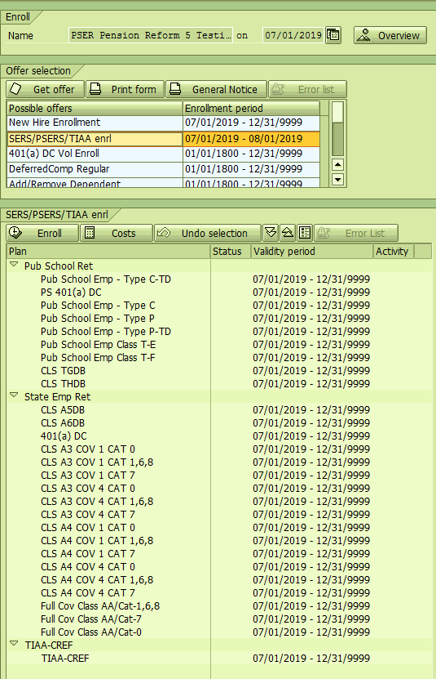

# PSERS Act 2017-5 Pension Reform Infotype 169 – Savings Plan Enrollment Configuration

Upon execution of the retirement plan enrollment through the HRBEN0001(Enrollment) transaction, the defined benefit and the defined contribution retirement plan records will appear on the Infotype 0169(Savings Plans). The defined contribution record is dynamically created in the background upon retirement execution through the HRBEN0001. Each PSERS Act 2017-5 Pension Reform retirement enrollment will have two records created on the Infotype 0169(Savings Plans) screen.

## Class T-G Defined Benefit/Defined Contribution enrollment

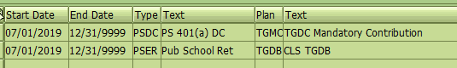

## Class T-H Defined Benefit/Defined Contribution enrollment

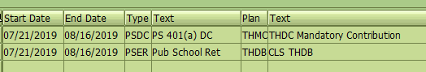

## PS 401(a) Defined Contribution enrollment

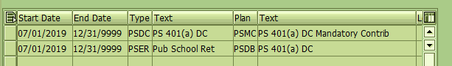

# Benefits Confirmation Page Text for Act 2017-5 PSERS Retirement Plan Enrollment

Below is the text that will appear on the benefits confirmation page if an employee is enrolled in an Act 2017-5 PSERS Pension Reform retirement plan option.

## Class T-G Defined Benefit/Defined Contribution enrollment

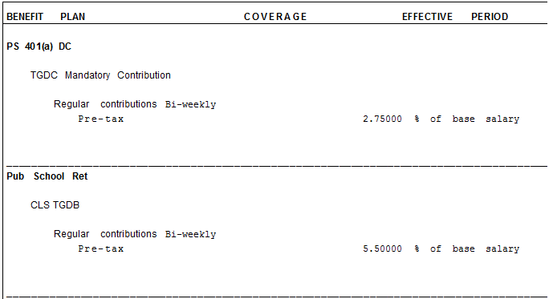

## Class T-H Defined Benefit/Defined Contribution enrollment

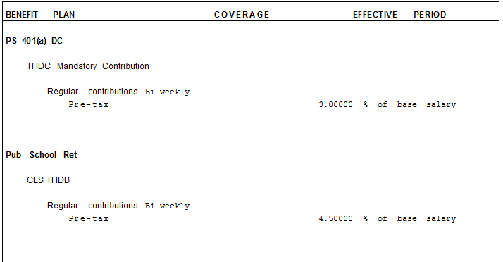

## PS 401(a) Defined Contribution enrollment

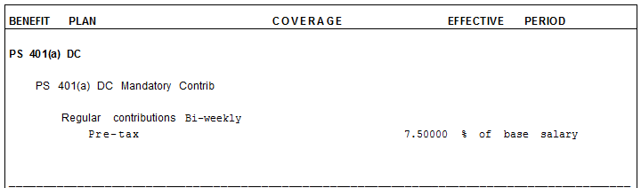

*Please note that only the defined contribution mandatory contribution record will appear for a 401(a) defined contribution enrollment due to the defined contribution defined benefit amount always being a 0.00%.

# Creation of A5/A6/401a Ineligible Indicators

A5/A6/401a Ineligible Indicators have been placed on Infotype 9106 (Detail Job Attribute) and Infotype 9105 (Detail Position Attribute) to identify if an employee is not eligible for enrollment in an Act 2017-5 Pension Reform PSERS retirement plan option. **Please note:** **There are no Education job classifications in SAP that are ineligible for Act 2017-5 Pension Reform.**

## Infotype 9106 – Detail Job Attribute Tab – Job Indicators Section

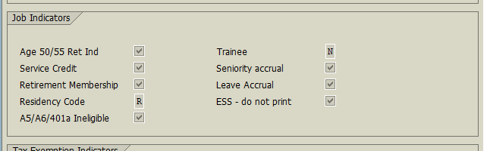

## Infotype 9105 – Detail Position Attributes Tab – Indicators Section

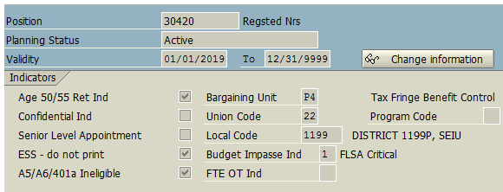

If the job classification is not eligible for Act 2017-5 Pension Reform retirement enrollment, the A5/A6/401(a) indicator will be checked on the job. If the ineligibility for Act 2017-5 Pension Reform retirement enrollment is based on the position, the indicator will be checked on the position. The A5/A6/401a Ineligible indicator should not be checked on both the job and the position for an employee. Below are examples:

* Corrections Officer – The A5/A6/401(a) Ineligible Indicator should be checked on the job since all employees in this job classification are ineligible to enroll in the retirement plan options under Act 5 of 2017.
* Registered Nurse - The A5/A6/401(a) Ineligible Indicator should be checked on the position since not every employee in this job classification is ineligible to enroll in the retirement plan options under Act 5 of 2017.

# Creation of Infotype 9013 – Inelig A5/A6/401a & OT Cap

Infotype 9013(Ineligible A5/A6/401a & OT Cap) has been created to identify if an employee hired on or after July 1, 2019 falls into one of the following categories:

1. Has a footprint that cannot be identified by the user by viewing State Employee Retirement System (SERS) information
2. Is ineligible for enrollment in an Act 2017-5 Pension Reform retirement plan option and is subject to the 10% cap on voluntary overtime towards pension compensation

The infotype 9013(Ineligible A5/A6/401a & OT Cap) is located on the “Employment Data” tab in SAP display access. Below is a screenshot of the infotype.

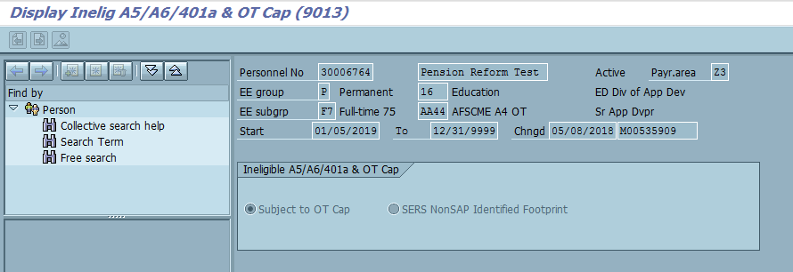

If an employee falls under both categories in which they have an unidentified SERS/PSERS footprint outside of SERS system and are ineligible for enrollment in an Act 2017-5 Pension Reform retirement plan option, the “Subject to OT Cap” option will be selected and text will be added to the infotype identifying as such.

In addition, the following roles will have view access only to the infotype 9013(A5/A6/401a & OT Cap):

* YPC_BNFT_ADMIN_COPA
* YPC:TIME_KEEPER_COPA
* YPC:TIME_KEEPER_1400
* YPC:TIME_KEEPER_EX14
* YPC:TIME_KEEPER_SUPT
* YPC:TIME_ADVISOR_1400
* YPC:TIME_ADVISOR_COPA
* YPC:TIME_ADVISOR_EX14
* YPC:HR_SERVICE_REP_OA_COPA