Please distribute this alert to any users within your agency who are responsible for benefit enrollments.

Verbiage Changes on the Benefits Print Confirmation Form in ESS and HRBEN0001 Transaction in SAP

- Information regarding verbiage changes on the Benefits Print Confirmation Form in ESS and HRBEN0001 transaction in SAP

Effective immediately, the following verbiage changes have been made on the Print Confirmation Form that can be found in ESS under the Benefits tab (Benefits / Participation Overview / Print Confirmation Form) and the HRBEN0001 transaction. These changes have been made to define the benefit more clearly.

Mental Health Benefits

Under the Medical Costs (Bi-Weekly) Notes section, the vendor name has been updated from “United Behavioral Health” to “Optum”.

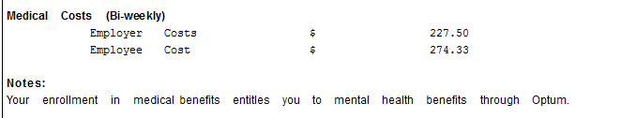

Retirement Benefits

Under the “State Emp Ret” section, the “% of base salary” text has been changed to “% of retirement covered earnings”.

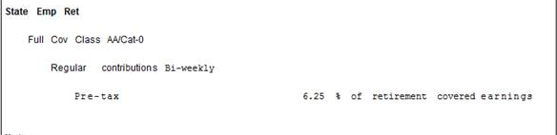

Deferred Compensation

Under the “DefComp” section, the “% of base salary” text has been changed to “% of salary” for the Deferred Comp, Deferred Comp Catchup and Roth 457 sections.

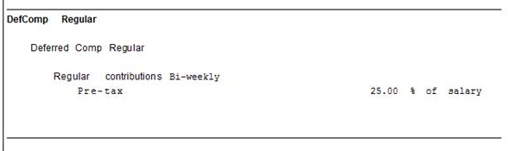

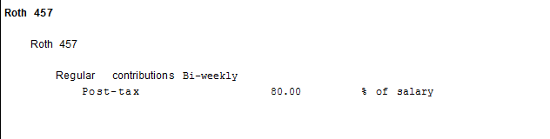

Questions?
If you have any questions regarding verbiage changes on the benefits confirmation page, please submit an HR help desk ticket in the benefits category. You may also call the HR Service Center, Agency Services & Operations Division at 877.242.6007.

