Please distribute this alert to any users within your agency who are responsible for Leave Without Pay Actions.

Processing Return from Leave Without Pay Without Benefit Transactions with an effective date on or after January 1, 2017

- Information regarding processing return from leave without pay without benefit transactions with an effective date on or after January 1, 2017

Pennsylvania Benefit Trust Fund (PEBTF) eligible employees that have been placed on a leave without pay (LWOP) without benefits status prior to the PEBTF Open Enrollment period (10/17/2016 through 11/04/2017) and who have not returned to commonwealth service are still showing in a 2016 medical plan offering. 2016 medical plan offerings are no longer available to employees effective 01/01/2017. An error will be received when trying to process return from LWOP without benefits actions using an effective date on or after 01/01/2017. Employees who were on LWOP with benefits received all open enrollment information and would have made a 2017 medical plan selection so they are not impacted.

For agencies served by the HR Service Center, the following steps should be taken prior to executing a return from LWOP without benefits transaction with an effective date on or after 01/01/2017.
- Review infotype 0000 (Actions) to determine if the employee has been out on a leave without pay without benefits status prior to 10/17/2016.
- Review infotype 171 (General Benefits Information) to determine if the employee returning from leave without pay without benefits is eligible for PEBTF benefits. The following infotype 171 (General Benefits Information) 2nd program groupings are eligible for PEBTF benefits:
- 01 – Full Time
- 04 – Part-time 40 hours
- 10 – PT LSC w/ H&W
- 11 – Part-time 37.5 hours
- 12 – FT LSC w/ H&W
- 15 – PT LSC w/o H&W
- 16 – FT LSC w/o H & W
- 24 – III > 1900 and no Life
- 25 – III 950-1900 no Life
- 28 – Perm PT 40 >50%-ACA
- 33 – Perm PT 37.5>50%-ACA
- 37 – III>950 No Life-ACA
- If the first two steps are applicable to the employee being reviewed, submit an E-PAR for the HR Service Center to process the return from LWOP without benefits transaction
  - After the transaction is entered, Employee Services will contact the employee so they can make their 2017 medical plan election and will update SAP accordingly.
- If the first two steps are not applicable to the employee, the agency will process the return from leave without pay without benefit transaction.

For those agencies not served by the HRSC, the following screen will be presented during the execution of the return from LWOP without benefits transaction for employees who have not elected a 01/01/2017 medical plan election. :

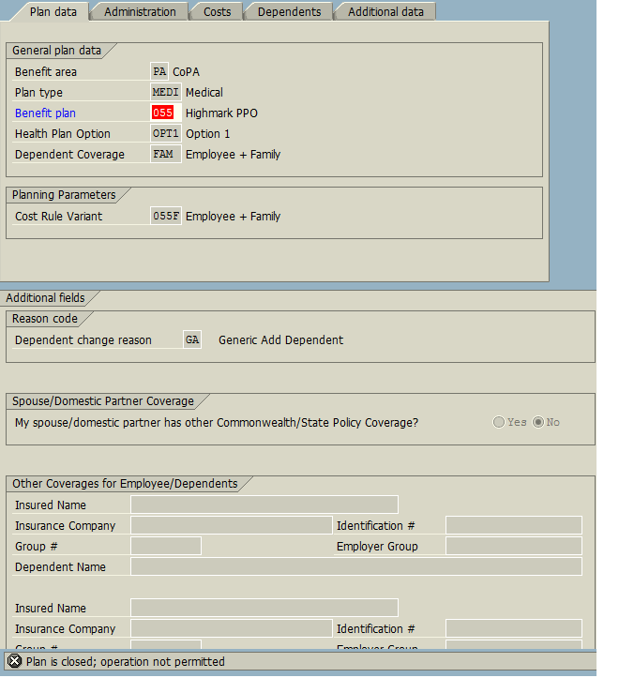
2016 medical plan election
Error message

The infotype 167 (Health Plans) will appear during the execution of the transaction with the following error message “Plan is closed; operation not permitted”. This message appears because the employee remains in a 2016 medical plan.

In order to continue the return from LWOP without benefits transaction, the user will have to update the “Benefit plan” to reflect declined “099” as shown below.

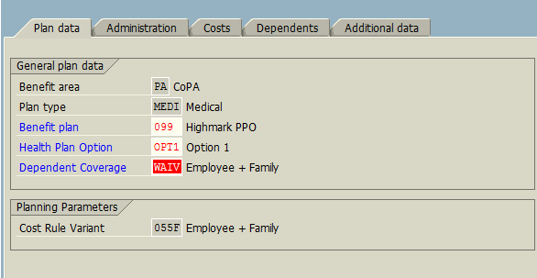
Update “Benefit Plan” to “099”

Once the field has been updated on infotype 167 (Health Plans), “Green Check” and “Save” the record, which will allow the user to continue through the remainder of the return from LWOP without benefits transaction.

Once the return from LWOP without benefits transaction has been completed, the user should place the employee in a declined prescription and declined supplemental status as well as the declined medical status. Outreach will need to be performed to the employee to make a 2017 medical plan selection and SAP will need to be updated accordingly.

Any policy questions regarding this process should be directed to ra-benhelp@pa.gov.

Questions?
If you have any questions regarding processing return from leave without pay without benefit transactions post January 1, 2017, please submit an HR help desk ticket in the benefits category. You may also call the HR Service Center, Agency Services & Operations Division at 877.242.6007.

