Please distribute this alert to any users within your agency who are responsible for benefits enrollments.

Creation of the COBRA Indicator in SAP

- Information regarding the creation of the COBRA indicator in SAP.

Under the 1986 Consolidated Omnibus Budget Reconciliation Act (COBRA) employers must notify newly enrolled employees, spouses, domestic partners, and common law spouses of their rights to temporary continuation of group health plan coverage when coverage is lost due to certain qualifying events. Currently, the COBRA notification process is manual executed by the HR Service Center and Independent Agencies.

Effective August 27, 2018, if your agency is supported by the HR Service Center, the COBRA notification process will be automated. For agencies not supported by the HR Service Center, current COBRA notification procedures should continue.

“COBRA Letter Indicators” have been created in SAP to identify that a COBRA notice has been sent to the employee, spouse, domestic partner or common law spouse. The “COBRA Letter Indicator” is located on the infotype 0376 – Benefits Medical Information record for the employee and on the infotype 0021 – Family/Member Dependents record for a spouse, domestic partner, or common law spouse. Please note: The indicator will only be checked for an employee, spouse, domestic partner, or common law spouse that received the COBRA notification on or after August 27, 2018.

Below is a screen shot of the COBRA indicator on the infotype 0376 – Benefits Medical Information record which is located in the “State of Health” tab.

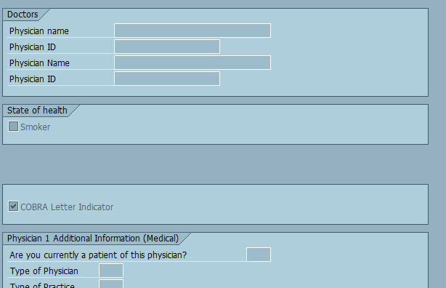
If the indicator is checked, the employee has received the COBRA notification on or after August 27, 2018 by the automated process.

Below is a screen shot of the COBRA indicator on the infotype 0021 – Family/Member Dependent’s record under the Physician information which is located under the “Physician” tab.

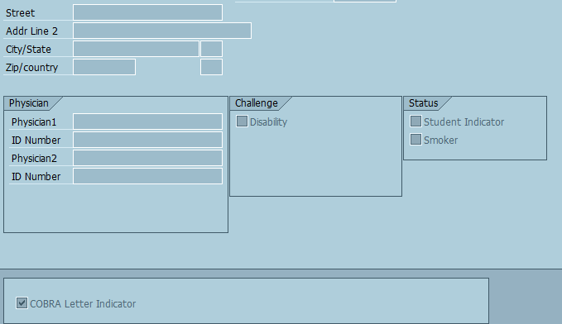

A mass upload of previously issued COBRA notifications will not be executed in SAP. Employees, spouses, domestic partners, or common law spouses who have received the COBRA notice prior to August 27, 2018 will not have this indicator checked.

In addition, no manual updates should be made to the COBRA Letter Indicator. If an update has been made in error, please submit an HR help desk ticket in the benefits category to correct the record.

Any policy questions regarding this updated process should be directed to ra-benhelp@pa.gov.

Questions?
If you have any questions regarding Creation of the COBRA Indicator in SAP, please submit an HR help desk ticket in the benefits category.

