***Please distribute this alert to any users within your agency who are responsible for benefit enrollments.***

**Updated Procedure for Newborn Indicator on IT0021 – Family Member/Dependents**

* Information regarding an updated procedure for the utilization of the newborn indicator on the IT0021 – Family Member/Dependents in SAP (Reference Benefit Alert 2012-02)

Previously, the following procedures were utilized upon receipt and verification of a newborn’s birth certificate on the IT0021 – Family Member/Dependent which applied to both the HR Service Center and agencies not supported by the HR Service Center.

* If the birth certificate is verified at the time of the initial enrollment of the newborn onto benefits, the newborn indicator should be checked upon the creation of the dependent record on the Infotype 0021 – Family Member/Dependent.
* If the birth certificate is not verified at the time of the initial enrollment of the newborn onto benefits, the newborn indicator should remain unchecked upon the creation of the dependent record on the Infotype 0021 – Family Member/Dependent.
* In the event the birth certificate is verified at a later date, Infotype 0021 – Family Member/Dependent should be updated using the COPY icon and then process these updates:
  + - Change the start date of the record to the date the PEBTF-33 was received
    - Check the newborn indicator box

**Effective immediately, the following process should be utilized upon receipt and verification of the newborn’s birth certificate.**

The newborn indicator on the Infotype 0021 – Family Member/Dependent should be checked on the **original newborn dependent record** created regardless if the birth certificate is verified on the date of the enrollment or at a later date.

The newborn indicator will be passed on the daily interface file to the PEBTF. The newborn indicator box is located on the IT0021 as shown below:

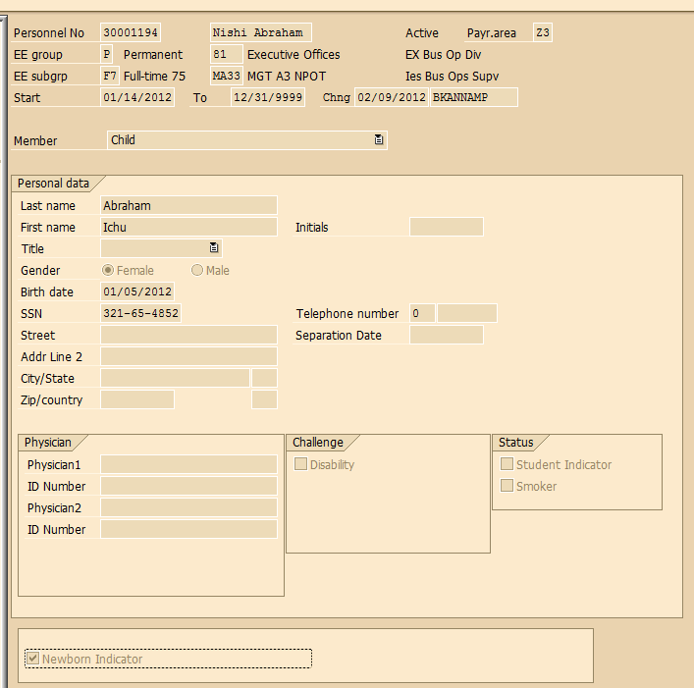

Newborn Indicator

PEBTF will send any discrepancies related to the newborn indicator to the HR Service Center or agencies not supported by the HR Service Center for resolution.

Any policy questions regarding this updated process should be directed to [ra-benhelp@pa.gov](mailto:ra-benhelp@pa.gov).

**Questions?**   
If you have any questions regarding the revision to the Updated Procedure for Newborn Indicator on IT0021 – Family Member/Dependents alert, please submit an [**HR help desk ticket**](http://oaiss.state.pa.us/HR-Pay_Help_Desk/) in the benefits category.