Viewing the Availability of OA Training Rooms in Microsoft Outlook
Instructions

- In Outlook, choose Open from the File menu, then choose Other User's Folder.
- Click on the Name button.
- Confirm that the Global Address List is displayed.
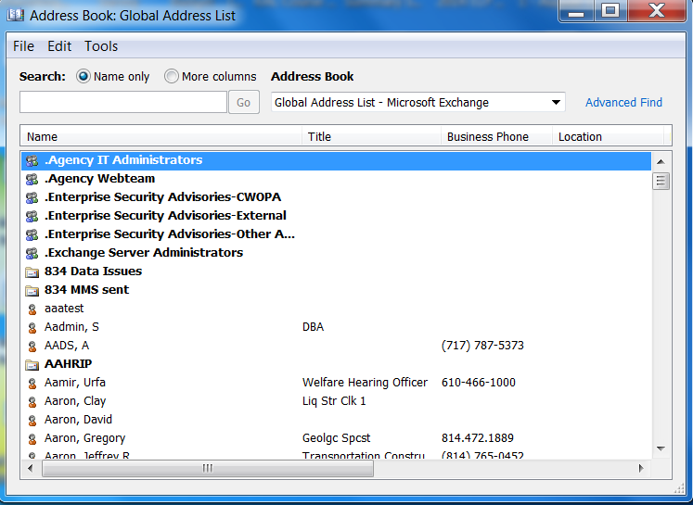
- In the Type Name text box type: "OA, Conf" and then scroll to the preferred conference room; 407A, 407B, or 407D.

- If you are trying to book a computer training room, in the Type Name text box type: “OA, FP” and then scroll to the preferred conference room; Training Rm 1, 2, or 3.
- Select the desired room and click OK.
- In the Folder text box select Calendar and click OK.
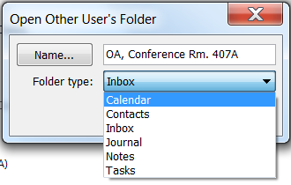
- Repeat for other rooms.
- Resize windows to view calendars simultaneously.

