Reserve an OA Training Room Using Microsoft Outlook
NOTE: You must receive a confirmation for use of the room from the OA Human Resource Development Division, so you may want to postpone inviting others to the meeting until you have received confirmation on the reservation and use of the room.
Instructions
- In Outlook, view the Calendar display.
- From the Actions menu, choose Plan a Meeting.
- Click on the Add Others button and choose Add From Address Book.
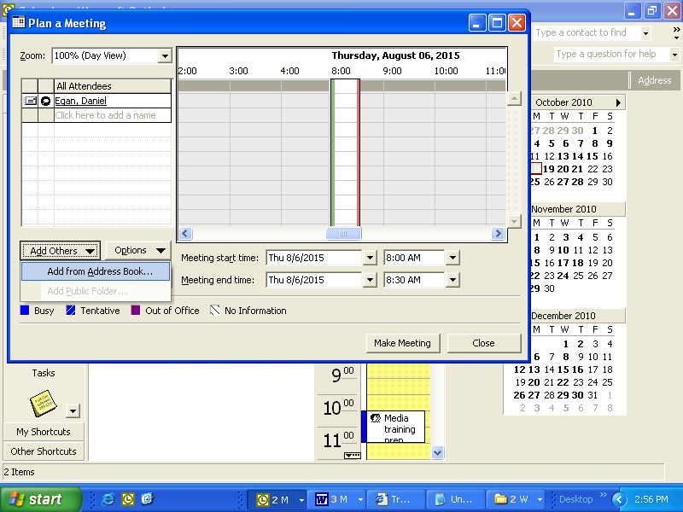
- Confirm that the Global Address List is displayed.

- In the Type Name text box, type: "OA, conf" and the list of rooms will be visible.
- Highlight the desired room with a single click then select Resources.
- You may add other attendees to the Planner by using the Required and Optional buttons and choose OK once all attendees have been added.
- Set the length of time for your session (total time room is needed from setup to cleanup) either by dragging the vertical bars in the graphic display or typing times in the time text box.
- Click the Options button and choose an option with One Resource.
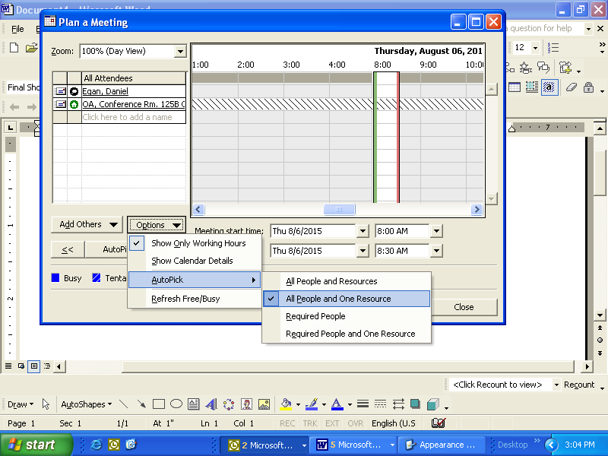
- If the first available time slot is not acceptable click the >> button. The suggested time will advance in 1/2 hour increments to the next available time period.
- When an acceptable time is identified, choose Make Meeting.
- Type the Subject and relevant meeting notes and Send.
- The meeting notice will automatically be sent to the OA Human Resource Development Division for review and approval.

