How to Refresh Linked IRIS Views
(for views already linked inside an existing database)

1) Once inside your database, select ‘Tools’, ‘Database Utilities’, ‘Linked Table Manager’:
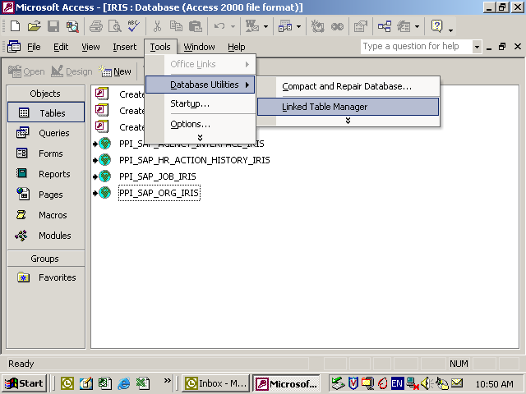

2) Select all IRIS views previously linked and click ‘OK’:
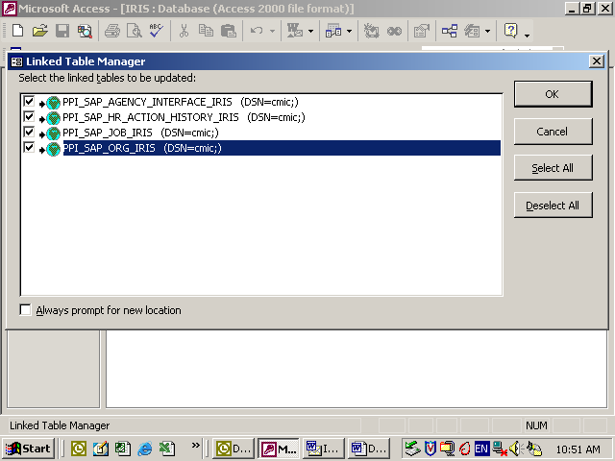
3) Enter your IRIS username and password if prompted:
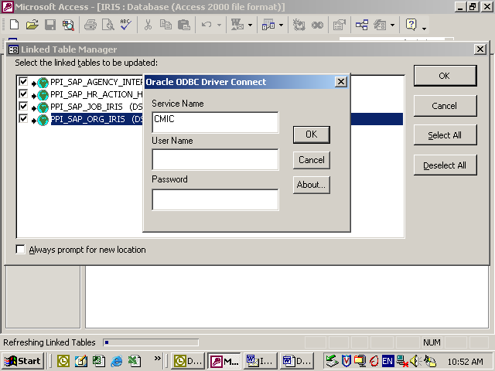

4) A confirmation message will appear:
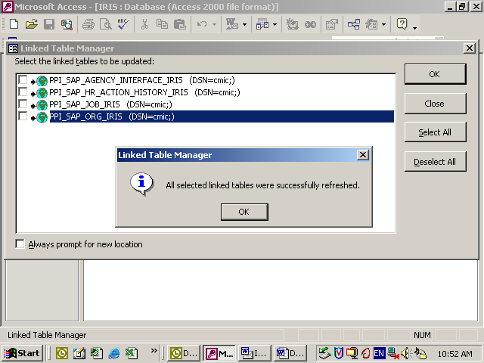
You may then hit ‘OK’ and close out of the ‘Linked Table Manager’ window.
You are now ready to continue using your existing IRIS queries or to build new queries. Fields in your linked views should now be alphabetized and any additional fields will now be available.

(NOTE: This procedure only applies to views already linked inside an existing database and will only refresh the design or structure of the views. The actual data within the views continues to be refreshed automatically each weekend.)

