MICROSOFT ACCESS

INTRODUCTION TRAINING
TO
MS-ACCESS

FOR

“ I R I S ”

Interim Reporting Information System

TABLE OF CONTENTS

Introduction 1
What is Access 2
Starting Access 3
Name and Store the Database File 4
Table 5
Select the Database to Link Tables 6
Queries 10

Creating a Query Using Design View 12
Select Query 13
Save 15
Run the Query 16
Datasheet Tool Bar Icons 18

Modify the Query in Design View 19
Sort and Show 23
Criteria (Values) 25
Criteria/Operators 27
Examples of Criteria 30
Group By/Count/Summarize 40
Parameter Query 41
Change or Reset Password 44
Importing Tables 53
SQL Statement 62
Quick Steps 68
Notes 70

INTRODUCTION

Welcome to Introduction to Access training for IRIS Users.

Goal:
To master the “skills” to Link Database Tables, Import Tables and produce Queries using the PC based software package MS-Access.

Objectives:
- Learn About Access
- Identify components of the Access Window
- Understand the Tale “Linking Process”
- Acquire the skills to Create, Design, Modify, Save and Print Queries.
- Work with Criteria and Operators
- Apply the Query Tool Bar Icons
- Count/Total/Summarize Queries
- Incorporate a prompt in a Parameter Query
- Rename and Delete Queries.

You will need security access for Oracle and the new SAP “IRIS” Tables.
WHAT IS ACCESS

Access is a Relational Database Management System (RDMS) for Windows. It enables you to store, organize, and manipulate collections of information in an electronic format. After information is stored in a database, the database program enables you to manage it in a variety of ways.

Database: A database is a collection of related information, or data.

RDMS: Computer-based program that contains multiple tables related through common fields.

Table: Tables are a collection of related information made up of fields and records and formatted into rows and columns.

Records: A collection of information about a person, place, occurrence, etc. Records are made up of individual fields. For example, a record of an employee would include the Employee Name, Birth Date, Original Hire Date fields, etc.

Field: An item name that contains specific information. Fields are categories of information that make up a record.

STARTING ACCESS

When you enter Access a dialog box will be displayed where you make a selection. There is a little button in front of each Option. This is known as a Radio Button. Click on the Radio Button of your choice then Click on OK.

More Files…
Open the most recently viewed databases.
Open a Database File that has already been created.
Create a New Database with the assistance of the Wizard
Create a New Database
NAME AND STORE THE DATABASE FILE

After selecting Blank Database the next window displayed is the File New Database Window. In this window you select where you want to store and name the file. A file folder can hold all the databases you create.

Instructions for Training:
- Click on the drop down arrow beside “My Documents”.
- Select “Desktop”.
- Click inside the window “File name” field and type in “Introduction to Access.mdb”

Instructions for your worksite:
1. Click on the drop down arrow beside “My Documents”.
- Select the drive where you want to save your database.
- If you have a file folder for databases, also select that folder.
- Click inside the window “File name” field and type in the name for your database (XXXXXX.mdb).

Type in name of new database then press Create Button.
Save file to your choice of drives.

5. Press the button.

TABLE

A Table is a collection of records that describe similar data.

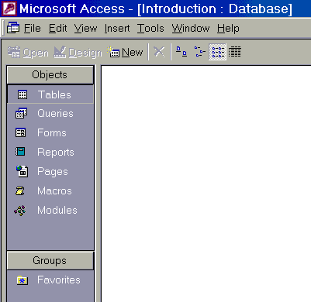

This is a Access Database File window. From this window you can create Tables, Queries, Forms, Reports, Macros & Modules. In Access these are known as Objects.

To create a new TABLE click on TABLES. Click on NEW.

The New Table window is displayed where you make a selection from a list. Select Link Table then click OK.

SELECT THE DATABASE AND FILE TYPE TO LINK TABLES

Link tables will bring in existing tables from an external file into the current database. Access needs to know where to locate the table(s) it is Linking.

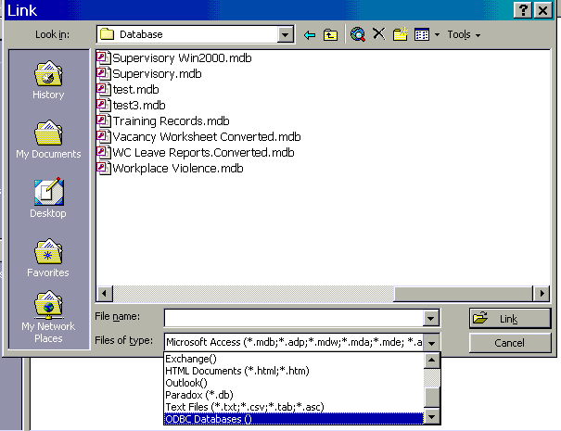

Use scroll bar to locate ODBC Databases

At the bottom of the Link Window in the “Files of type” window box, click on the down arrow or use the scroll bar located at the right to find ODBC Databases().
Click mouse on ODBC Databases()

The Select Data Source window will automatically appear. Click on the second tab “Machine Data Source”.

Click “cmic” to select then click on the OK button.

You will receive this prompt for your User Name and Password. This is your Oracle username and password. Your User Name will be your 8 digit Personnel Number and your assigned password, or whatever you had changed it to.

After your security logon is typed, click on the OK button.

All of the tables that you have security clearance for are displayed.

Select the table you want to work with (PPI.SAP_AGENCY_INTERFACE_IRIS), and then click the OK button.

In Access you can select as many tables as you want to link. After you have selected the tables and clicked on OK the link table window will be displayed, quickly followed by the window “Select Unique Record Identifier”. Click on the Cancel button. This process will be repeated for each table that you selected to be linked to your database. Continue to Cancel for each selected Table. Do not click on a field name or the OK button. Always click Cancel.

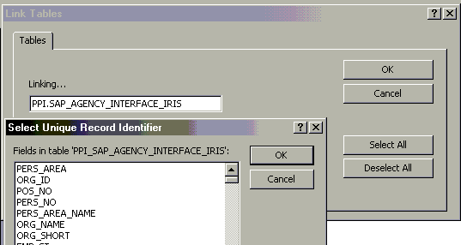

- IMPORTANT- Click on Cancel when the Unique Record Identifier window is displayed. Do this for each Table displayed that you linked.

table wi
Wait until the link process has completed. Your pc is linking the tables to the Access software and placing the tables in the Database file that you selected to Link, using the ODBC database drivers.

LINKED TABLES IN DATABASE WINDOW

When the linking process is complete, the selected Tables will appear in the Database File Window. In general, the IRIS are updated once a week.

IMPORTANT! – NEVER OPEN A LINKED IRIS SAP TABLE. Opening a Table may cause system problems and cause your PC to lock up.

QUERIES

A query provides a means to extract specific information (data) from an established table. The data is refreshed when you run a query.

INTRODUCTION TO QUERIES

A query asks a question. These questions are in reference to the type of data selected to be included in the query. You may not need to display all the fields and the contents of those fields (data) from a Table. Most of the time you will want to extract some specific information from a Table.

Create a New Query

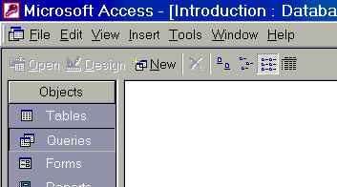

To create a new query- On the Database File window, click on the Queries object tab then click on the New button.

New Query Window

When you select Query and New on the Database File window, the “New Query” window will be displayed where you make a selection.
Highlight the selection of your choice to create a new Query then single click on OK button.

Select Design View for this exercise.
When you select the Design View and click OK, a “Show Table” window will be displayed. A Query design grid will be in the background. Highlight the table that you want to work with then click on the ADD button.

The Table that was added will be displayed at the top of the Design View of the Query. When you click on the Close Button the “Show Table” window will be removed.

CREATING A QUERY USING DESIGN VIEW

Query Design View - Top portion of Query Design View

NAVIGATION BUTTONS

The top portion of the design view will contain the Table(s) or queries you will use to create a new query. From the Table you select the fields that you want included in the query.

Bottom portion of Query Design View

NAVIGATION BUTTONS

The bottom portion of the design view of a query consists of rows and columns. The little boxes are called cells.
Each row has a specific identifier. They are:
Field, Table, Sort, Show, Criteria and or.
Each field selected for the query would consist of the following:
Field & Table Name. Sort, Show, Criteria & Or are optional.
SELECT QUERY

A Select Query is the most common type of query. A Select Query retrieves data from a Table using criteria you specify, then displays it in the order requested.

Click on any field to activate the table.

Selecting Fields from the Table
- Click on any field within the Table. This will highlight the field selected.
- Press the first letter of a field that you want to select for your query.
The first field starting with that letter will appear.
3. OR Use the up/down arrows to scroll bar to the right of the table to locate the fields in the Table.

Five different ways to select fields for a Query –

- Double click on a field from the Table. The field selected will go into the first or next available field cell.

- Single click on the field from the Table. Hold the left mouse button and drag the Table field to a field cell and drop it (release the left mouse button).

- Place the mouse pointer inside a blank field cell. Click inside the cell. Click on the down arrow, Use the scroll bar to locate a field. Click on a field.

- Place the mouse pointer inside a blank field cell. Click inside the cell. Type in the first letter of a field. Click on the down arrow. The first occurrence of a field starting with that letter will be displayed. Click on a field.

- Place the mouse pointer inside a blank field cell. Click inside the field cell. Type in the name of the field. The name must be spelled exactly as it appears in the Table. Typed in upper case and underline. Ex. POS_ST

SAVE

GO AHEAD AND SELECT JOB_ID AND BG_UNIT

You should have the following fields:
ORG_ID
EMP_FIRST_NAME
EMP_LAST_NAME
JOB_ID
BG_UNIT

After you have completed your input for the query and before retrieving data from a database, it is a good idea to SAVE the query at this time.

Depending on what type of criteria that you are requesting the PC may hang up and you will have to reboot the PC. If you did not save the query before you ran the query, you will lose all input up to that point or lose all the input for a new query.

To Save the Query: On the Tool Bar, single click on the Disk Icon OR up on the Menu Bar click on File, glide down to Save, click on Save.

A save Dialog box will be displayed. Type in a Name for the Query. Save this Query as Qry_Names and Jobs Click on OK. The name may have up to 64 characters. Spaces, upper or lower case are allowed. Some symbols are not accepted.

Type in a new name

NOTE: The name given to the Query will be displayed at the top of the output result, which in Access is known as the Datasheet.
Title Bar of Query in Design View

Suggestion: In the future when you are working with other types of Access Objects you may need to know that this is… a Query, Report, etc. At that time when saving you may want to precede the name with an identifier such as: Qry for Query, Frm for Form, Rpt for Report, Mac for Macro. This will be very helpful as a reference in the future.
RUN THE QUERY
(PRODUCE RESULTS)

To run a Query: On the Tool Bar Click on the exclamation point.
or
On the Tool Bar Click on the View Button
or
On the Menu Bar click on Query, ! Run.

The Logon window will be displayed. Type in your User Name and Password. Click on OK.

When you run the query Access retrieves and displays the records from the selections on the design grid. The Query output is known as a “DATASHEET”.

Return to the Design View from the Datasheet

To return to the Design View of the query from the Datasheet go up to the Datasheet Tool bar and click on the Design View Icon.
or
On the Menu Bar click on View, down to Design View.

OUTPUT of QUERY

When you run the query Access retrieves and displays the records from the selections on the design grid. The Query output is known as a “DATASHEET”. To increase or decrease the field size of a Column Heading such as EMP_LAST_NAME, etc, place the cursor on the vertical line between the Column Heading names. The mouse pointer will turn into a cross. Press and hold the left mouse button, drag the vertical line left to decrease or right to increase the field.

Sizing the Column Headings
Press hold and drag the vertical line to increase or decrease the field size.
OR
Highlight the column or all columns. Double Click on the line between the two fields. This auto sizes fields to maximum length or the size of the field name, whichever is greater.

New Record – The button is not activated because Records may not be added to these Linked Tables
Previous Record

Number of Records

DATASHEET TOOL BAR ICONS
Move to Last Record
Move to Next Record
Move to First Record

Inside the “Datasheet” click on a value of a field. Single Click on the appropriate Icon on the Tool Bar.

Sort Ascending – Sort the records lowest to highest values (A-Z or 0-9)

Sort Descending – Sort the records highest to lowest values (Z-A or 9-0)

Filter by Selection – Filters records by selected data.

Filter by Form – Provides a blank datasheet with Column Headings where you type in what you want to filter.

Apply/Remove Filter – After you select to filter this Icon is activated. You now have the option to apply or remove the filter.

Find – When you select this Icon a find Window will be displayed. Type in what you want to look for (Find). Be sure to have cursor in correct field to use Find function.
MODIFY THE QUERY IN DESIGN VIEW

To Insert a field before or after another field. Click to select a field from the table. Press and hold the left mouse button then drag & drop the field on top of an existing field in the design grid.

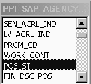

Insert POS_ST field

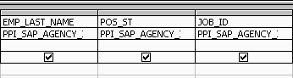

To Replace a field, click inside a filled field cell. A down arrow will be displayed. Click on the down arrow. A list of the fields will be displayed. Locate the field to replace the one in the cell and single click.

Replace JOB_ID with JOB_NAME

Click

Click

To Move a field, position the mouse pointer on the top of the column until you receive a down arrow Click to highlight the entire column.

Place you pointer on the top of the highlighted column, hold your left mouse button and drag the column to the desired location.

Note the dark vertical line in the grid that indicates where the field will be placed when you release the mouse button.

Run your query. NOTE: POS_ST added; JOB_NAME in now there instead of JOB_ID; and ORG-ID is now after last name.
To Delete a field, position the mouse pointer on the top of the column until you receive a down arrow Click to highlight the entire column.

Press the delete key on the keyboard. Note: the entire column must be highlighted.
To Rename a field, place the mouse pointer right before the first letter of the original field name and click. Type in a new name followed by a colon : Do not remove the original Table name. This new name will replace the original name only on the output result (datasheet) as the Column Heading.
Run your query. NOTE: BG_UNIT no longer shown.

BEFORE AFTER
The colon keeps the original field name.

OUTPUT (Data Sheet)

Rename EMP_LAST_NAME to LAST then run your query.

To Insert a column, click inside a filled field. On the Menu Bar: Click on Insert. Click on Columns.

A new Column can be used to add a “Note” field and/or “Expression”

A new Column will be displayed.
In order to get a blank “Note” field you must type NOTE:”” in the criteria field.

Delete this new column, we don’t need it.
SORT AND SHOW

Access Sort format: Access sorts fields in the order that they appear in the query. From Left to Right. The Sort selections are Ascending, Descending or not sorted. Not sorted is the default. To remove a sort, use the (not sorted) selection.

In the sort box of the field, click once, then click on the down arrow, select the sort order.

Sorts from Left to Right.

Add these new fields to your query: WORK_CONT, PERS_NO

Change Access Sort format:

To sort on the Org ID first, Job Name second and Last Name third, BUT display the fields in Last Name, Org ID and Job Name - Access sorts on the left most field first, then on the next field to the right, and so on.

If the field is not in the order of the sort sequence add a dummy (duplicate) field. Position that field to satisfy the sort sequence then take out the check mark from the Show box. Make sure the sort for that field appears on the dummy field not the field that you want to display on the datasheet.

The fields will be displayed in the order of the show selection but the sort sequence will be: Org 1st, Last Name 2nd, and Job Name 3rd.
“Show” will display or not display the data on a query. “Show” is the default. A check mark (X) will be displayed. To include a field in a query but not display it on the datasheet, click inside the Show box. The check mark (X) will be removed.
CRITERIA (Values)
Save your query as QRY_Sort and Show. Run your query.

Criteria (values) provides a means for Access to search the table for information from a field and extract specific values from that field.

In the below example the query requests only Filled positions (F). To request specific values from a field click inside the Criteria cell of a field to activate the cursor. Type in the Criteria (values) in the Criteria cell for a specific field. Press the Enter Key on the keyboard. Access by default will surround text with double quotes.

Click, Type, Press the Enter Key

The next query shows an and type of search. The query states that the criteria for Work_Cont is equal to SS (salary staff) and the Position Status code is equal to F (Filled Positions). All two criteria must be met in order to generate a record.

Change JOB_CD field to JOB_NAME. Save query as QRY_Criteria and then run the query.

ORG_ID | FIRST | LAST | POS_ST | JOB_CD | WORK_CONT | PERS_NO
00813710 | Robert | Cover | F | 00110 | SS | 00123456
00813046 | Judy | Bridges | F | 00230 | SS | 00789123

In the below query the criteria for JOB_CD, WORK_CONT, and POS_ST is an “and” search. Within the JOB_CD it is an or search. Use the or operator to include more equal to values. In this example the value is equal to the JOB_CD 00220 or equal to 00230. The = operator is not needed; it is the default.

Valid criteria for Pos St is : F = Filled and V = Vacant. The F and V must be capitalized. If you want active staff select only F for filled.
Save query as QRY_Clerk Typist 2 and Clerk Typist 3 and then run the query.

NO DATA

The datasheet may be displayed with only Column Headings. Depending on the type of criteria that you requested in the query this may be a valid result.

If the output results are not correct return to the Design View. Check the Criteria. The Criteria could be incorrect. Make changes to the criteria. If you still do not receive data go back to the design view and take out off the criteria and run the query again. Take a careful look at the results on the datasheet. The data on the datasheet may not meet the criteria you are requesting. When you have the correct data, don’t forget to “save” the changes.

F must be capitalized!
CRITERIA/OPERATORS

Criteria provides a way to SEARCH one or more fields on a Query and extract specific values from a Table.

Operators: Mathematical or logic symbol used with criteria

The comparison Operators Retrieve Records containing values greater than >, less than <, equal to =, greater than and equal to >=, less than and equal to <= the specified criteria (values).

Between – Retrieve Records containing specific values using And.

? Retrieve Records that match any single alphabetic character. The question mark ? is character position specific.

Like Finds values in a field that match the pattern you specify.

* The asterisk is a wildcard that matches any number of characters.

<> (not equal) Eliminate records that match the specified values (s).

Not – will Retrieve records other than the specified values (s).

Is Null – Retrieve records that contain a blank value in a field.

Is Not Null – Retrieve records that do not contain a blank value.

Date() is the current date. No space between the parentheses.

Examples: retrieve records that are:
Date()-14 14 days (2 weeks) prior to the current date.
>=date() greater than or equal to the current date
date()+29 retrieve records that are 30 days from current date.

Note: Operators such as Like, Or, Between, Not and Null may be in upper or lower case (optional).
CLOSE the QUERY

Before any query is closed, make sure that any changes are saved. Click on the X to the right of the Datasheet Title Bar (not the Microsoft Access Title Bar).

OR on the Menu Bar click on File, glide down to Close, click on Close.

If changes were made to the Datasheet and you select to close the datasheet (X) a message asking if you want to save the changes to the datasheet will be displayed. If you want to keep the changes, click on the disk on the tool bar. When you run the Query again the changes to the datasheet will remain.

Return to “Introduction” Database

After you close the query, you will return to the Queries window of your database.

From the Database window you can select Tables, continue with Queries or select any of the other objects in the Database window.

To create a new query, click on Queries, the click on New.

To modify a query, click on Queries. On the Queries Window, click to highlight a Query name then click on the design button.

To run a query, click to highlight the query name, then click on Open.

Reminder: NEVER OPEN A LINKED TABLE.
EXAMPLES OF CRITERIA

OR Criteria/Operators

When including more than one value for a field the operator that separates the values is the Or. The or may be in upper or lower case. Access will adjust it.

Or Criteria within a Field

When requesting more then one value within a field the Or operator must be inserted between the values. The above query states that the criteria for the field Position Status Code (POS_ST) is = to F or is = to V. Filled or Vacant

Another Example of Or Criteria

The below example requests six Job Code values. If the Job Code field holds any one of the selected values, the record will display on the datasheet.

Another Example of Or Criteria

This example requests two job code values. The selected Job codes values must be in the two selected Organization ID Codes for the record to be displayed on the datasheet.

Use Your Org_ID Code

Suggestion: To view the entire criteria, make the column wider. Place the cursor on the vertical line of the column selector after the column heading until a cross is displayed. With the cross displayed press and hold the mouse button and drag the vertical line to the right to increase or left to decrease the column. This does not change the column size on the datasheet but provides a means to view the information if it is longer then the cell size in the query design view.

Note: Placing the values in sequential order make the query process more efficiently but it will not display that way. The field must be sorted.

OR Criteria With a Condition

The following query is an example using the Criteria cell and the or that is located underneath criteria on the design view grid.

Scenario: The OA needs a list of everyone who has to file a Financial Disclosure form. Employees in certain position have to file, but other employees will need to file if they perform certain functions (Job).

Don’t forget to duplicate the other criteria in the or cells.

Between (this is a range search) Criteria/Operators

Use Your Org_ID Code
Use Your Org_ID Code
Type in the ORG_ID criteria using AND next ORG_ID criteria.
When you press the Enter Key. Access surrounds the criteria with the quote signs.

When you press the Enter Key. Access surrounds the criteria with the pound signs #.
Type in the BIRTH_DT criteria. Dates are in month/day/year order. The slash / must be included.

Example of multiple ranges using the Between Operator

Use Your Org_ID Code
When using multiple ranges (Between) the OR operator separates the range request. The AND separates the values.

? Criteria/Operator

? Finds values in a field that match the pattern you specify. The ? is position specific. In Access 2000 you have to type Like and the Quotes

BG_UNIT | LAST
A3 | Andrew
A3 | Robert
The ? was in the first position and the 3 is in the second position of the 2 character field.

? Also matches any single character. This sample shows how you type it in and how it will look when you press the enter key.

4/12/1950 | Ivonne
4/30/1955 | Margaret
4/18/1947 | Thomas
Displays the dates that have 2 digits in the day position of the date.

4/5/1947 | Albert
4/2/1952 | Robert
4/3/1962 | Fred
Displays the dates that have 1 digit in the day position of the date.

* - Wildcard Criteria/Operator

The wildcard works with Alpha items and Dates. The asterisk * scans the entire character length of the value with a field and will look for a character string of values. It is not position specific.

Output
Found the value Box anywhere within the field named Street

Asterisk before and after the word Box

Another Example (Alpha):

Output
Found Titles that start with Cl for the field Job Name

Another Example (Dates):

Displays the entire contents of the date field for the month of April
Output
Not Equal to <> Criteria/Operators

When using the <> it must be an exact match. Example of the not equal format using the field Job Code: <>03660. When using the <> operator for more than one value in the criteria cell and is the correct operator for more than one value in the criteria cell and is the correct operator. The Operator And may be typed in upper or lower case.
When using multiple not equals <> the and operator indicates that there will be another <> repeat.

The above example specifies that the job code is not equal to this and not equal to this and not equal to this, etc. These job codes will be eliminated from the query and will not be displayed on the output result.

Not Criteria/Operator

Not will retrieve records other than the specified value.

Retrieve all records that do Not have Job Codes starting with a U.
Retrieve records that do Not have a 3 in the second position.

NOTE: The <> operator will not work when using the ? or *.

Null Criteria/Operators

Is Null will display only those records that do not have a value (blank) in the field.

Result of Is Null

Is Not Null criteria will display only those records that have a value in it for the Middle Name field. If you do not include criteria for Middle Name you receive all the records, those that have a value and those that do not have a value in the Middle Name field.

Result of Is Not Null

Greater Than and Equal To and Less Than and Equal To Criteria/Operators

Greater Than – Example withText Fields:

This example will produce staff who are 55 years of age or older and have 25 years or higher of State Service. Both of these conditions must be met for a record to be displayed on the datasheet.

Less Than – Example with Date Field:

This example will produce staff who’s Original Hire date is less than or equal to January 1, 1970.
GROUP BY/SUMMARIZE

Group By: Combines records with the same values together from the selected field and places the value into a single record.

Select the field(s) that contains the values to be grouped together.

To Group By: click the Totals ICON on the Tool Bar.

A new item called Total has been added to the design view and Group By has been placed in all the Total cells for each field.

Click inside the Group By Total cell. Click on the down arrow. Locate and click on the Where function.
Change PERS_AREA and POS_ST code functions from Group By to Where. Use Where for “No Show” fields. When the Where clause is used the check mark in the show box is removed. Where states “Where” a value(s) should match the selected criteria.
Output Result:
Note: Group By automatically Sorts the fields.
GROUP BY/COUNT/SUMMARIZE

A summary value is created for each record if you include an aggregate function, such as Sum or Count.

This query will Count the number of staff within an Agency.

Select the field(s) that contains the values to be grouped together (PERS_AREA) and a field to Count – a good choice is PERS_NO. For active personnel add the POS_ST field and include criteria.

On the Tool Bar, click on the Totals Icon

For PERS_NO, change Group By to Count.

Save query as QRY_Count of Employees then Run your Query.

Output Results:

CountOfPERS_NO
2119

When you select a field for a count Access displays a unique Column Heading name on the datasheet. The name is CountOf followed by the name of the selected field. The field can be renamed in the design view (see page 25).
PARAMETER QUERY

A parameter query displays a dialog box prompting you for criteria for a field. The dialog box is displayed when you Run a query.

Set up a Query that will display a prompt.

Select the following fields:

EMP_FIRST_NAME
EMP_LAST_NAME
PERS_NO
STREET
CITY
STATE
ZIP_CD
POS_ST (Criteria – enter “F” for Filled)

In the criteria cell for EMP_LAST_NAME type in text that will prompt for your input. The text must be surrounded with brackets.

Example: [Type in Employee’s Last Name]

Save Query as QRY_Employee Address then run the query.

Dialog Box Prompt
Text that you typed between the brackets in the criteria cell.

Type in a Value (criteria) for the field then click OK button.

Example of “Smith”
EMP_LAST_NAME | EMP_FIRST_NAME | PERS_NO | STREET | CITY | STATE | ZIP_CD
Smith | Judy | 00665544 | 5th Avenue | Steelton | PA | 17113
Smith | Faith | 0002468 | Few Avenue | Middletown | PA | 17057
Smith | Robert | 00998877 | 2nd Avenue | Harrisburg | PA | 17110

After receiving your results, you can look up another employee, by holding down the SHIFT and press F9 and you will receive the Dialog Prompt Box that you can enter new criteria.

Results for Smith
EMP_LAST_NAME | EMP_FIRST_NAME
Smith | Dee
Smith | Guy
Smith | Jim

You can design a query to include prompts for different fields.

Example:
NOTE: Text inside prompt box will display what the user is to do.

You can design a query to include more than one prompt for one field.

When you run the query the first prompt will be displayed. Type in the information that you would place in the criteria cell and click OK button. The next prompt will be displayed. Type in the criteria, click on OK and the query will generate the data.

CHANGE OR RESET ORACLE PASSWORD

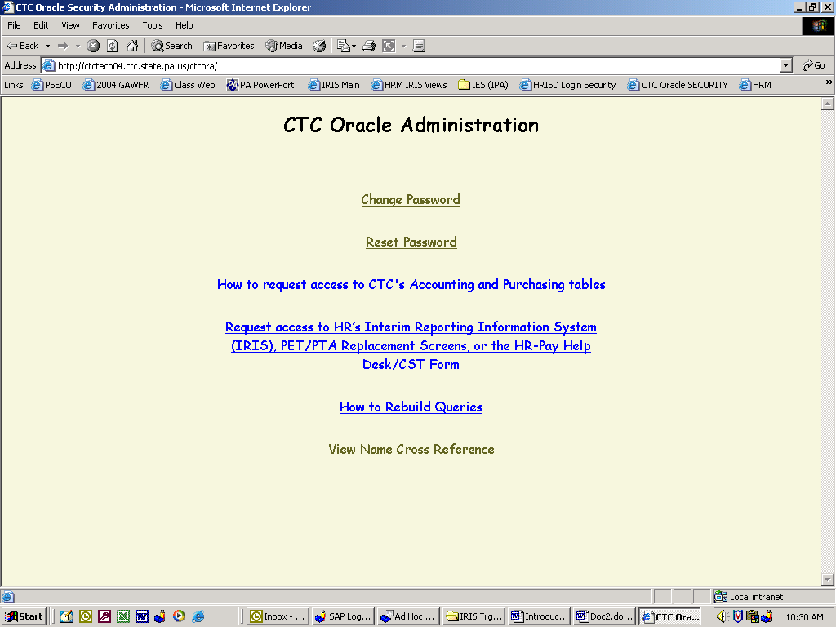
Select “Reset Password”

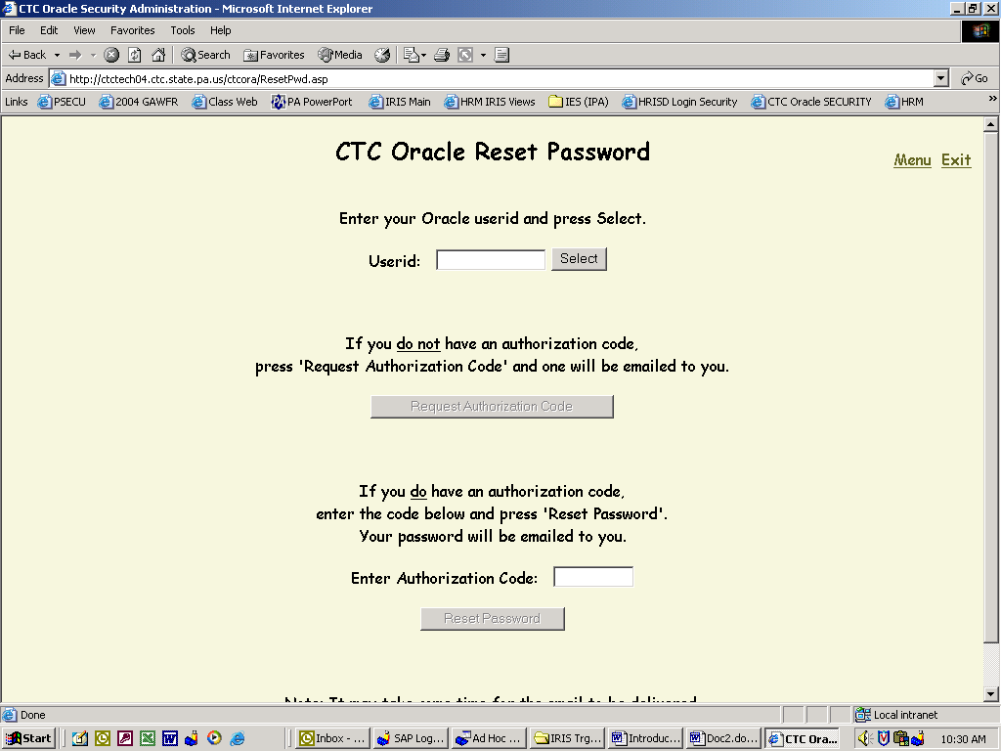
Enter your 8 Digit
Personnel Number

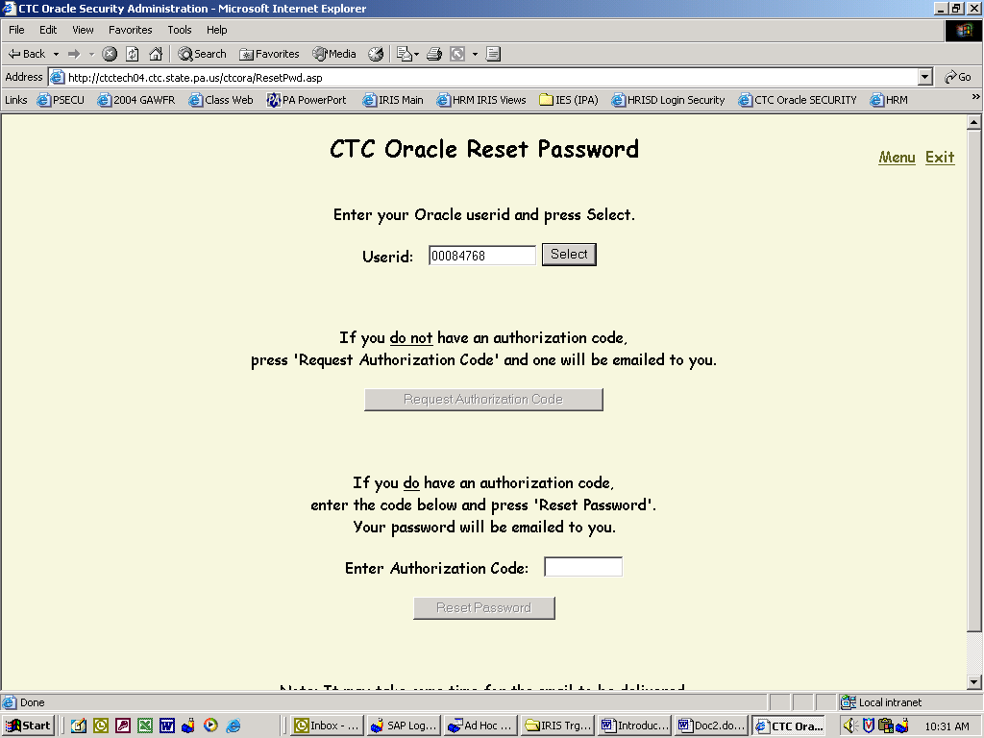
Press Select

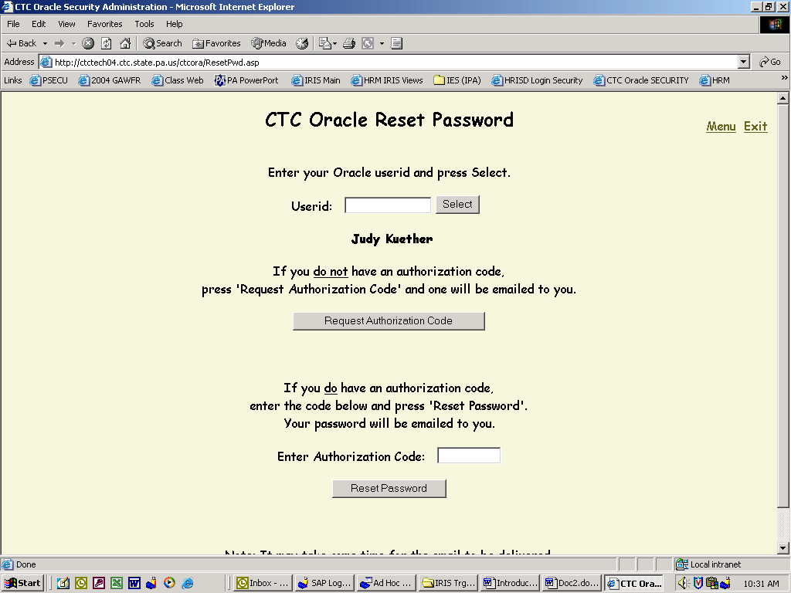
Select “Request Authorization Code”

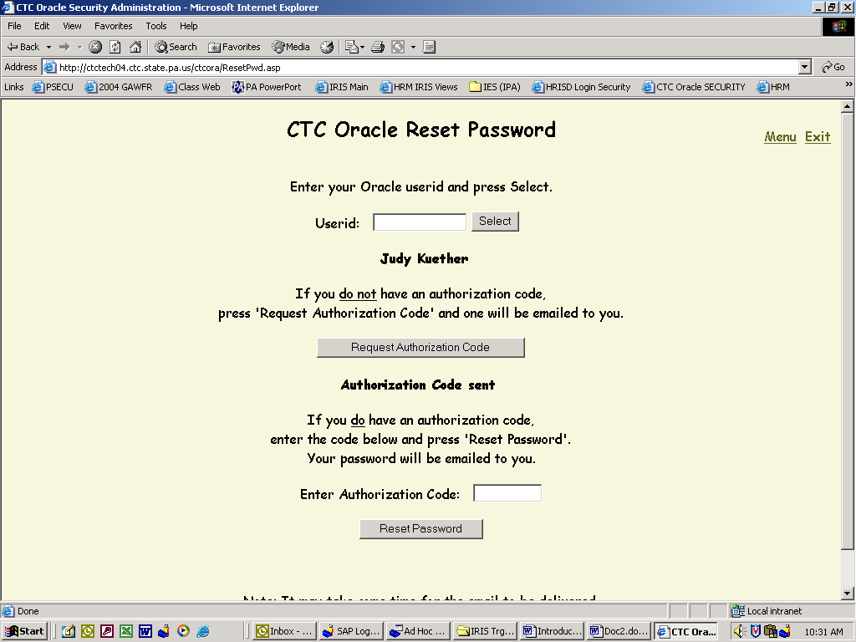
“Authorization Code” sent via e-mail to Outlook
Switch to Outlook

Open the e-mail in Outlook to access the Authorization Code

Copy the “Authorization Code”
Switch to “Reset Password” Screen

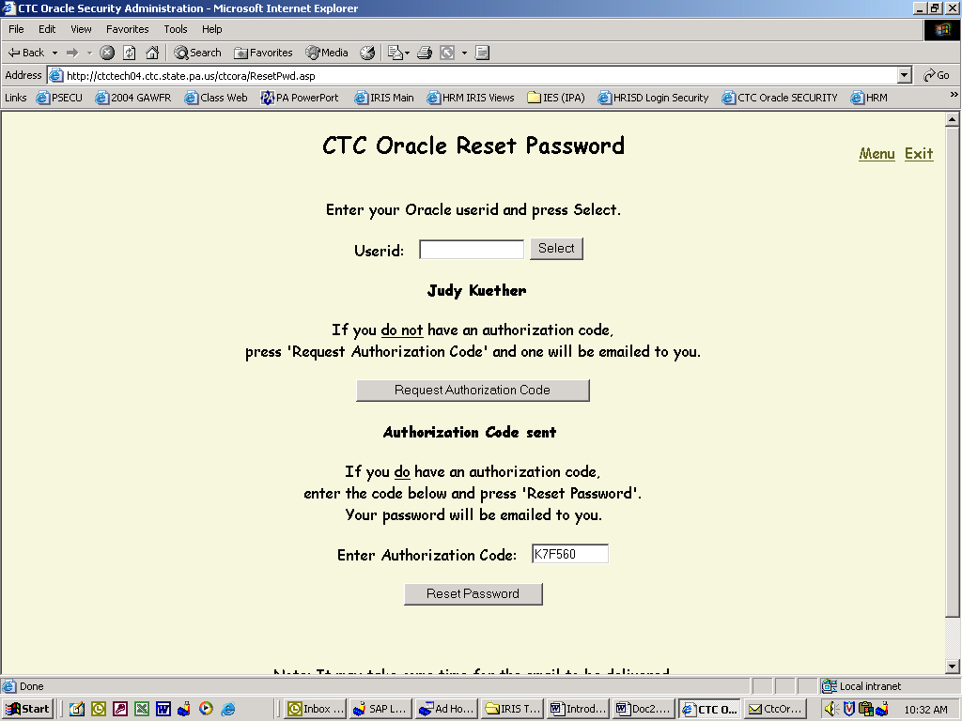
Enter the “Authorization Code” received in the e-mail & select “Reset Password”

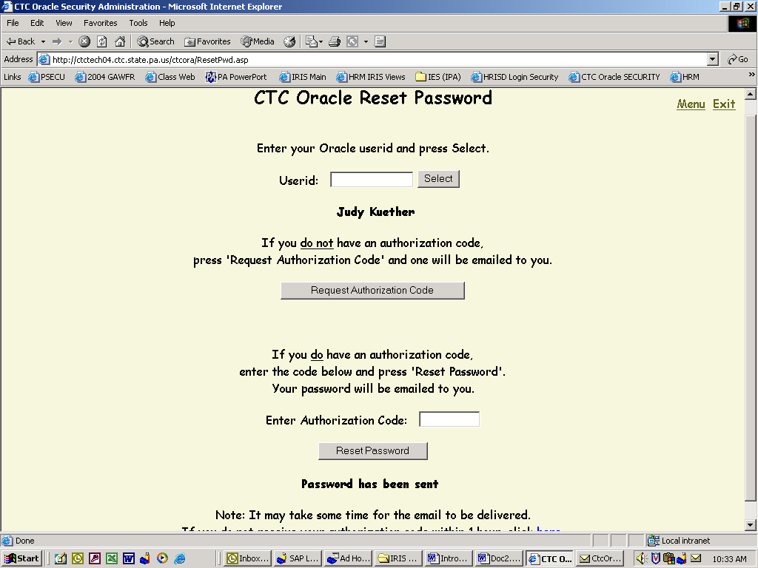
“Password” sent via e-mail to Outlook
Switch to Outlook

Open the e-mail in Outlook to access the “Password”

Copy the “Password”
Switch to “Reset Password” Screen

Select “Menu”
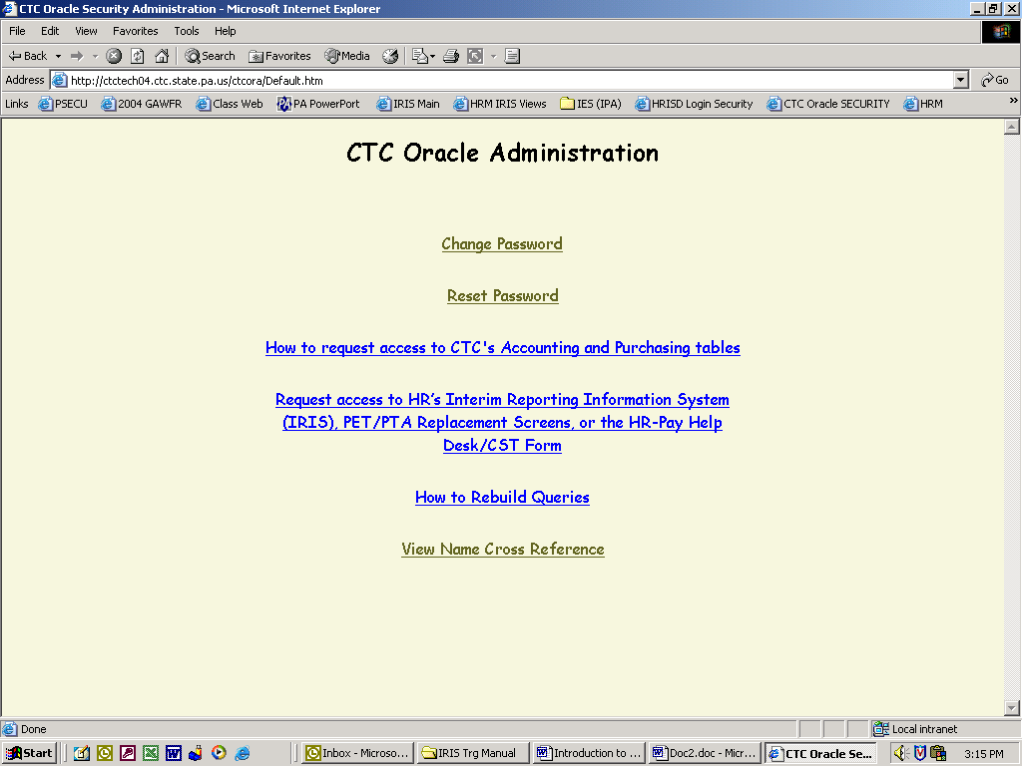
Select “Change Password”

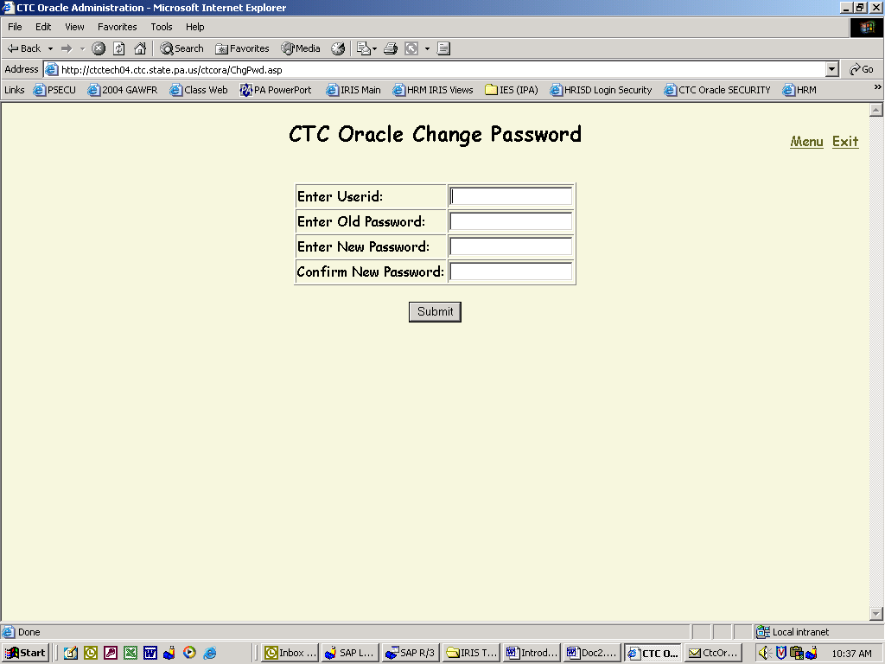

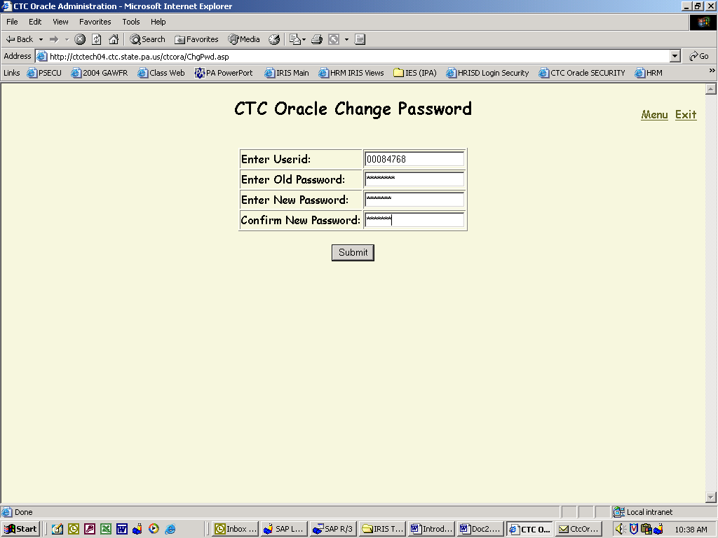
Select “Submit”

Enter the required data
Note: “Old Password” is the “Password” received
via e-mail

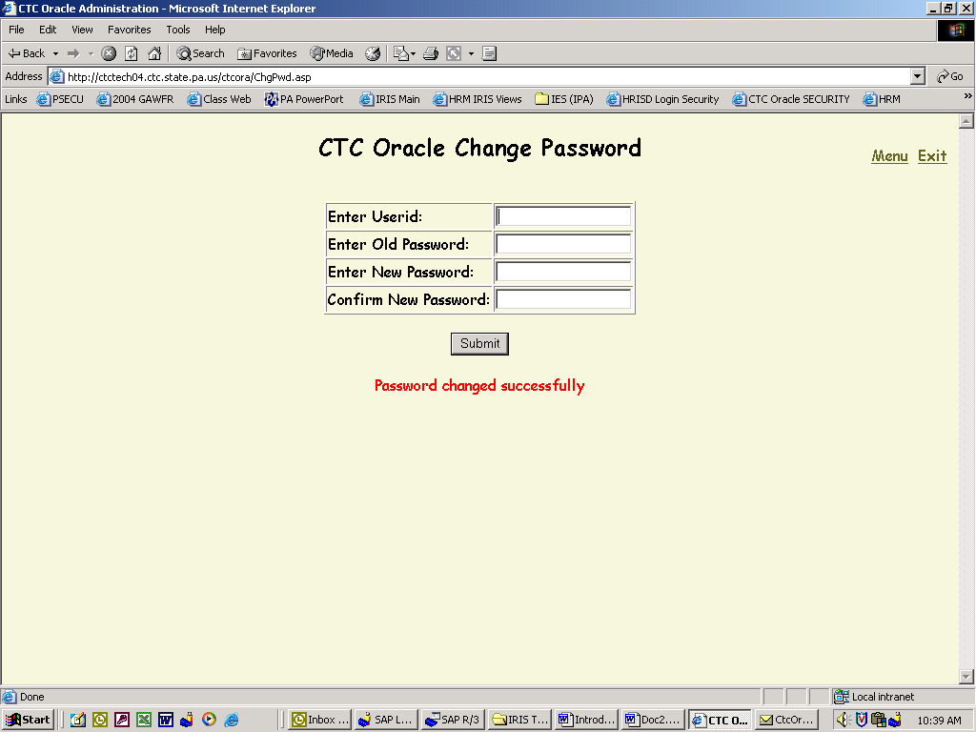
After “Password Change Successfully”
Select “Exit”

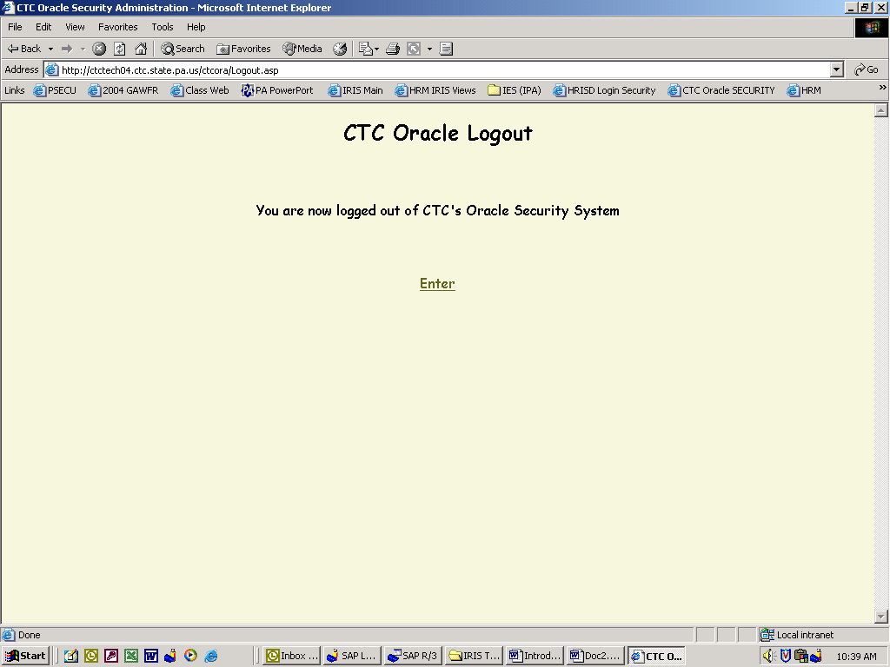
IMPORTING DEFINITIONS FROM EXCEL
INTO ACCESS

OPEN DEFINITION BY “DOUBLE CLICKING” ON DEFINITION
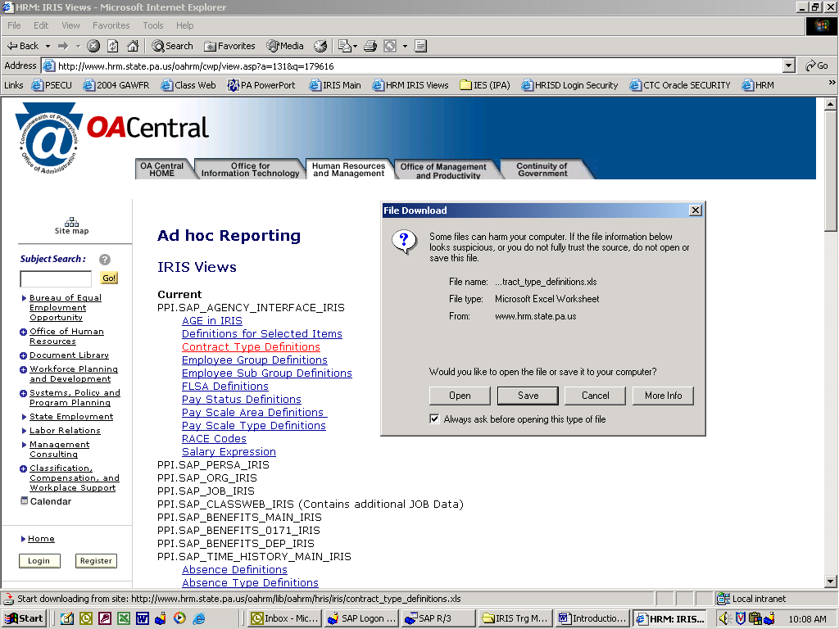

“SAVE” TO DESKTOP, “CLOSE”, “VERIFY THAT EXCEL DEFINITION IS ON DESKTOP”
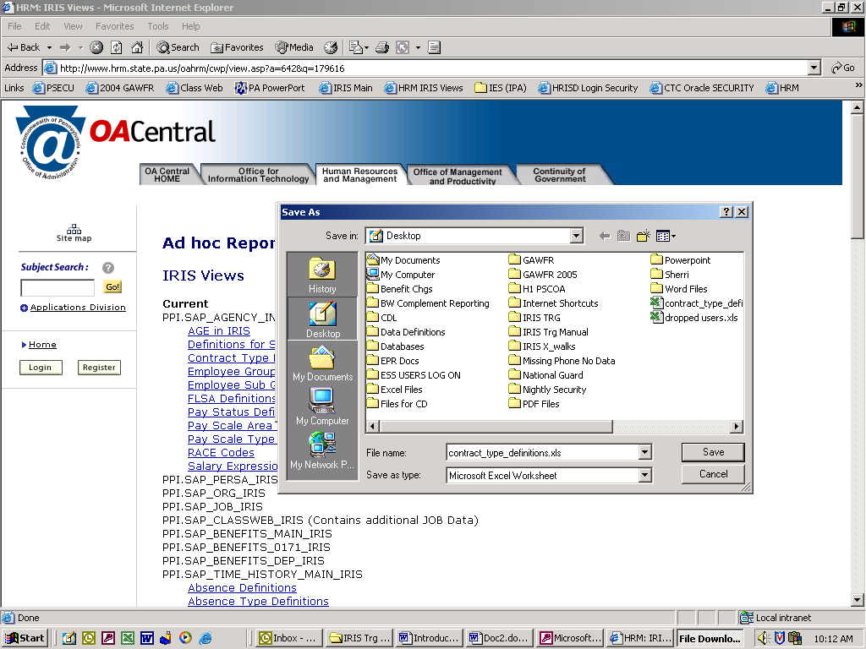
GO TO YOUR DATABASE; SELECT OBJECT “TABLE”, “NEW”
Select “New”

HIGHLIGHT “IMPORT TABLE”; SELECT “OK”

SELECT “DESKTOP”

SELECT “FILES OF TYPE” – CLICK ON “DROP DOWN ARROW” -
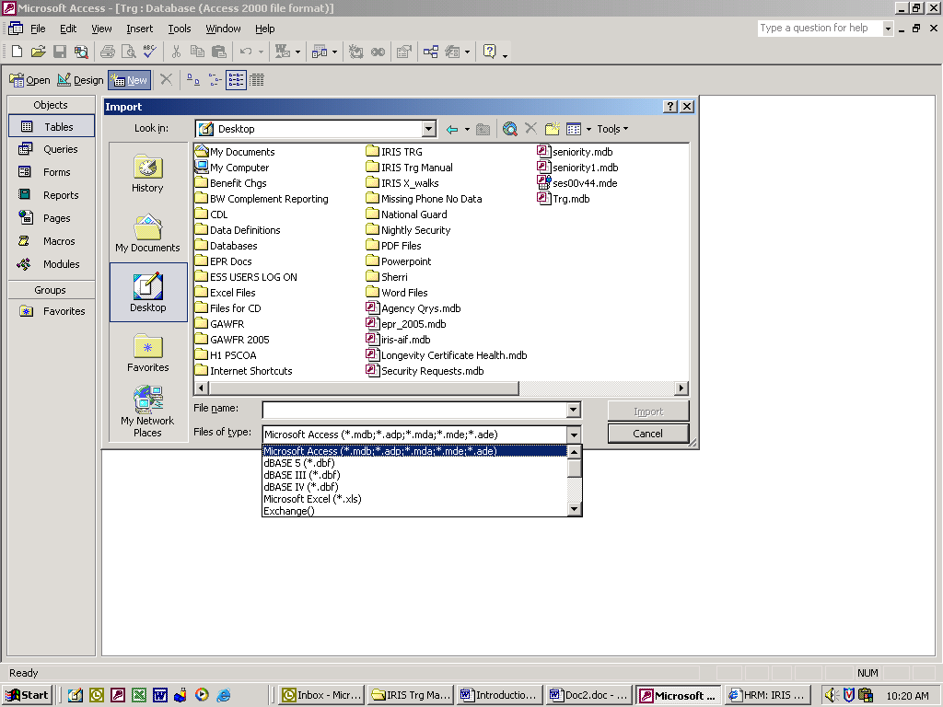
SELECT “MICROSOFT EXCEL”

HIGHLIGHT FILE
“contract_type_definitions.xls”

SELECT “IMPORT”

CHECK “FIRST ROW CONTAINS HEADINGS”; “NEXT”

SELECT “IN A NEW TABLE”; “NEXT”

SELECT “NEXT”

SELECT “NO PRIMARY KEY”; “NEXT”

SELECT TO CHANGE TABLE NAME OR LEAVE AS IS; “FINISH”
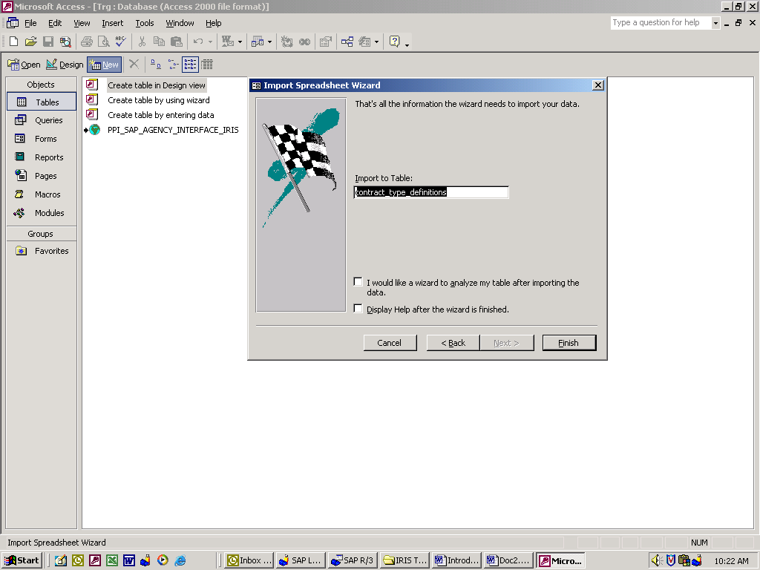

MESSAGE RECEIVED: “FINISHED IMPORTING FILE, ETC.”
TABLE IMPORT IS FINISHED; SELECT “OK”
LOOK FOR THE TABLE YOU CREATED IN YOUR DATABASE
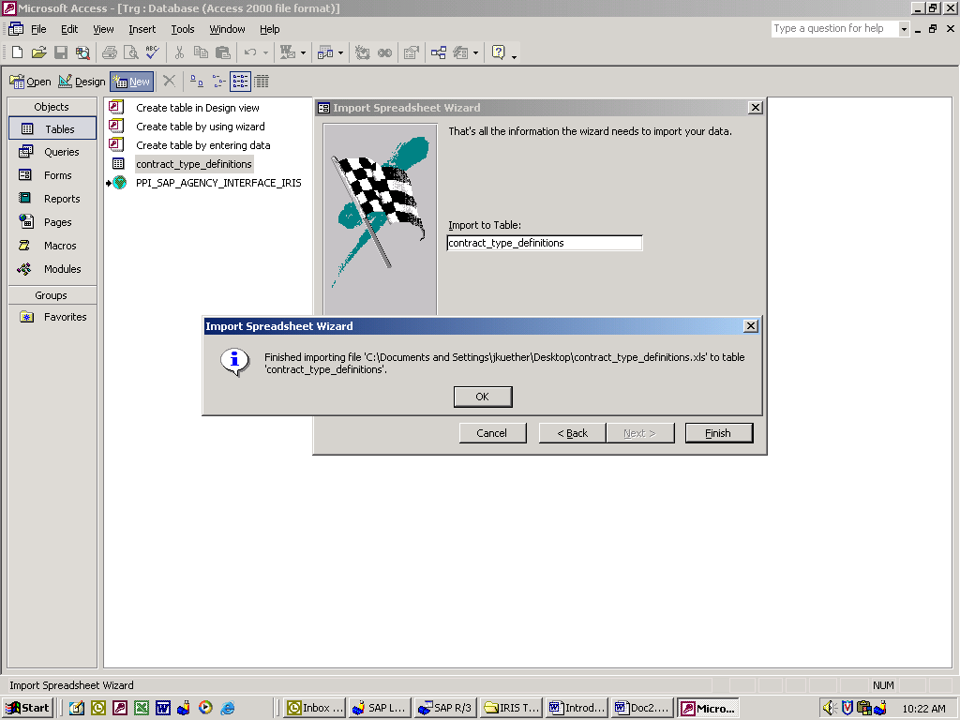

OPEN TABLE “contract_type_definitions”

RESULTS

SQL Statement

To Send a query via e-mail

Open MS Access query in design view

Click on view – change to SQL view

Copy highlighted information
Control “C” or Copy Icon

Click on view – change to design view
Query Design Grid is returned
Close MS Access query or switch to e-mail message

Paste in message and send
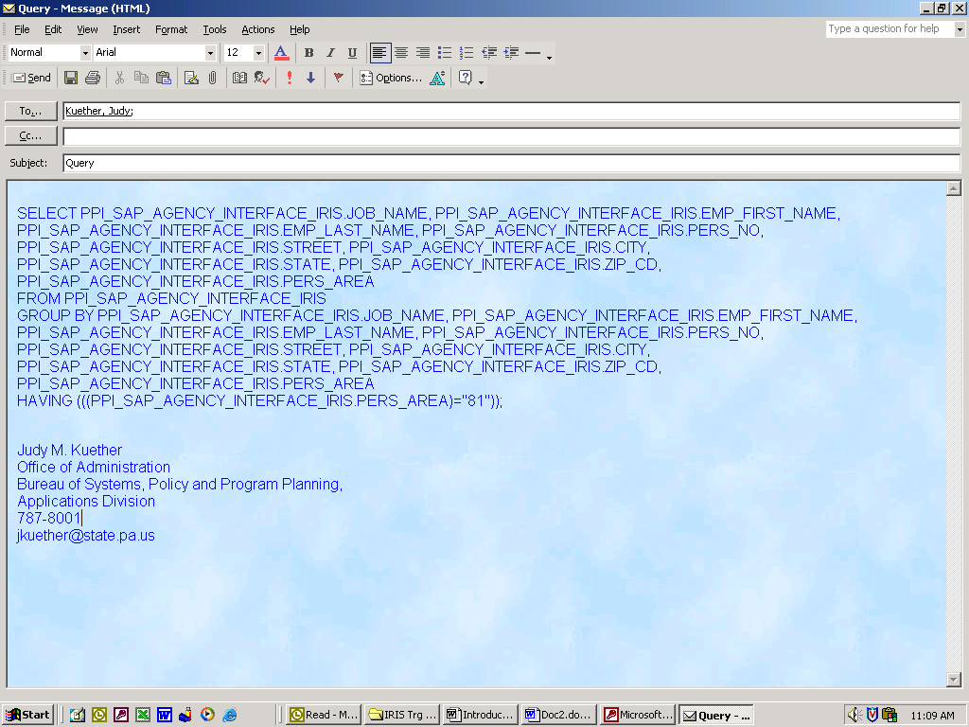
Control “V” or Paste Icon

Receiving a query via e-mail

Open e-mail message

Copy SQL Statement
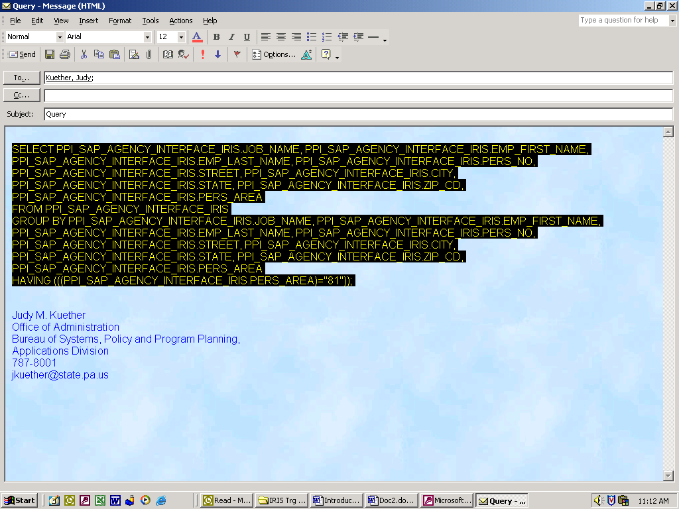
Control “C” or Copy Icon

Open or switch to MS Access

Check to see that the table/view has been linked in the database

Open new query in design view

Add table/view to query and close Show Table Box

Click on view – change to SQL view

Delete the information that is highlighted
Paste SQL Statement
Control “V” or Paste Icon

Click on view – change to design view

Save query

QUICK STEPS
Create a Blank Database
On the Create using Window
- Click in the Radio button of Blank Database
- Click on the OK button
- Click on the third file folder across from the “save in” window
- Type in a name for the new folder and click the OK button
- Double click on the new folder to place it in the “save in” window
- In the File name window, type in a new name for the blank database
- Click on the Create button on the right side of the window
A Blank Database File will be displayed

Link TABLES
On the Database Window
- Click on the Tables Object Tab
- Click on the New Button to the right of the window
- On the New Table window Click to highlight Link Table
- Click on the OK button
- At Files of Type click on the down arrow and locate ODBC databases
- Click on ODBC databases
- At the top of the window click on the Tab named Machine Data Source
- Under the Machine Data Source Name click on cmic. Click the OK button
- On the Logon window type in your User_id Password then click on OK
- Highlight the Tables of your choice by a single click
- After you have selected the Table(s) click on the OK button
- Press the CANCEL button for each Table when the window Unique Record
Identifier is displayed.
You should now be back at the Database File with the Linked Tables displayed under the Table object Tab. ***Important*** Do not open a Linked Table.

Design a QUERY
On the Database Window
- Click on the Queries Object Tab
- Click on the New Button to the right of the window
- Click to highlight Design View
- Click on the OK button
- Click to highlight the Table of your choice
- Click on the Add button
- Click on the Close button
- Click inside the Table to activate it
- Ref. Starting on page 15 to Design, Save and Run a new Query
10. Ref page 28 to Print the query.

HELP!

To receive assistance with any process that was covered in class: Introduction to MS-Access for “IRIS” – Interim Reporting Information System
CONTACT: OA/Systems, Policy and Program Planning/HR Systems and Services Division
Matthew McKenzie, Human Resource Analyst (Systems)
Judy Kuether, Human Resource Analyst (Systems)
Lynne Taylor, Human Resource Analyst (General)
Jodi Dorman, Administrative Assistant

Phone: (717)787-8001
E-Mail mmckenzie@state.pa.us
jkuether@state.pa.us
ltaylor@state.pa.us
jdorman@state.pa.us

NOTES:

