Procedures for Transaction Y_DC1_32000670 (Time Evaluation Messages Display)

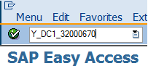
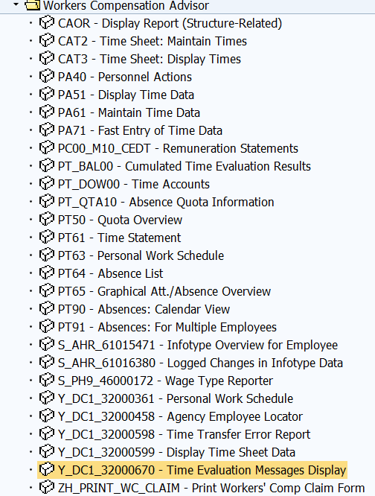
To access the report, workers’ compensation advisors can select transaction Y_DC1_32000670 from the workers compensation advisor role folder located on the SAP Easy Access screen.

The report may also be accessed by entering the transaction name in the Command Field located at the top of the SAP Easy Access screen.

When running the report, it is important to use detailed selection criteria in order to minimize the need for the report to pull heavily from other SAP resources that are needed for critical systems jobs. The report selection screen should include the period (i.e. date range) and any additional selection criteria such as personnel area, organizational unit, etc. To add these additional search criteria, the user must first select the “Further selections” button.

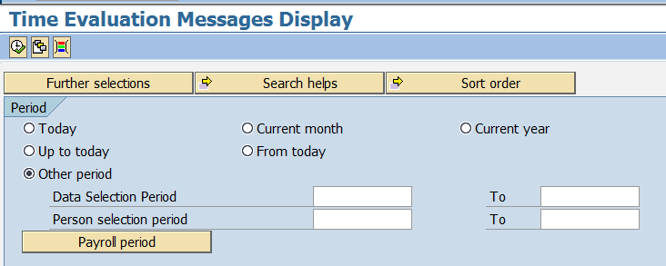

Upon clicking the “Further selections” button, the “Choose Selection Fields” pop-up window appears. The left column, “Selection options”, displays the available fields that can be added to the report. The right column, “Selection fields”, displays the fields that will be used when executing the report.

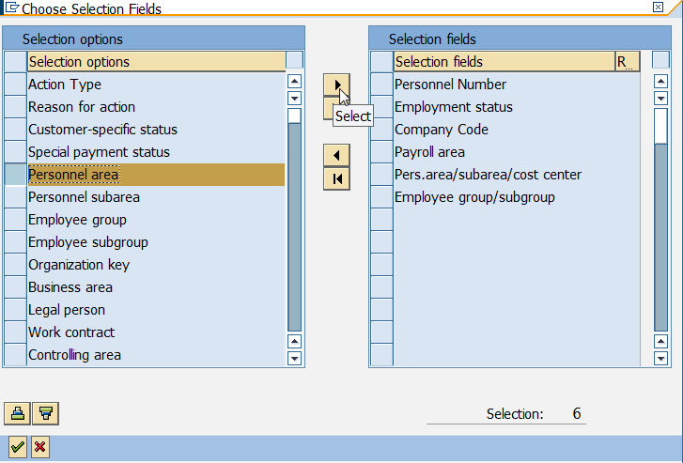
In the left hand column, click the box to the left of the desired data field to add it to the report selection. Click the button to add the field to the right hand column.

TIP: Highlight multiple data fields at once to add other search criteria to the report.

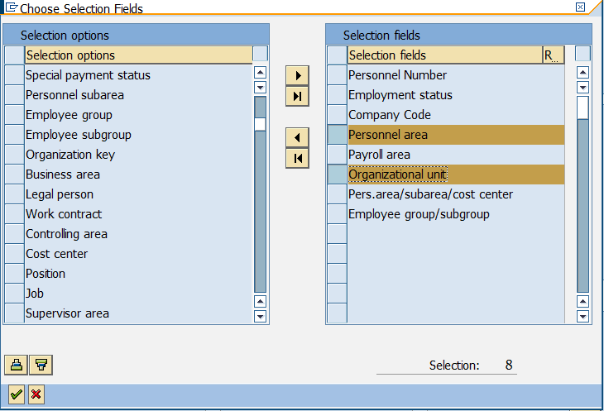
Note the highlighted fields shown in the “Selection fields” column that have been added to the report.

Once all the additional selection fields have been added, click to add the fields to the report.

After clicking , the user is returned to the main selection screen and the new data fields now appear under the “Selection” portion of the screen. The user must now enter specific search criteria before executing the report.

Enter the date range for the “Data Selection Period” and the “Person selection period”. The “Person selection period” is required to eliminate employees no longer employed by the specified agency. NOTE: For larger agencies, it may be necessary to search on shorter date ranges.

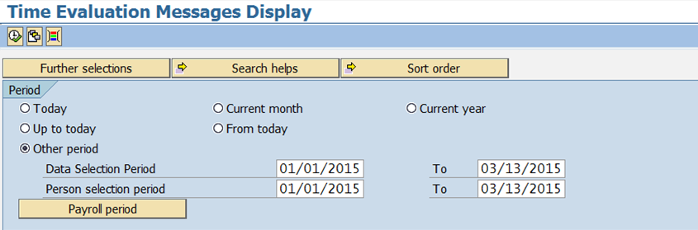
Next, enter the Selection criteria. Generally, search for current employees within the agency. NOTE: Larger agencies may also wish to include the organizational unit, or agencies with more than one payroll area may wish to include a specific payroll area on this screen.

By completing the search fields as shown in the example below, only data for current employees, based on the personnel area entered will be searched. The example below reflects Personnel area 11, which will result in a search of only the Department of Corrections.

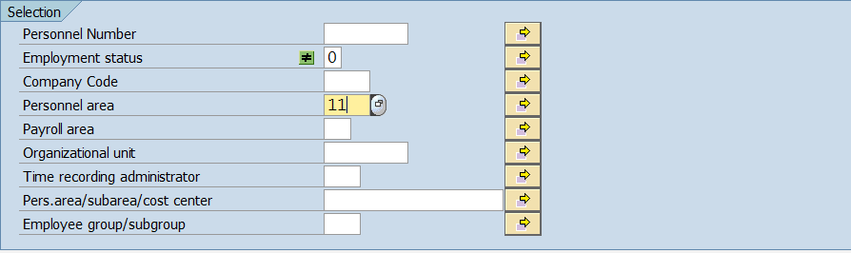
To eliminate withdrawn employees, double click in the selection field to the right of “Employment status”. When the “Maintain Selection Options” pop-up window appears, select “Not Equal to” .
On the main selection screen, enter “0” for withdrawn.

Because the workers’ compensation advisors are solely interested in searching for the H2 and H6 messages, additional criteria should be entered under the “Error attributes” section to further define the search criteria by “Number of message type”.

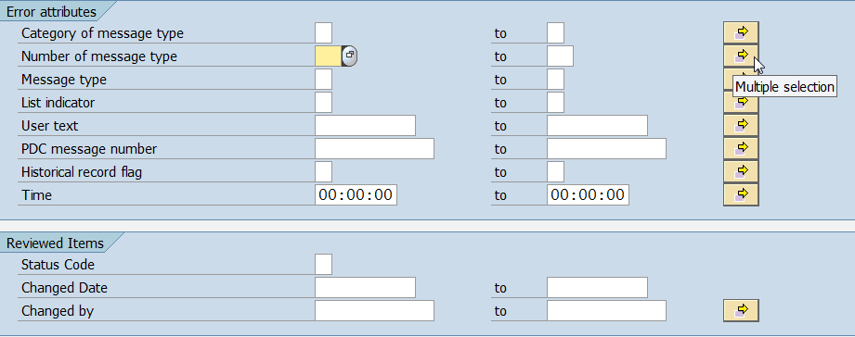
To search only for H2 and H6 messages, place your cursor in the selection field beside “Number of message type”.

Then click on the Multiple Selection button located on the far right.

The “Multiple Selection for Number of message type” pop-up window will appear.

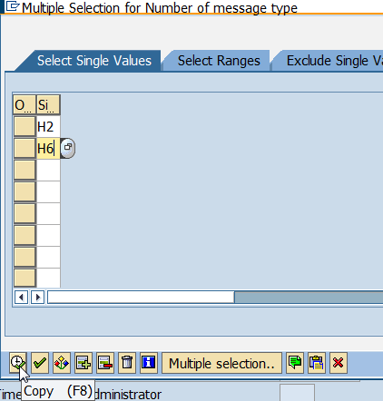
Enter “H2” and “H6” to search only for those message types.

Click the copy icon.

Note that the Multiple Selection button will be highlighted in green to indicate that there is more than one value entered.

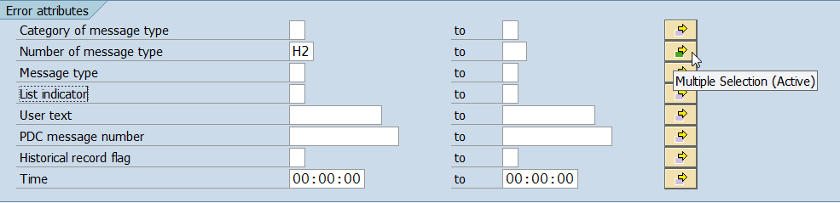

Once all of the desired criteria has been entered, select the Execute icon to run the report. It is not unusual for the report to take up to several minutes to complete.

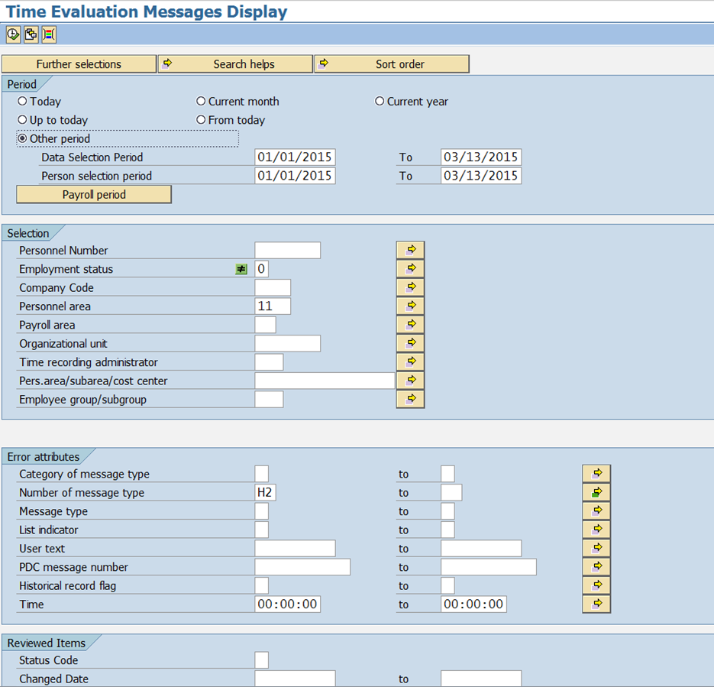

When the report has completed, the Time Evaluation Messages Display screen will appear. If no messages appear, no action is required. If an H2 or H6 message appears, the workers’ compensation advisor must identify the messages that are due to a paid sick-injury absence (SI – WRI Sick Leave) and contact the Bureau of Commonwealth Payroll Operations (BCPO). BCPO will begin or remove the tax exemption for Social Security and Medicare taxes for the employee as appropriate. After BCPO has been notified, mark the message as reviewed so that it is removed from the report.

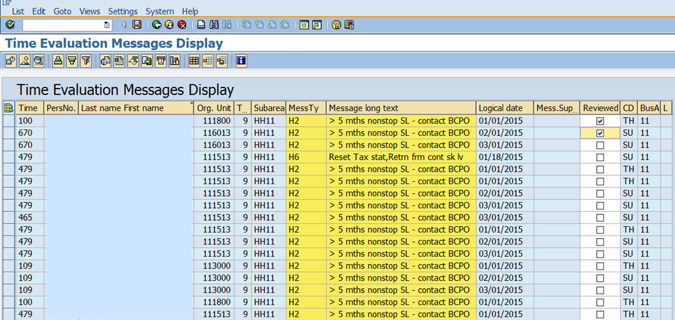
After taking the necessary action, close the error from the report by clicking the box in the “Reviewed” column. A checkmark will appear in the box.
Then click the Save icon .

TIP: Once a message has been reviewed and the report saved, any reviewed messages are changed to a status of “2” in the background. Users can search for reviewed messages via the main selection screen by searching “Status Code” type “2” under “Reviewed Items”.

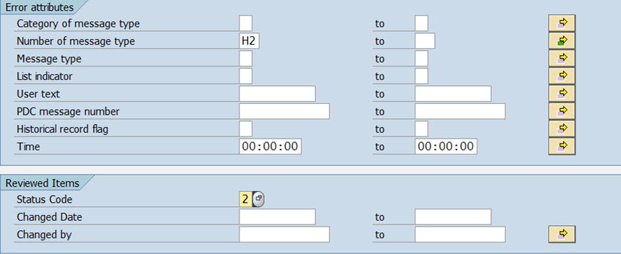

Questions?
If you have any questions regarding this transaction, please submit an HR help desk ticket in the time category. You may also call the HR Service Center, Agency Services Division at 877.242.6007, Option 2.

