Time Alert 2005-36: Sick Quota Amount & Payout at Separation - 08/11/2005
PROCEDURES FOR DETERMINING AN EMPLOYEE’S ACTUAL SICK QUOTA AND PAYOUT AMOUNT AT SEPARATION:
- View the “Accrual information” tab on PT50. Scroll to the last day of employment. Determine the amount removed from absence quote type 21 (sick actual).
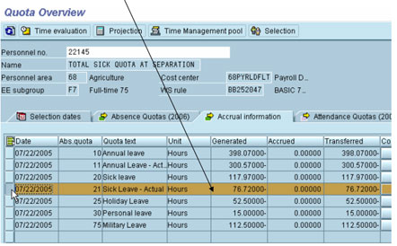

- Add the sick accruals generated on the last day of employment and subtract any sick leave used on the last day of employment. These amounts can be found on PT_BAL00. Enter the last day of employment as the period. Enter the personnel number. Select the radio button “Day balances”. Enter types 4026 & 4212 and execute.
76.72 (quota amount as of 7/21/05) + 3.75 (accrual for ppd) – 7.50 (sick usage on 7/22/05) = 72.97 (ending sick actual quota)
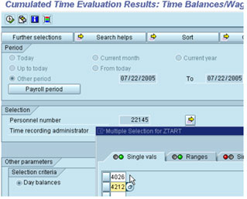
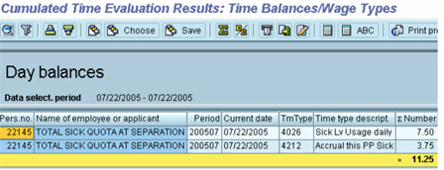

- The sick quota amount PAID at separation can be found using PT_BAL00. Enter the last day of employment as the period. Enter the personnel number. Select the radio button “Time Wage Types” and execute.
72.97 (ending sick actual quota) divided by 7.50 (daily work hrs) = 9.73 x 30% (Percentage Buy-Out) = 2.92 round to full days = 2 days x 7.5 hours (daily work hrs) = 15.00 hrs (amt paid)
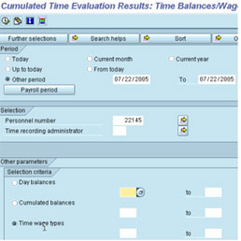

The sick quota paid at separation is reflected as wage type 2751.
