Please distribute this alert to any users within your agency who are responsible for time administration in SAP.

Clock Times Added to the Timesheet Workflow Approval Screen

- Information regarding the addition of clock times to the timesheet workflow approval screen.

Effective February 28, 2021 the timesheet workflow approval screen will include the Start Time/End Time fields. The addition of these fields eliminates the need for supervisors to use the change icon to open the timesheet to view the clock times before approving timesheet entries.

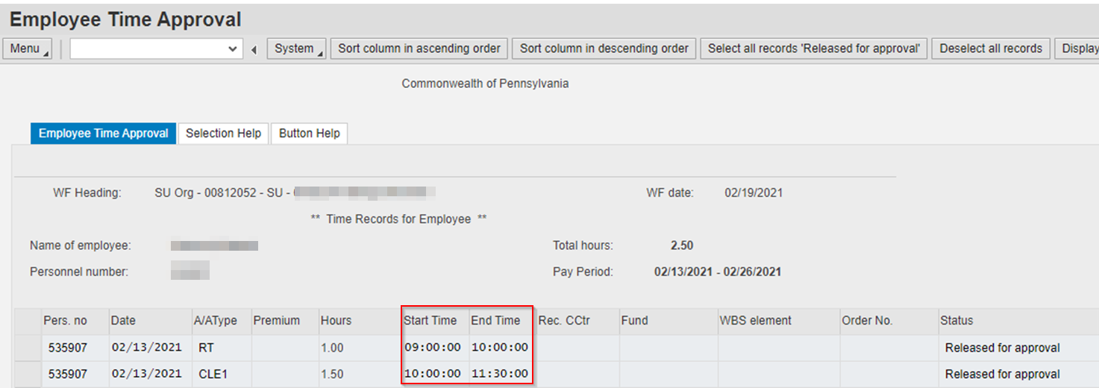

Questions?

Field time advisors should direct any questions related to this alert to their central agency time advisor. Central agency time advisors may submit questions via an HR help desk ticket in the time category or call the HR Service Center, Time Services team at 877.242.6007, Option 2.

