Annuitant employees are required to enter time worked into a computerized timekeeping system. This guide provides step-by-step instructions on how to enter time worked into the CATS (Cross Application Time Sheet). It is recommended that time worked is entered daily; however, all time MUST be entered and approved by the last day of the pay period or payment of hours worked may not occur timely.

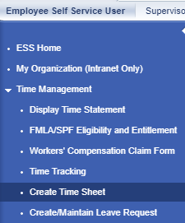
Log onto any Commonwealth computer using your CWOPA account. Problems logging into your computer should be directed to your agency timekeeper. If you do not have access to a computer, you will complete a paper timesheet and your agency timekeeper will enter the hours worked.

STEP 1 - Log into Employee Self-Service (ESS)
- Access ESS through Microsoft Explorer using the following web address:
https://www.myworkplace.state.pa.us

- Click on Time Management
- Click on Create Time Sheet
Your timesheet will redirect you to another window labeled “SAP NetWeaver Portal – Microsoft Internet Explorer
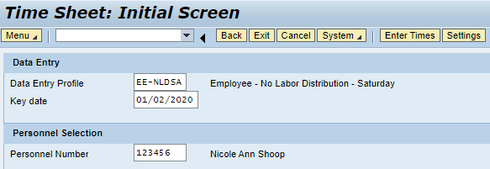
STEP 3 – Enter Time Worked
- Enter “RT” in the A/A column (drop down menu). Enter the start (From) and end (To) time worked each day in Military Time format. If “No Hours” are listed in the clock row (), two lines of RT are required to separate the unpaid meal period from time worked.
- Verify all hours worked by clicking the “Enter” key on your keyboard. The total hours worked will auto-fill in the date column.
- Click on the Save icon to submit your request to your supervisor for approval.
STEP 2 – Verify Your Name and Personnel Number
- Verify that your Name and Personnel Number are correct.
- Verify Data Entry Profile is set to an EE profile.
- Key Date defaults to current date. If entering time for a previous pay period, change the Key Date to the date you wish to enter time worked. Note, time can be entered up to two pay periods prior to the current date.
- Click on the Enter Times icon to continue.
John Smith
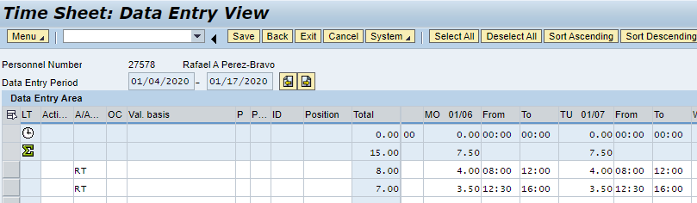
John Smith
123456

