Attachment to Time Alert 2019-12:
Information Regarding the Addition of Transaction PP6A
12.4.2019
Transaction: PP6A – Personal Shift Plan
Timekeepers, Time Advisors, and Work Schedule Assigners now have access to transaction PP6A (Personal Shift Plan) which provides an overview of an employee’s time records for a specific time period.
Procedure/Steps:
- Select the Display Personal Shift Plan Transaction from the SAP Easy Access Menu

- Under the Display Personal Shift Plan, enter the employee’s Personnel Number (select from drop down list if unknown) and the period to be viewed under the Reporting Period. After entering the selections, click the execute icon. Note, to bypass the “shift group not unique” message, click the green check mark icon.
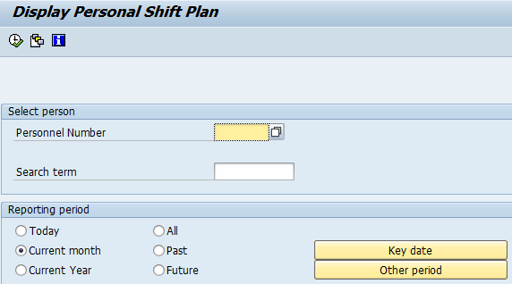

To display a specific period, select Other Period icon and list the date range
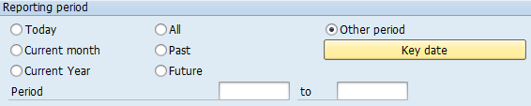

- Under the Personal Shift Plan: Overview screen, click the Detail View icon to view the employee’s personal shift plan, including any deviations to the employee’s schedule (e.g., Substitutions, Absences, and/or Attendances).
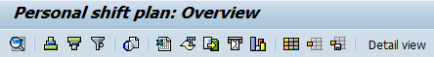

If a Substitution was entered for the day, the deviation from the assigned work hours will be reflected in the Substitution column. The amount in the Hours column will reflect the updated scheduled hours for the day.

If an Absence was entered for the day, the type of absence will be reflected in the Absence column. The amount in the Hours column will reflect the total hours reflected for each separate absence reported for that day.

If an Attendance was entered for the day on the CATS, the attendance type and times of time worked will be reflected in the Attendance column. The amount in the Hours column will reflect the total hours reflected for each separate line on the CATS.

Additional Tips and Tricks:
- To view a field definition, click in any field and select F1.
- If the personnel number is unknown, click on the drop-down box in the field to access the
search feature.
- To select a custom-made report, use the Get Variant icon, or Shift +F5.
- To sort records ascending, use the Sort in Ascending Order icon, or Ctrl + F4.
- To sort records descending, use the Sort in Descending Order icon, or Ctrl + Shift + F4.
- To set a filter, use the Set Filter icon, or Ctrl + F5.
- To total records, use the Total icon, or Ctrl + F6.
- To print preview, use the Print Preview icon, or Ctrl + Shift + F10.
- To export the report to MS Excel, use the Microsoft Excel icon, or Ctrl + Shift + F7.
- To export the report to MS Word, use the Word Processing icon, or Ctrl + Shift + F8.
- To export to a local file, use the Local File icon, or Ctrl + Shift + F9.
- To send via e-mail, use the Mail Recipient icon, or Ctrl + F7.
- To analyze the data, use the ABC Analysis icon, or Ctrl + F1.
- To create a graph, use the Graphic icon, or Ctrl + Shift + F11.
- To change the report layout, use the Change Layout icon, or Ctrl + F8.
- To select a custom layout, use the Select Layout icon, or Ctrl +F9.
- To save a custom layout, use the Save Layout icon, or Ctrl + F10.
- For an overview of the report, use the Overview icon, or Shift + F4.
- For a detail view of the report, use the Rotate detail view icon, or Shift + F5.
- To view comments, use the Comments icon, or Shift + F6.

