Important Information Related to Researching Out of Sync Quotas
Following is a list of some of the reasons why an employee’s anticipated and actual annual and/or sick quotas may be out of sync. Please note that this is not an all-inclusive list:
- The employee changed payroll areas.
- User error – quota corrections may have been incorrectly created.
- The employee transferred from a permanent position to a non-permanent position and the anticipated quotas were not adjusted.
- Absences were not resaved when a work schedule change was entered.
- The employee is TMS1 or permanent part-time TMS9 and the quotas were not reviewed and adjusted at the end of each leave calendar year.
- The employee has more than one line of the same quota type (Ex. Two quota type 20 records).
- The employee is a management employee hired/rehired in the middle of a pay period and the quotas were not reviewed and adjusted.
- The employee transferred from an agency with a reciprocal leave agreement and quota corrections were entered incorrectly.
- The employee was permanent and separated prior to the Earl.pers.rec.date on IT0003.
- A rounding issue involving some accrual rates.

Two new time types have been created to display differences between anticipated and actual quotas. These time types are part of the configuration used to generate the “PB” and “PC” time evaluation warning messages.
These two time types are only populated on the last day of the leave calendar year and can be viewed via PT_BAL00, Day Balances. The values associated with these time types represent the difference between the anticipated and actual quotas.
ZQAF – Annual Qta Diff – LCY End
ZQSF – Sick Quota Diff – LCY End

The new time evaluation messages (PB – TEST-Out of Sync Annual Quota 10/11 and PC – TEST-Out of Sync Sick Quota 20/21) will only generate on Time Evaluation Messages Display (Y_DC1_32000670) if the positive or negative difference found in time types ZQAF and ZQSF is greater than .10. Differences of less than .10 will not generate the message(s).

Researching anticipated and actual accruals using PT_BAL00
The below screenshot of the Time Evaluation Messages Display shows the two new time evaluation messages (PB – TEST-Out of Sync Annual Quota 10/11, PC – TEST-Out of Sync Sick Quota 20/21). If the user looks a little closer, they can identify the reason why the employee’s anticipated and actual annual and/or sick quotas are out of sync. The employee switched payroll areas during the 2014 leave calendar year. Reference Message Type: PA - Pay Area Change-Ck LSC & Quotas.
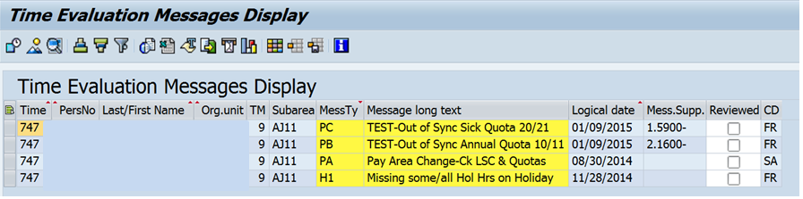
The values associated with time types ZQAF / ZQSF represent the difference between the anticipated and actual quotas which generates in the time evaluation message.

The two new time types used to display discrepancies in anticipated and actual quotas are shown on the below screen shot.
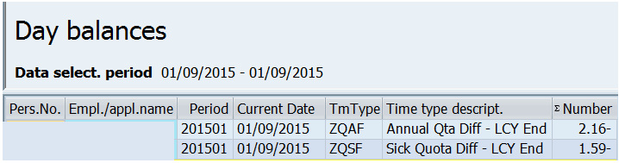

Following are screenshots showing the procedure for running PT_BAL00 to compare anticipated and actual accruals:
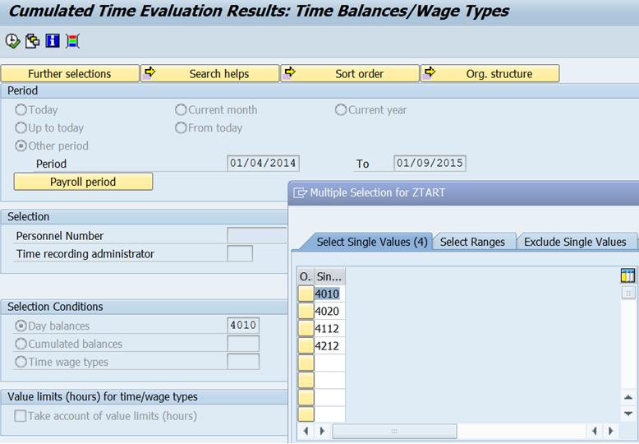
4010 = Annual Leave Accrual (Anticipated)
4020 = Sick Leave Accrual (Anticipated)
4112 = Accrual this PP annual (Actual)
4212 = Accrual this PP sick (Actual)

In the example above, the employee switched payroll areas (from Z2 to Z3) during the 2014 leave calendar year.
- The first date, 1/4/14, is the first day of the 2014 leave calendar year for payroll area Z2 (the payroll area that the employee was in at the start of the 2014 leave calendar year).
- The second date, 1/9/15, is the end of the 2014 leave calendar year; for payroll area Z3 (the payroll area that the employee was in at the end of the leave calendar year).
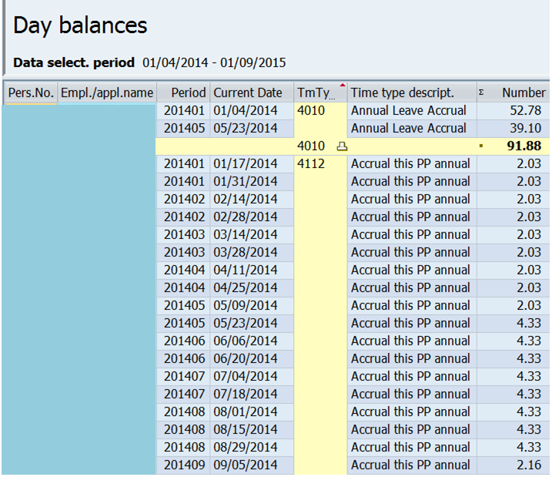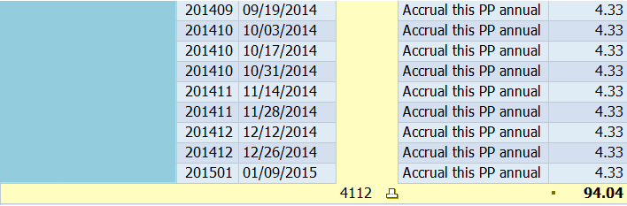
Note: This screenshot shows the results for anticipated and actual annual accrual only.

In this example, the employee’s annual accrual rate increased from 2.70% to 5.77% on 5/23/14. This change is also reflected in the anticipated annual accrual earnings.
Compare the results. The total anticipated annual accrual amount (91.88) is less than the actual annual accrual earned (94.04) in the amount of -2.16.
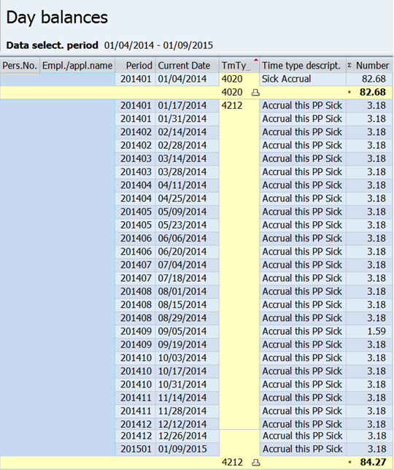
Note: This screenshot shows the results for anticipated and actual sick accrual only.

Compare the results. The total anticipated sick accrual amount (82.68) is less than the actual sick accrual earned (84.27) in the amount of –1.59.
The anticipated quotas are less than the actual quotas because anticipated quota is generated at the start of the leave calendar year based on the employee’s payroll area, personnel sub area, leave service credit and weekly working hours. Actual accrual generates each pay period based upon actual hours worked and is generally accurate. In this example, the 2014 leave calendar year was increased by one week (payroll area switch from Z2 to Z3), so quota corrections will need to be created effective 8/30/2014 to add one week of accrual to the anticipated quotas (QT10/20) to sync them up with the actual quotas (QT11/21).

Following correction of the quotas and time evaluation, the “PC” and “PB” Out of Sync messages will no longer generate on the Time Evaluation Messages Display. Users must mark the “PA” Pay Area Change message as reviewed to remove the message from the report.

