Please distribute this alert to any users within your agency who use the NEOGOV, Applicant Tracking System.

April 2021 NEOGOV Enhancements

- Information regarding the April 2021 release of enhancements to the NEOGOV Applicant Tracking System.

The following enhancements were released to NEOGOV Insight and Career Pages the evening of Wednesday, April 21, 2021 and are currently in effect for all users and applicants:

- Insight: Perform Offers and Hires via Insight Referred List
- Insight: Updated Candidate Status Details on Insight Referred List
- Insight: View OHC Offer and Hire Pages via Insight Referred List
- Career Pages: Appointment Reminder Notices for Applicants

Insight: Perform Offers and Hires via Insight Referred List
Insight Users are now able to move referred candidates to the ‘Offer’ or ‘Hire’ step directly in Insight without having to navigate to the Online Hiring Center (OHC). New actions of “Move to Offer” and “Move to Hire” have been added to the ‘Select Action’ dropdown on the referred list in Insight. This will allow users with the appropriate permissions to perform these OHC actions via Insight.

Please keep in mind the system will leverage OHC permissions to determine if users should have access to these actions in Insight. Users must have the necessary permissions to perform these actions from OHC for them to appear in Insight. Specifically, users must have access in OHC to the department for the requisition and be assigned as a hiring manager on the requisition or have the HR Liaison role on their user account.

Insight Referred List
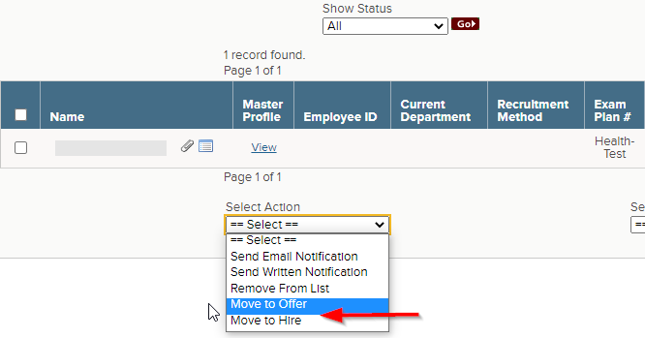
Insight: Updated Candidate Status Details on Insight Referred List
The candidate status on the Insight referred list has been updated to include more details when candidates are in an ‘Offer’ or ‘Hire’ step and will mirror the status shown on the OHC referred list. For example, if a candidate is in the ‘Offer’ step and has accepted the offer, the status in Insight will show as “Offered – Accepted” instead of the generic “Offered” status.

Insight Referred List
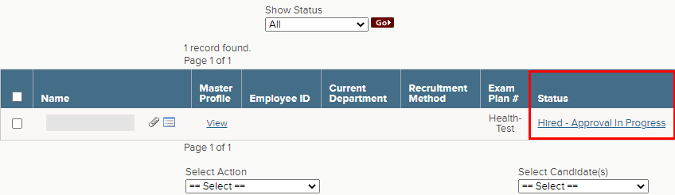

Insight: View OHC Offer and Hire Pages via Insight Referred List
Insight users with the appropriate OHC permissions will be presented with the OHC version of the offer and hire pages after selecting the candidate status on the Insight referred list. Insight users who do not have permissions to these pages in OHC will continue to see the Insight versions. This does not impact or change the process for authorizing hires in Insight.

Insight Referred List
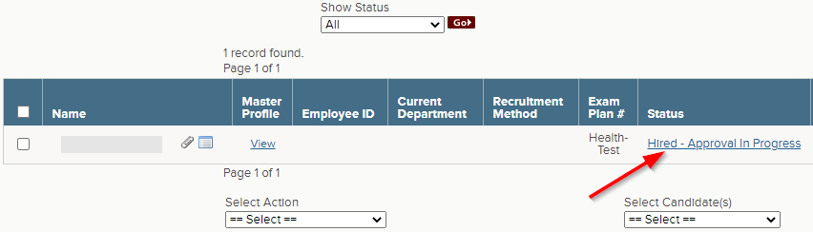

OHC Hire Form
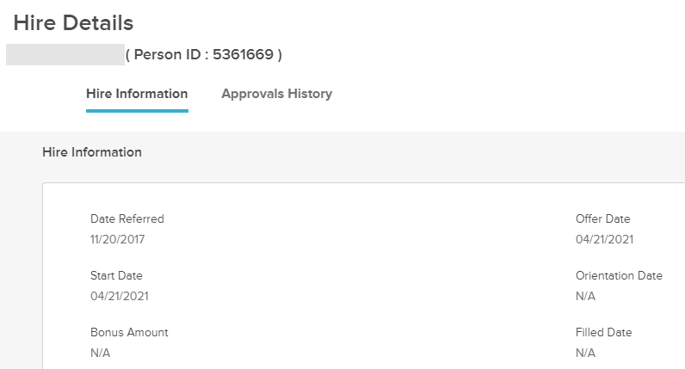

Career Pages: Appointment Reminder Notices for Applicants
Applicants will begin receiving automated email reminders for upcoming appointments after self-scheduling for an interview or exam. The automated notices will be sent two days before the scheduled appointment and remind applicants about the details of the upcoming appointment including date, time, location and employer information. The notifications will be sent to the personal email address associated with the applicant account as well as the applicant inbox within the online account.

Questions?
If you have any questions regarding the April 2021 NEOGOV Enhancements, please submit an HR/Pay Help Desk ticket under the ‘HR Application Support’ category.

