Please distribute this alert to any users within your agency who use the NEOGOV, Applicant Tracking System on a regular basis.

July 2020 NEOGOV Enhancements

- Information regarding the July 2020 release of enhancements to the NEOGOV Applicant Tracking System.

The following enhancements were released to Insight, OHC and Online Applications in July 2020 and are available to users and applicants:

Insight: Reorder Evaluation Steps
Insight users can reorder evaluation steps in exam plans that have not yet accepted or received applications. Evaluation steps can be reordered by dragging and dropping into the desired location or by using the provided up and down arrows. Once an exam plan receives an application, the evaluation steps will lock and the option to reorder the steps will be disabled.

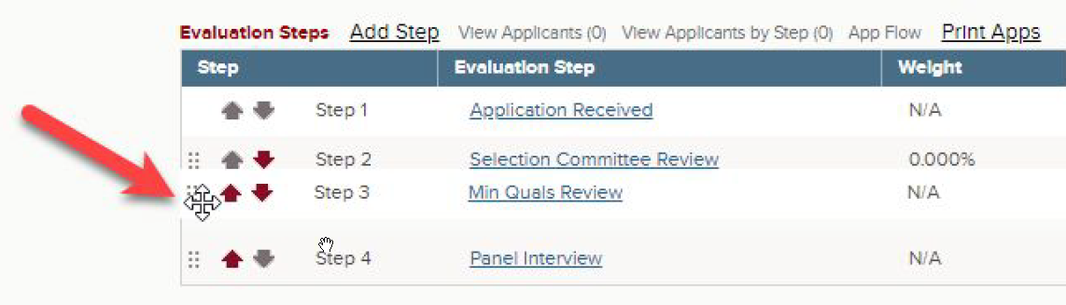

Insight: Access Referred Lists from Eligible List
Insight users have the ability to navigate directly to a referred list when viewing the eligible list. The user can select “Show Referrals” at the top of the page to see all referrals made from the eligible list. The referral view will include a new “Referred List” column with a link to access the referred list. After clicking on the “View” link, users will be redirected to the list of referred applicants for that requisition.

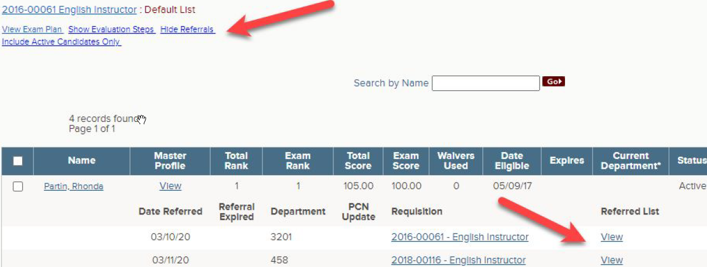

Insight: Bulk Unarchive Job Postings and Exam Plans
Insight Users have the ability bulk unarchive job postings and exam plans. A new “Unarchive” option has been added to the Bulk Actions dropdown on the Exam Plans and Postings pages.

Insight users can select multiple records and choose the “Unarchive” option from the dropdown. This eliminates the need to unarchive each item individually and saves processing time for the user.

The ability to bulk archive job postings and exam plans was announced in TA Alert 2020-01.

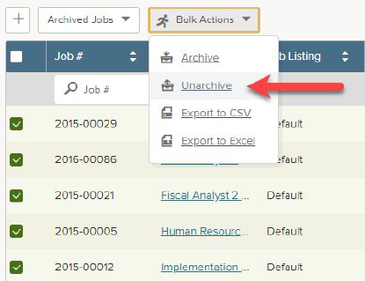

Insight and OHC: Email Notices to Large Volume of Applicants
Insight and OHC users can send bulk email notices to up to 2,500 applicants at a time. This includes notices sent from within the evaluation steps, eligible lists and referred lists.

OHC: Hiring Manager(s) Included in Self-Scheduling Notifications
Hiring Managers on a requisition will also receive the automated confirmation emails sent to raters when applicants self-schedule interviews. If the hiring manager is also a rater on the interview step, the user will only receive one email notification.

The automated confirmation emails related to the OHC calendar integration and candidate self-scheduling functionality were announced in TA Alert 2020-06 and TA Alert 2020-08.

Online Applications: Applicant Calendar Integration
Applicants now have the ability to add appointments to their personal calendar(s) after self-scheduling for interviews. The confirmation screen applicants receive after self-scheduling will include a link to upload the appointment to their calendar(s). This enhancement currently supports Google Calendar, Outlook Web and Microsoft Outlook.
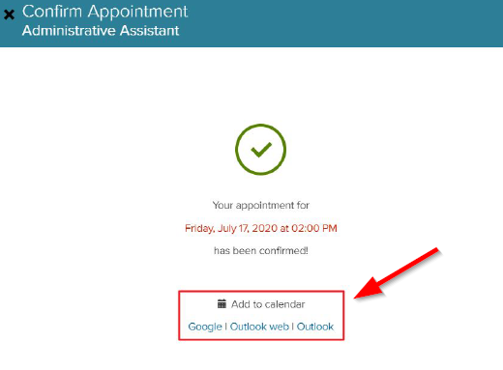

Online Applications: Self-Scheduling Confirmation Email
Applicants will receive automated confirmation emails when they self-schedule interviews. The automated emails will generate after the applicant self-schedules or upon changing or cancelling their appointment. The notice will also include a link to upload the appointment to their personal calendar(s) and be sent to the applicant inbox that is part of their online account.

Applicants will have the option to unsubscribe from these emails notifications similar to other system generated notices. However, the change will only apply to their personal email account. The notification will still be delivered to the applicant inbox in their online account.

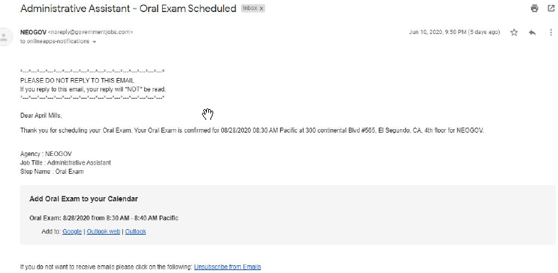

Questions?
If you have any questions regarding the July 2020 NEOGOV Enhancements, please submit an HR/Pay Help Desk ticket under the ‘HR Application Support’ category.

