Please distribute this alert to any users within your agency who use the NEOGOV, Applicant Tracking System on a regular basis.

OHC Calendar Integration and Candidate Self-Scheduling

- Information regarding the release of OHC calendar integration and candidate self-scheduling.

As announced in TA Alert 2020-06 - OHC Calendar Integration, automated notifications have been developed for interviewers (i.e. raters) assigned to interview steps on the OHC referred list. This new feature will deliver automated email notifications to users when an interview is scheduled by an applicant and includes a link for the user to upload the appointment to their personal calendar.

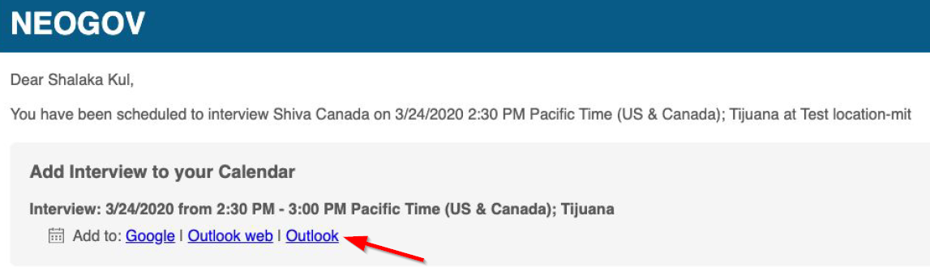

Effective Tuesday, 06/02/2020, the “rater” permission required for this enhancement to function will start being assigned to all OHC Users.

The OA-Bureau of Talent Acquisition has developed instructions to setup candidate self-scheduling for phone and in-person interviews, which includes processing steps to utilize the calendar integration feature. These instructions have been posted to the HRM NEOGOV Resources site. Links below.

HR Self-Scheduling Instructions

Candidate Self-Scheduling Instructions

Questions?
If you have any questions regarding the OHC Calendar Integration and Candidate Self-Scheduling, please submit an HR/Pay Help Desk ticket under the ‘HR Application Support’ category.

