Please distribute this alert to any Insight users within your agency who use the NEOGOV, Applicant Tracking System on a regular basis.

March 2020 NEOGOV Enhancements

- Information regarding the March 2020 release of enhancements to the NEOGOV Applicant Tracking System.
- Revised Alert (04.01.2020): This revision includes information regarding additional changes as a result of the “State/Province” field enhancement.

The following enhancements were released to Insight in March 2020 and are available to all Insight users:

Insight: Quick Sort for Supplemental Questions and Response Options
There is now a ‘quick sort’ option available for supplemental questions and supplemental question response options on a job posting. Insight Users can quickly sort and reorder supplemental questions or their responses by dragging and dropping them into the desired locations.

Supplemental Questions
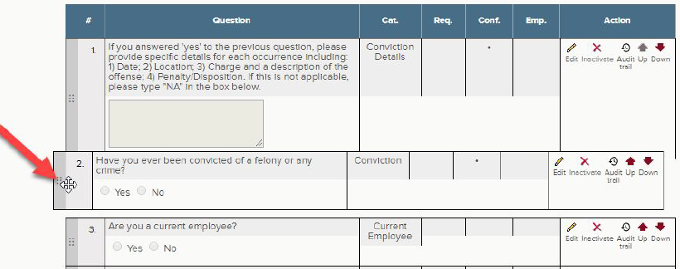

Supplemental Question Response Options
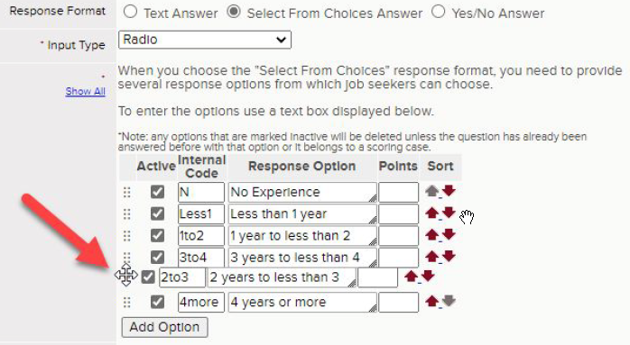
Insight: Ability to Modify Column Width
Insight Users can now modify the table column width on various Insight pages including:
- Requisitions Page
- Postings Page
- Exam Plan Page
- Job Spec Page

The user can modify the column width by hovering over the grid line and dragging it to the desired length. The column width modifications made by the user will be retained until the user clears web browser cookies or clicks the “Reset” button. This will ensure users are not required to resize columns each time they access the page.

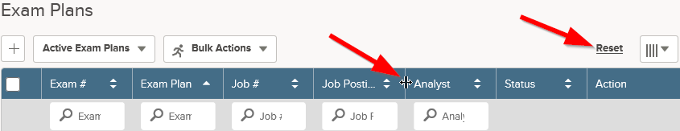

Insight: Notice Template Library Enhancements
Several improvements have been made to the layout and functionality of the Insight Notice Templates and OHC Notice Template pages in Insight. The improvements include the following:
- Insight Notice Templates:
  - “Category” column added to the notice templates grid
  - “Last Used” column added to the notice template grid
  - Ability to sort on any grid column
  - Ability to search by template name, description, category or subject

Insight Notice Templates
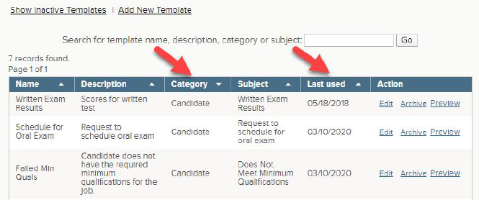

- OHC Notice Templates:
  - “Last Used” column added to the notice template grid
  - “Created” date column added to the notice template grid
  - Ability to sort on any grid column

OHC Notice Templates
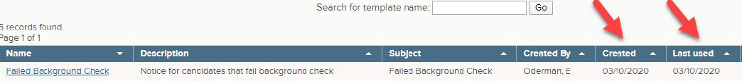

Insight: Applicants by Job Report – All Applicants Date Range Filter
An option to view “All” applicants has been added to the Application Received Date Range filter within the ‘Applicants by Job’ standard report. Previously, users were only able to select a custom or predefined date range. This enhancement gives users the option to see all applicants for a job posting without having to enter or choose a specific date range. This change is in addition to the ‘Applicants by Job’ report enhancements announced in TA Alert 2019-09.

Insight: State/Province Field
The following changes have been made in Insight to support the use of Canadian addresses:
- All “State” address fields within Insight (i.e. applicant master profile, printed application, etc.) have been renamed to “State/Province”.
- The “Country” field on the Applicant Master Profile has been changed to a required field.
- The selection values within the “State/Province” field on the Applicant Master Profile are now determined by the country selected. If the user selects Canada as the country, the system will display a list of provinces instead of states. If a country other than “US” or “Canada” is selected, the only “State/Province” option available is “International”. Please note: If updating the “Country” field due to it previously being blank, the “State/Province” field will reset and need to be re-selected.
- The “Zip/Postal Code” field on the Applicant Master Profile and candidate application accepts alphanumeric postal codes.

Applicant Master Profile
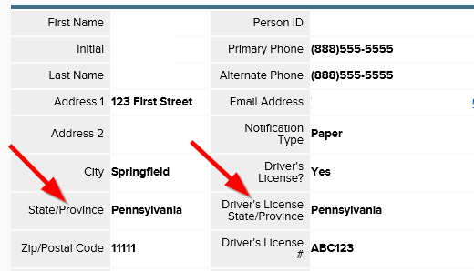

As a result of the above changes, the “Country” of residence field has been activated and made required on the candidate application. Applicants will continue to see a field labeled “State” that will include a list of US states and territories, Canadian provinces and an “International” option. All these options will display to the applicant regardless of what country is selected.

Candidate Application
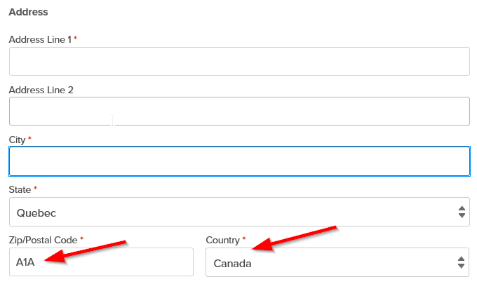

Questions?
If you have any questions regarding the March 2020 NEOGOV Enhancements, please submit an HR/Pay Help Desk ticket under the ‘HR Application Support’ category.

