Please distribute this alert to any users within your agency who use the NEOGOV, Applicant Tracking System on a regular basis.

Requisition Form – Removal of Selective Certification Fields

- Information regarding the removal of selective certification fields on the requisition form.

Effective 01/27/2020, detailed information regarding selective certifications will no longer be collected on the requisition form. All information for selective certification requests should be provided on the Job Posting Form and/or by adding an attachment to the requisition.

Users will be required to complete a new field, “Are you requesting selective certification criteria?” to indicate if selective criteria are being used to fill the vacancy.

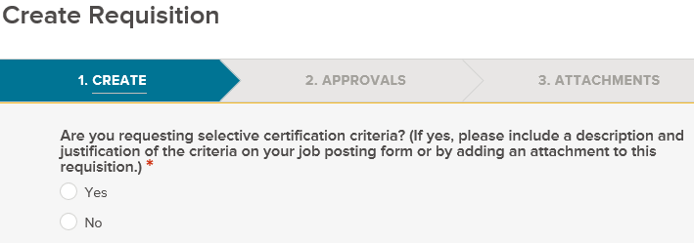

All other fields pertaining to selective certification requests will be removed from the requisition form. Fields being removed are listed below:
- Are there any special knowledge, skills or abilities required for this position? [If yes and the position is Civil Service covered, please complete all Selective Certification fields and attach Form SCSC-5274 (Request for Selective Certification). For Non-Civil Service positions, please provide a brief description in the comments section.]
- CS Selective Certification Criteria
- CS Selective Certification Description
- CS Selective Certification Approval (HR & SCSC USE ONLY)

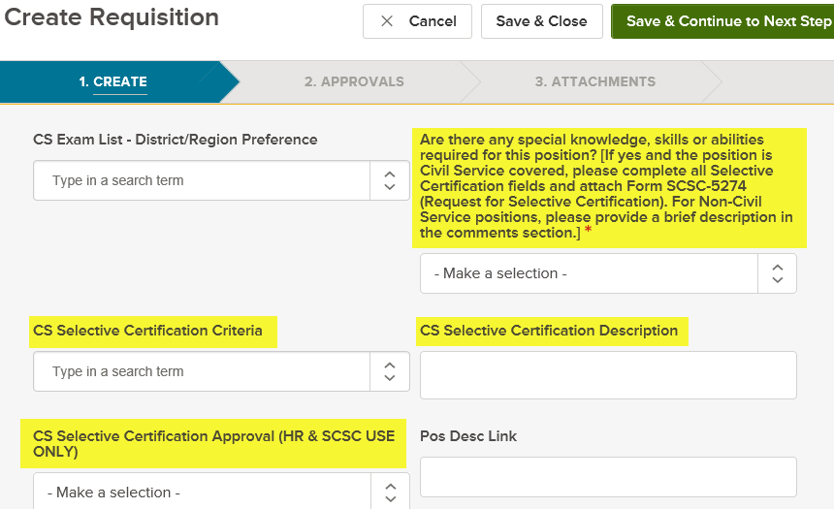

In addition, the certification type field, “DO NOT USE: CS Exam List - Certification Type”, was discontinued upon implementation of the one requisition process for Civil Service exam requests. This field is no longer needed with the conclusion of the cutover period and will be removed along with the selective certification fields.

Questions?
If you have any questions regarding the Requisition Form – Removal of Selective Certification Fields, please submit an HR/Pay Help Desk ticket under the ‘HR Application Support’ category.

