Please distribute this alert to any Insight users within your agency who use the NEOGOV, Applicant Tracking System on a regular basis.

Bulk Archive

- Information regarding a new bulk archive feature in Insight.

Insight users can now bulk archive the following items:
- Exam Plans
- Job Postings
- Eligible Lists
- Referred Lists

A “Bulk Actions” dropdown field has been added to the Eligible Lists and Referred Lists pages to support this feature. Additionally, the “More” dropdown on the Exam Plans and Job Postings pages has been renamed to “Bulk Actions”. The previous options under the “More” dropdown to “Export to CSV” and “Export to Excel” are still available with this change.

Insight users can select multiple records and choose the “Archive” option from the dropdown. This eliminates the need to archive each item individually and saves processing time for the user.

Referred Lists Page
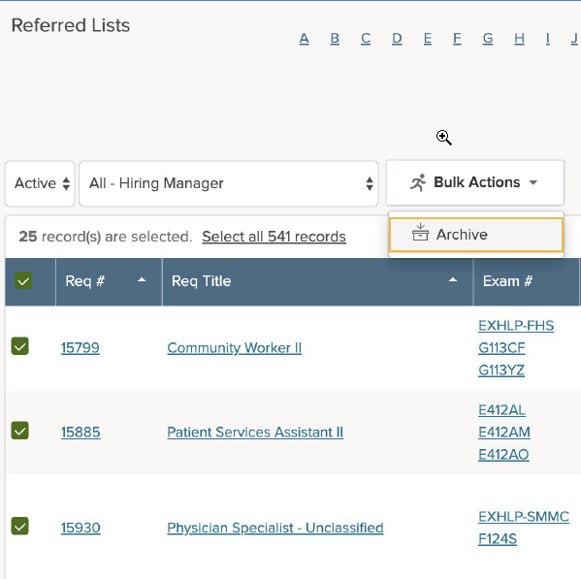

Exam Plans Page
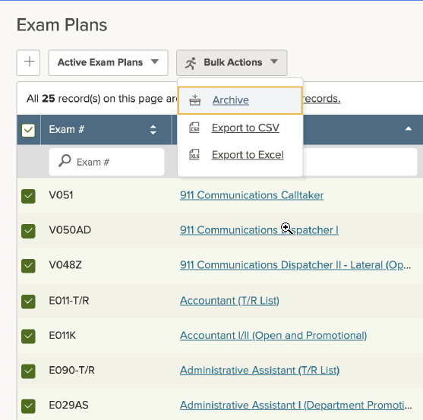

Questions?
If you have any questions regarding the Bulk Archive, please submit an HR/Pay Help Desk ticket under the ‘HR Application Support’ category.

