Please distribute this alert to any Insight users within your agency who use the NEOGOV, Applicant Tracking System on a regular basis.

December 2019 NEOGOV Enhancements

- Information regarding the December 2019 release of enhancements to the NEOGOV Applicant Tracking System.

The following enhancements were released to Insight in December 2019 and are available to all Insight users:

Insight: “Select All” Option for Eligible List and Referred List Candidates
A “Select All” option is now available for Eligible List and Referred List candidates. This will allow Insight users to select all candidates on the same page or across all pages and then perform an action on those selected candidates.

This will also make it easier for users to exclude candidates when the action applies to most, but not all candidates. Users can select all candidates and then unselect the few candidates for whom the action does not apply, eliminating the need to select candidates manually on a single page or across multiple pages.

When using the “Select All” option, it is recommended to use the “Selected Candidates” action from the actions dropdown.

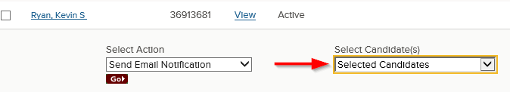

Please note the “Select all 23085 records” option that is choosing all eligible list candidates in the below example does not appear until all records are selected for a single page.

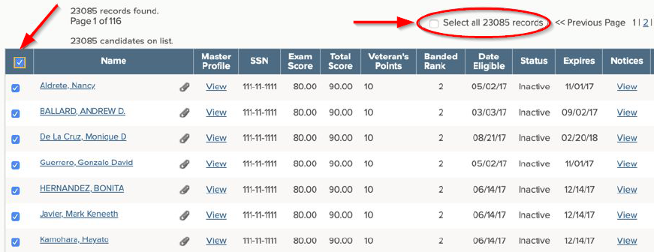
Insight: Automatically Advance Passing Candidates
Insight users can now automatically advance passing candidates to the next evaluation step when updating the disposition for a single candidate or multiple candidates. Users will see an “Advance passing candidates to next steps” option on the candidate disposition page. In some cases, this will eliminate the need to manually advance passing candidates to the next step after updating the disposition.

Please keep in mind this option is only available when updating the disposition through the link within the “Disposition” column or the “Change Disposition” action in the actions dropdown.

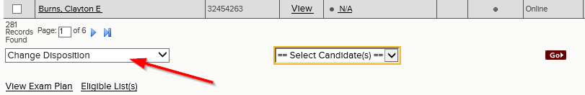

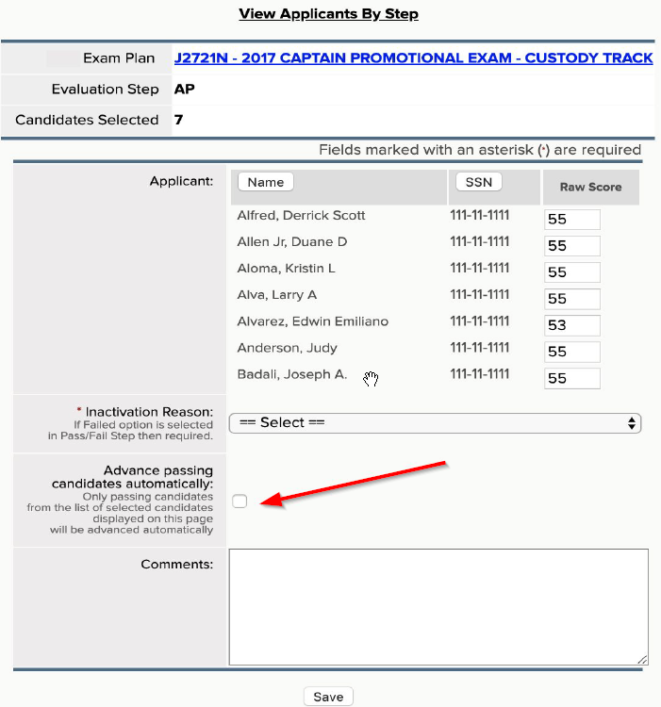

Insight: Career Pages Link
A “Career Pages” (i.e. posting sites) link has been added to the Insight dashboard menu. This allows for easy navigation to the posting sites through a single click.

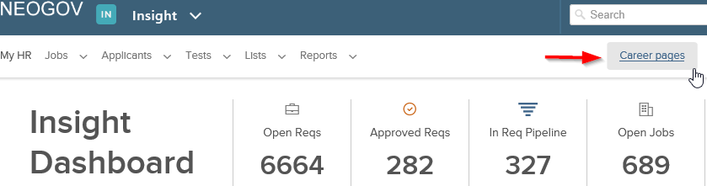

Questions?
If you have any questions regarding the December 2019 NEOGOV Enhancements, please submit an HR/Pay Help Desk ticket under the ‘HR Application Support’ category.

