Please distribute this alert to any Insight users within your agency who use the NEOGOV, Applicant Tracking System on a regular basis.

October 2019 NEOGOV Enhancements

- Information regarding the October 2019 release of enhancements to the NEOGOV Applicant Tracking System.

The following enhancements were released to Insight in October 2019 and are available to all Insight users:

Insight: New User Interface – Add/Create Requisition

Insight users will see a revamped user interface when adding or editing a requisition in Insight. The new look and feel will be identical to the layout of the Online Hiring Center (OHC).

Users will see the entire requisition creation workflow, divided into three sections: Create, Approvals and Attachments. The new design will default all department approval workflow configured for requisitions into the Approvals section. This will allow human resource staff with Insight permissions to create and submit requisitions within Insight.

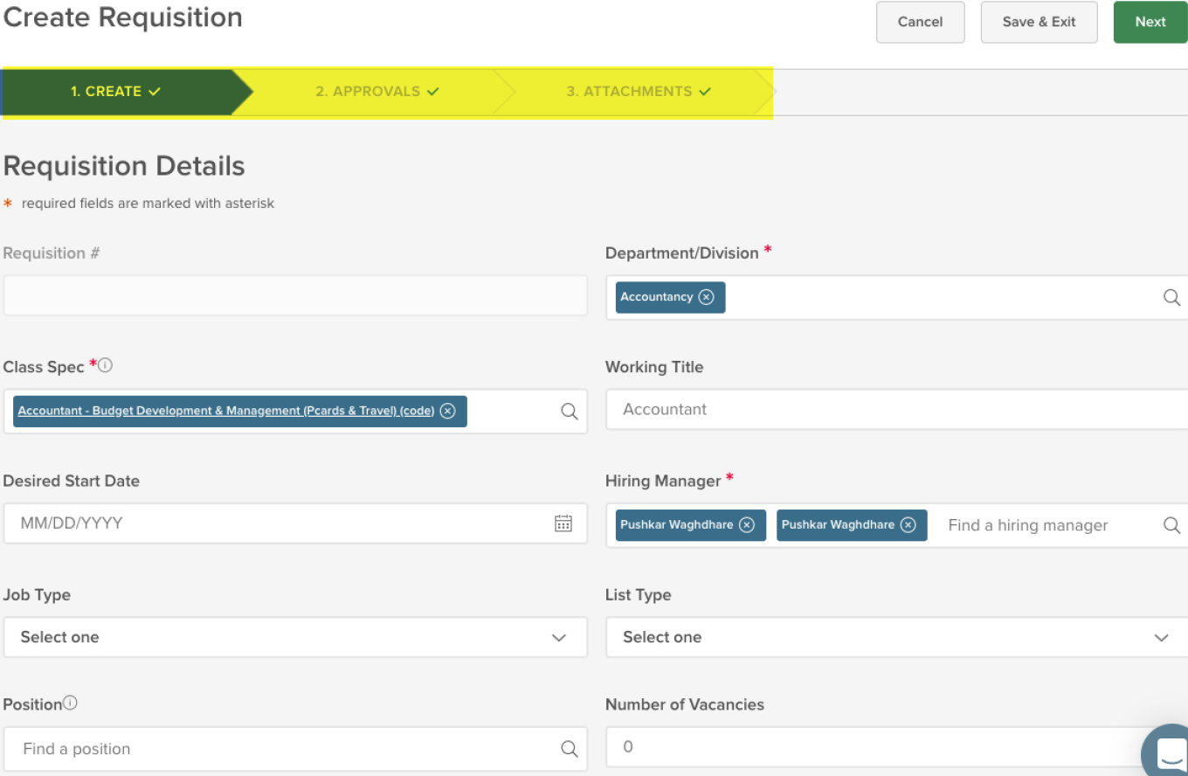
Insight: New User Interface – Requisition Detail

Insight users will see a revamped user interface when viewing requisitions in Insight. The new look and feel will be identical to the layout of the Online Hiring Center (OHC).

The Requisition Detail page is divided into three sections: Requisition Information, Approvals and History. This will allow human resource staff with Insight permissions to monitor requisition approvals and view all changes to requisitions within Insight.

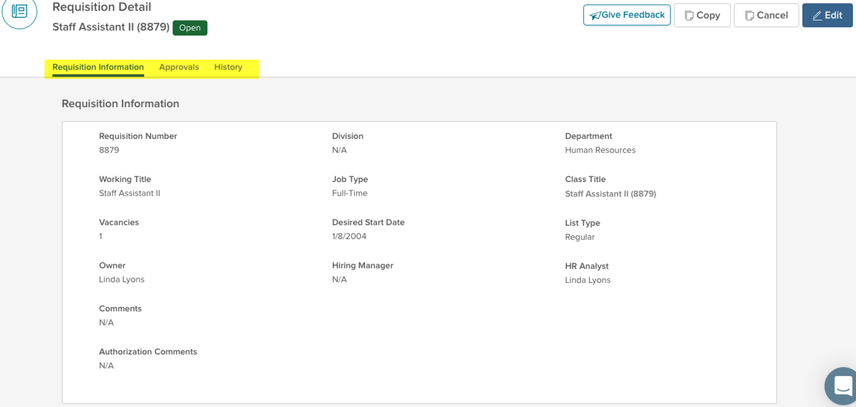

Insight: Revised Standard Report – Supplemental Questions by Job

The Supplemental Questions by Job report has been revised to simplify running the report and provide easier controls for selecting report criteria. The report changes include the following features:

- Report Filter Pane: Users can perform basic filtering on the Application Received Date Range, Application Status and Application Type.
- Advanced Filtering Icon: Users can perform advanced filtering on certain criteria such as Person ID, Last Name, First Name, Application Status, etc.
- Column Selector Icon: Users can specify which columns to show in the report including any agency-wide or supplemental questions.
- Column Search Icon: Users can search or filter within the columns displayed on the report.
- Default Icon: Users can create and save report ‘views’.
- Bulk Actions Icon: Users can export data in PDF, Excel or CSV formats.
- Chart that provides a visual summary of the candidate responses for each question.

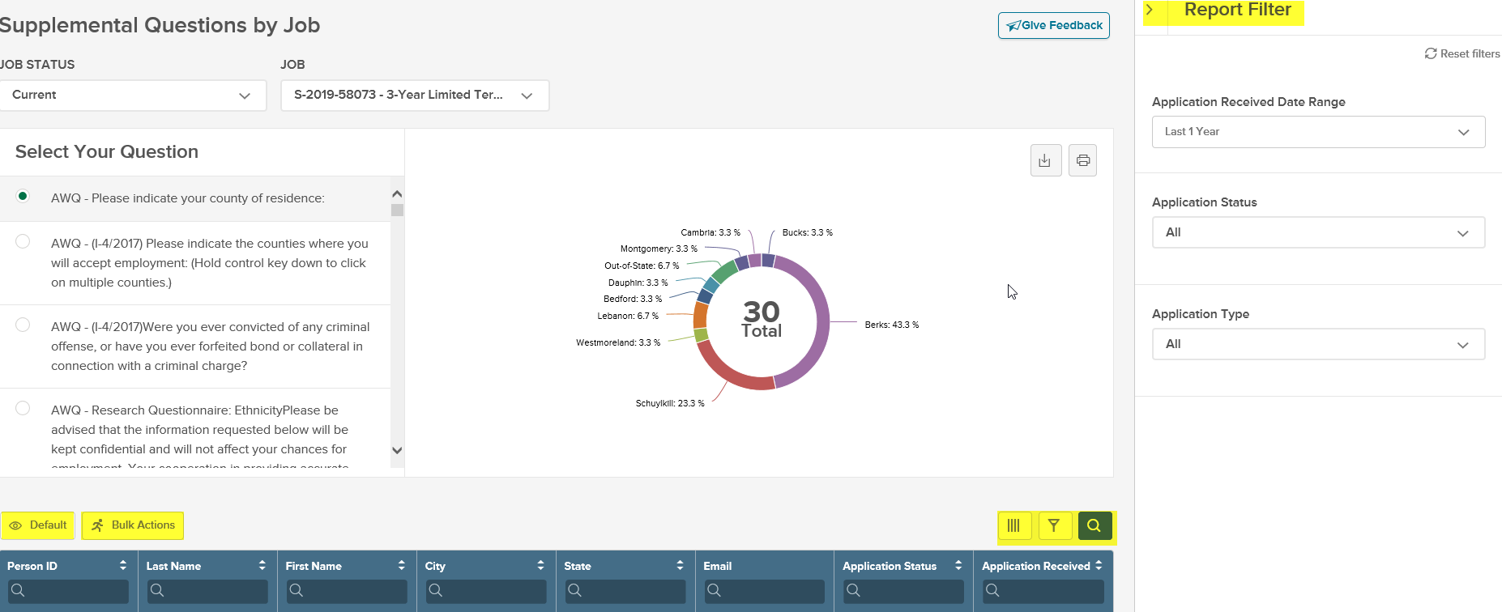

Insight: Revised Standard Report – Applicants by Job

The Applicants by Job report has been revised to simplify running the report and provide easier controls for selecting report criteria. The report changes include the following features:

- Report Filter Pane: Users can perform basic filtering on the Application Received Date Range, Application Status, Application Type and Evaluation Steps.
- Advanced Filtering Icon: Users can perform advanced filtering on certain criteria such as Person ID, Last Name, First Name, Application Status, etc.
- Column Selector Icon: Users can specify which columns to show in the report including any custom fields on the applicant master profile.
- Column Search Icon: Users can search or filter within certain columns displayed on the report.
- Default Icon: Users can create and save report ‘views’.
- Bulk Actions Icon: Users can export data in PDF, Excel or CSV formats.
- Chart that provides a visual summary of the candidates at each phase of the exam plan and their current disposition.

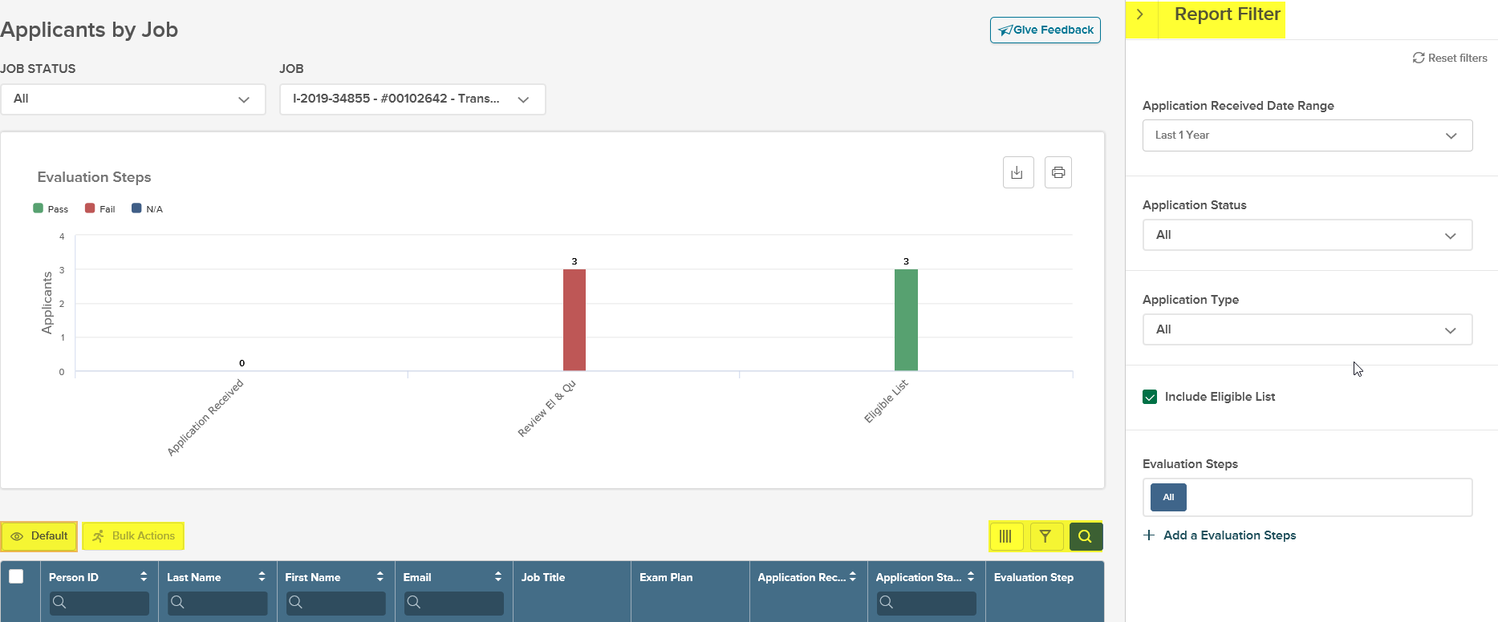

Insight: Revised Standard Report – Eligible List

The Eligible List report has been revised to simplify running the report and provide easier controls for selecting report criteria. The report changes include the following features:

- Report Filter Pane: Users can perform basic filtering on certain criteria such as the Eligible Date, Inactivation Date, Department, Job Spec, Exam Plan, etc.
- Column Selector Icon: Users can specify which columns to show in the report including any agency-wide questions as well as certain eligible list and candidate data.
- Column Search Icon: Users can search or filter within certain columns displayed on the report.
- Default Icon: Users can create and save report ‘views’ and schedule automated exports to automatically generate reports.
- Bulk Actions Icon: Users can export data in PDF, Excel or CSV formats.

Questions?
If you have any questions regarding the October 2019 NEOGOV Enhancements, please submit an HR/Pay Help Desk ticket under the ‘Applications Support’ category.

