Please distribute this alert to any Insight users within your agency who use the NEOGOV, Applicant Tracking System on a regular basis.

September 2019 NEOGOV Enhancements

- Information regarding the September 2019 release of enhancements to the NEOGOV Applicant Tracking System.

The following enhancements were released to Insight in September 2019 and are available to all Insight users:

Insight: Show Candidate Disposition on Referred List
Insight users can view the disposition for scored referred list steps from the Online Hiring Center (OHC). A new “Disposition” column will display beside the “Status” column when viewing referred lists in Insight.

The new column will reflect the disposition for the candidate’s current status as applicable. The column will show a pass or fail status along with the inactivation reason. However, scores and star ratings will not be displayed. The column is also available in the list export.

Navigation: Insight > Main Menu > Lists > Referred > View
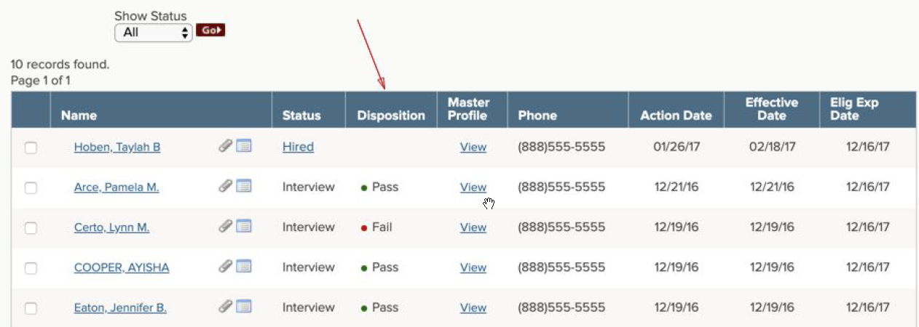

Insight: Ability to sort by Candidate Status on Referred List
Insight users can filter candidates by a specific status on the referred list in Insight. The filter includes all OHC evaluation steps set up by OHC users. All statuses/evaluation steps will display by default. When filtering on a specific status, the list will only display the candidates who are currently in that status.

Navigation: Insight > Main Menu > Lists > Referred > View > Show Status
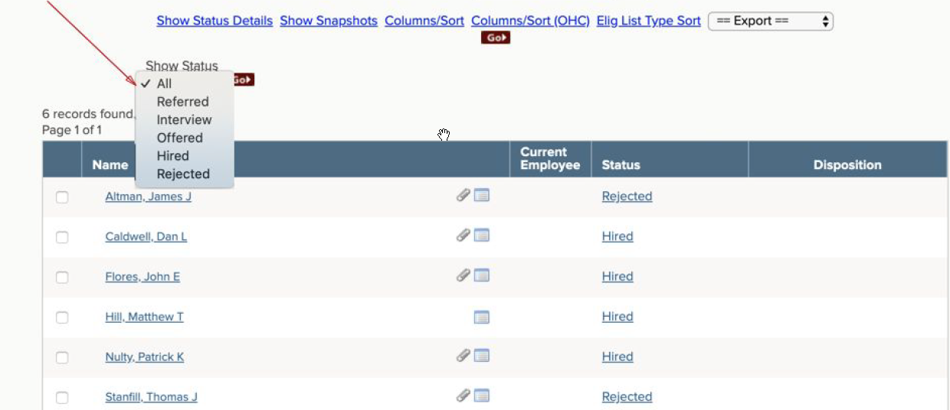

Insight: Hire Approval Report
Insight users have access to a Hire Approval Report to help track the status of selected candidate approvals. The report can be found within the standard reports under the Hires or Statistical Reports categories (Insight > Main Menu > Reports > Standard Reports > Hire Approvals).

The report has several features for users including:
- Basic filtering on the following parameters:
  - Date Range
  - Department
  - Approval Group
- Advanced filtering on the following criteria:
  - Req Number
  - Req Title
  - Person ID
  - Department Code
  - Applicant Name
  - Approval Group Name
  - Approver Taking Action
- Export data in PDF, Excel or CSV formats
- Create and save report ‘views’
- Schedule automated exports to automatically generate reports

Please refer to the Hire Approval Report Instructions for more detailed information on how to navigate and use the report features.

Insight: Requisition Approval Report
Insight users have access to a Requisition Approval Report to help track the status of requisition approvals. The new report can be found within the standard reports under the Requisitions or Statistical Reports categories (Insight > Main Menu > Reports > Standard Reports > Requisition Approvals).

The report has several features for users including:
- Basic filtering on the following parameters:
  - Date Range
  - Department
  - Approval Group
- Advanced filtering on the following criteria:
  - Req Number
  - Req Title
  - Department
  - Approval Group Level
  - Approval Group Name
  - Approver Taking Action
  - Job Posting
  - Department Code
- Export data in PDF, Excel or CSV formats
- Create and save report ‘views’
- Schedule automated exports to automatically generate reports

Please refer to the Requisition Approval Report Instructions for more detailed information on how to navigate and use the report features.

Questions?
If you have any questions regarding the September 2019 NEOGOV Enhancements, please submit an HR/Pay Help Desk ticket under the ‘Applications Support’ category.

