Please distribute this alert to any Insight users within your agency who use the NEOGOV, Applicant Tracking System on a regular basis.

Updated Electronic Signature Verbiage

- Information regarding a change to the electronic signature verbiage.

In accordance with Commonwealth policy, the electronic signature verbiage presented to candidates during the application process has been updated to include the following acknowledgement statement:

I acknowledge that the Commonwealth does not sponsor applicants holding H1 visas, nor do Commonwealth positions qualify for participation in CPT, OPT, or STEM OPT programs for F-1 visa holders.

This change is effective immediately and will display within the signature verbiage that appears to all applicants on the “Certify” screen.

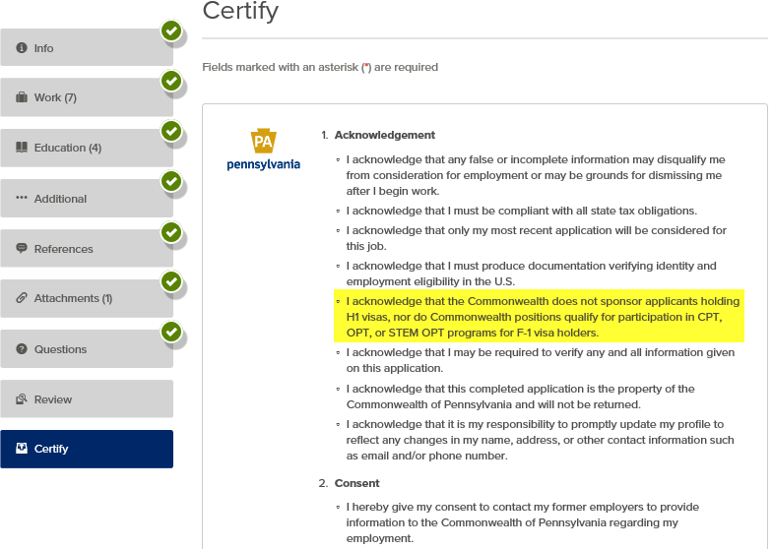
Questions?
If you have any questions regarding the Updated Electronic Signature Verbiage, please submit an HR/Pay Help Desk ticket under the ‘Applications Support’ category.

