Please distribute this alert to any Insight users within your agency who use the NEOGOV, Applicant Tracking System on a regular basis.

May 2019 NEOGOV Enhancements

- Information regarding the May 2019 release of enhancements to the NEOGOV, Applicant Tracking System.

Effective May 16, 2019, Insight users can print applications from the Hires List page (Insight > Main Menu > Lists > Hired). Users may bulk print up to 20 applications at a time. Applications will export in PDF format and include both application and hire form attachments. Applications can be printed for any hired candidate regardless of status (i.e. In Progress, Awaiting Authorization and Hire Authorized).

Insight users can print applications by selecting the checkboxes next to the applicant names and then the “Bulk Actions” button.

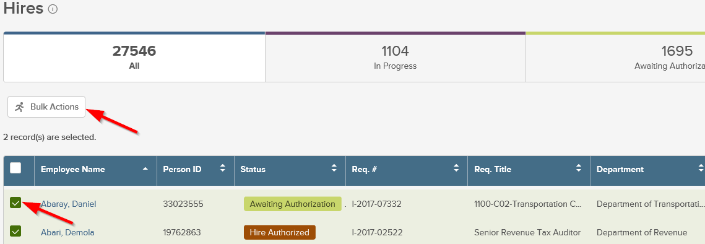

A flyout will open on the right-hand side of the screen. Select “Print Application”.

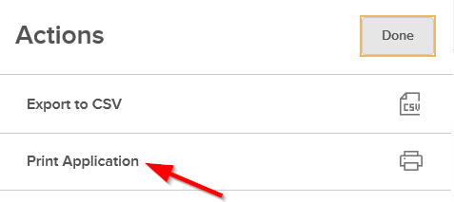
A confirmation page will then appear on the flyout screen. Click “Yes” to continue.

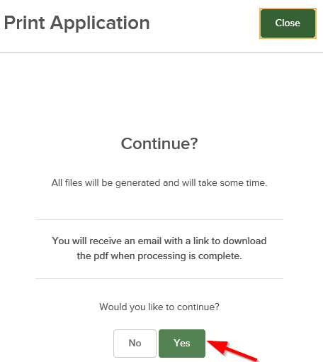

Users will receive an email when the application(s) are ready for download. The file can be accessed from the new printed applications page for hires (Insight > Main Menu > Applicants > Printed Apps: Hires).

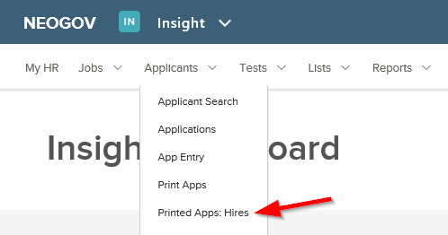

The printed applications page will display the batch number, time of request, total applications selected, report type and start and end times. Select the link within the PDF column to open the file.

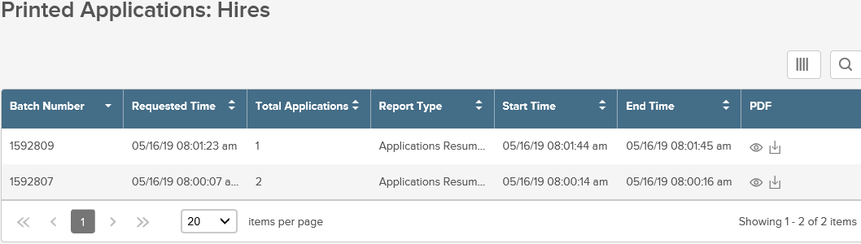

Questions?
If you have any questions regarding the May 2019 NEOGOV Enhancements, please submit an HR/Pay Help Desk ticket under the ‘Applications Support’ category.

