Please distribute this alert to any users within your agency who use the NEOGOV, Applicant Tracking System on a regular basis.

April 2019 NEOGOV Enhancements

- Information regarding the April 2019 release of enhancements to the NEOGOV, Applicant Tracking System.

Effective April 11, 2019, all email notices sent to applicants will come from the email address of info@governmentjobs.com and display the name of a user in the ‘From’ field.

This change is to resolve recent delivery issues due to email providers tightening spam filters and blocking emails.

Email notices sent from Insight will show the name of the user assigned to the job posting in the ‘From’ field. Direct replies to these emails will be sent to the user’s email address associated with their NEOGOV account.

Email notices sent from the Online Hiring Center (OHC) will show the name of the user who generated the notice in the ‘From’ field. Direct replies to these emails will be sent to the user’s email address associated with their NEOGOV account.

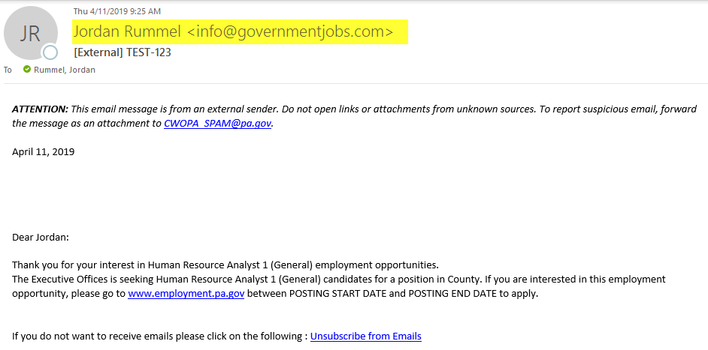

In addition, the ‘Replies to’ verbiage previously included on applicant notices has been removed.

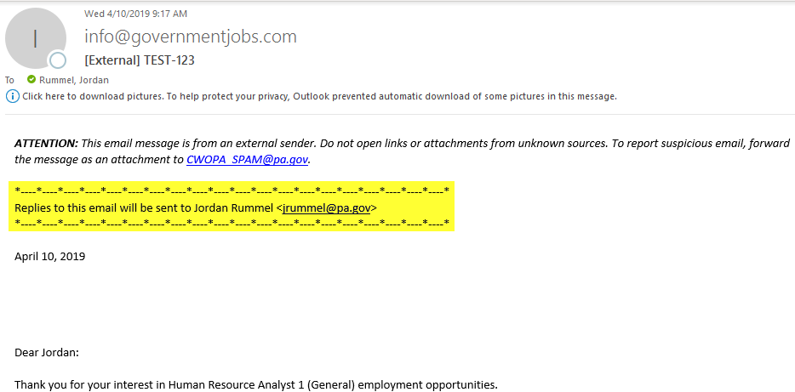

Questions?
If you have any questions regarding the April 2019 NEOGOV Enhancements, please submit an HR/Pay Help Desk ticket under the ‘Applications Support’ category.

