Please distribute this alert to any users within your agency who use the NEOGOV, Applicant Tracking System on a regular basis.

March 2019 NEOGOV Enhancements

- Information regarding the March 2019 release of enhancements to the NEOGOV, Applicant Tracking System.

Effective March 15, 2019, OHC users will have access to a new ‘Hires’ page, which will contain a list of all hires and related information. Users can access the ‘Hires’ page from the OHC Dashboard by selecting the ‘Jobs’ menu and selecting ‘Hires’ (OHC > Dashboard > Jobs > Hires).

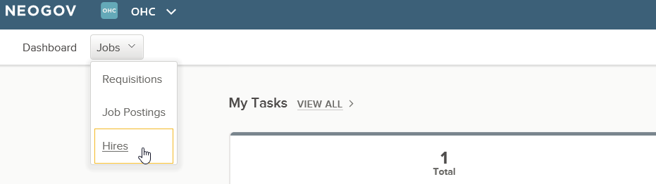

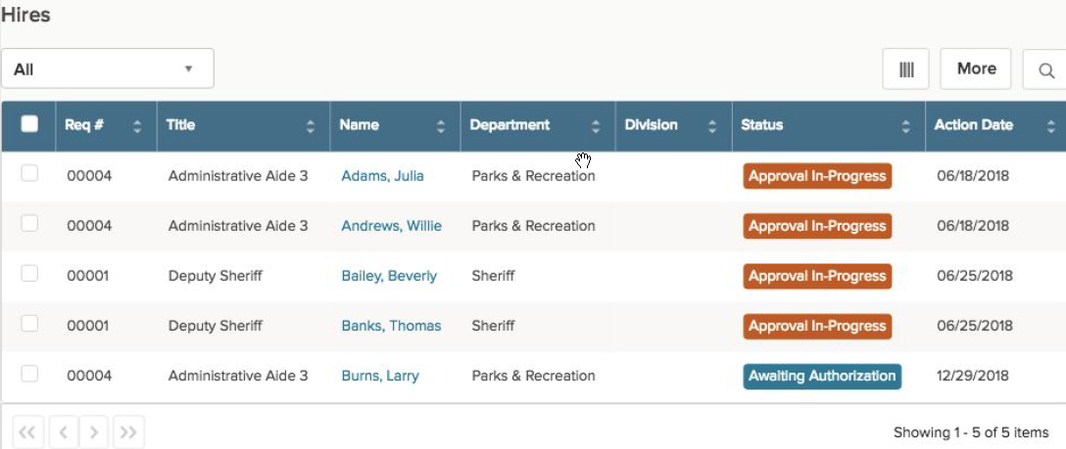

The ‘Hires’ page will be available to all users who have the following roles assigned in SAP:
- YQC>OHC_LIAISON_COPA
- YQC>OHC_LIAISON_SL_COPA
- YQC>OHC_HIRING_MGR_COPA

Users with the OHC Liaison role(s) will have access to all hires for their assigned departments. Users with the OHC Hiring Manager role will only have access to hires for which they are an assigned hiring manager on the requisition.

This enhancement will provide users with a single source to review and monitor the status of hires for their departments and program areas.

Users can access the candidate’s application from this page by clicking on the name of the candidate under the ‘Name’ column. Additionally, users will be able to access the hire form and approval history by clicking on the hire status under the ‘Status’ column.

The ‘Hires’ page also provides users with the ability to search, filter, sort and export the list of hires.

There is no change to the functionality of authorized hires. Users will not be able to edit the hire form and approvals for hires that have been authorized. Changes to the hire form for authorized hires must still be processed via Insight.

Questions?
If you have any questions regarding the March 2019 NEOGOV Enhancements, please submit an HR/Pay Help Desk ticket under the ‘Applications Support’ category.

