Requisition Approval Report Instructions
Issued 10.09.2019

Insight users have access to a Requisition Approval Report to help track the status of requisition approvals. This report has several features for users, which includes the ability to filter notices as follows:
- Basic filtering parameters:
  - Date Range
  - Department
  - Approval Group
- Advances filtering criteria:
  - Req Number
  - Req Title
  - Department
  - Approval Group Level
  - Approval Group Name
  - Approver Taking Action
  - Job Posting
  - Department Code

This set of instructions will walk through how to access and use the following features:
- Accessing the report
- Filtering the report
- Creating and saving report views
- Scheduling automated exports and emails
- Exporting the data to a PDF, Excel, or CSV file

If you have any additional questions regarding the requisition and hire approval reports, please submit an HR/Pay Help Desk ticket under the “Applications Support” category.

1. Accessing the Report

The Requisition Approval Report is located within the standard reports section of NEOGOV Insight, under the Hires or Statistical categories.

First, navigate to the standard reports section of NEOGOV Insight.
Navigation: Insight > Main Menu > Reports > Standard

Within the standard reports section, select the “All Reports” tab. From here are three different ways to access the report:
- Filter the “All Categories” dropdown to “Requisitions” or “Statistical Reports”
- Type “Requisition Approvals” into the search box
- Look for “Requisition Approvals” within the “Report Title” column

See Figure 1 for more details.

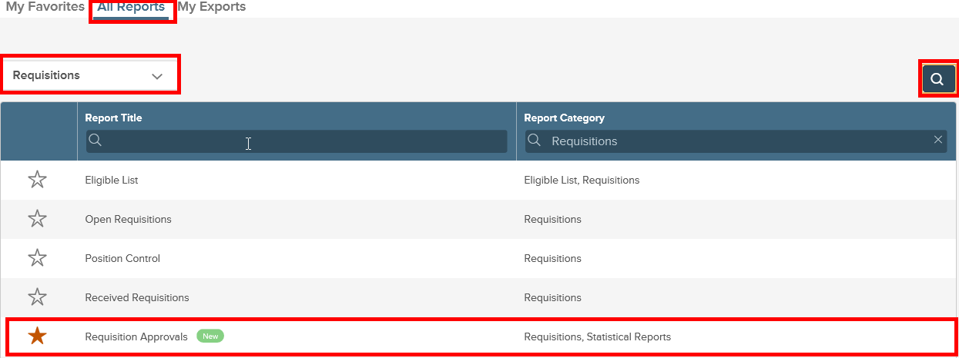
Figure 1

2. Filtering the Report

Once you have navigated to the Requisition Approvals Report, you will see a Filters tab in the upper right-hand corner of the screen. You will need to click on the arrow to view all the filter options. See Figure 2.

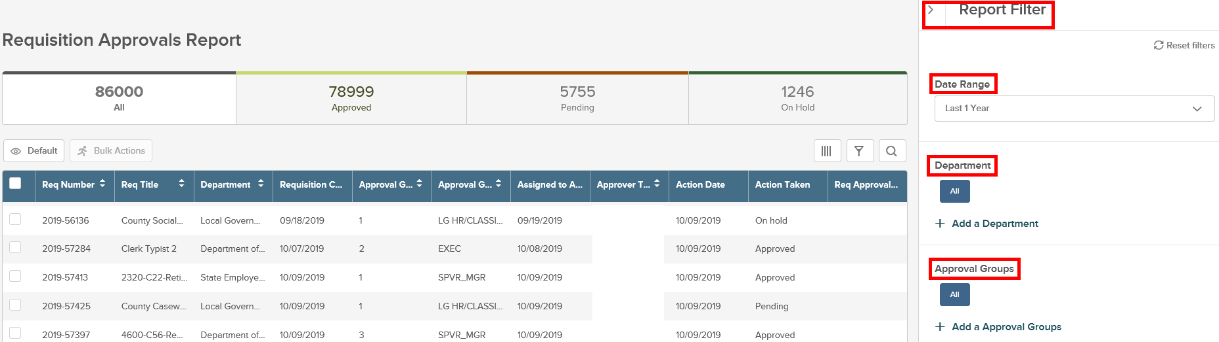
Figure 2

As shown in Figure 2, users can filter the report by categories including date range, department and approval group. Please note that once a user changes any of the listed filters, the data displayed will be immediately updated to reflect the filter changes. There is no limit on how many filtered views a user can apply at a time.

Users can then further filter the data through the advanced filtering options. As shown in Figures 3 and 4, users can filter the report by certain criteria including req number, req title, approval group name, etc.

The advanced filtering is a three-step process and will require a user to select a filter (e.g. req number), an operator (e.g. starts with) and the specific value (e.g. 2019-12345) to be reported on.

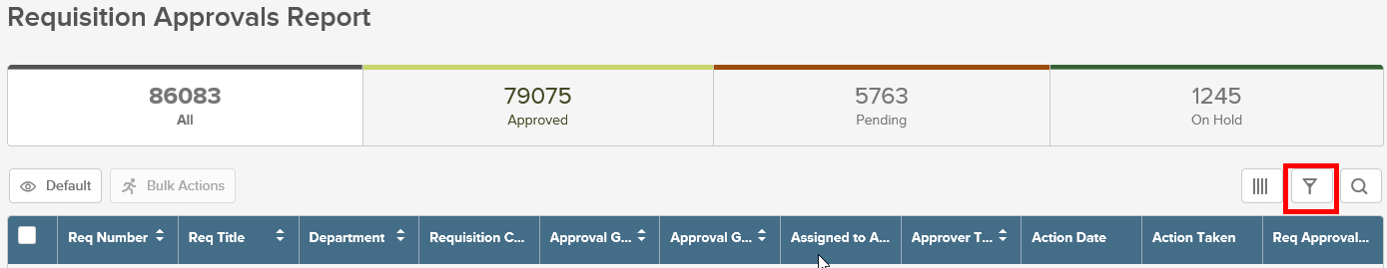
Figure 3

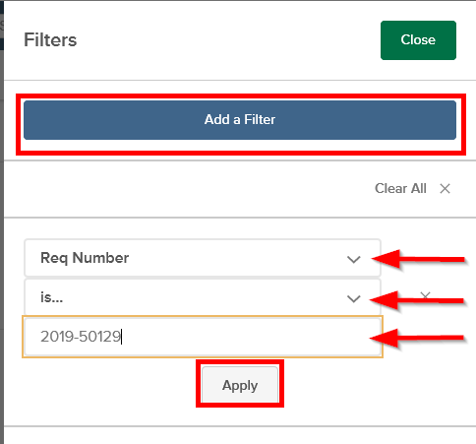
Figure 4

3. Creating and Saving Report Views

In addition to the applicable filters, users will also be able to create and save new reporting views. To create a new view, users will start by clicking the “Default” button, located below the report title. See Figure 5.

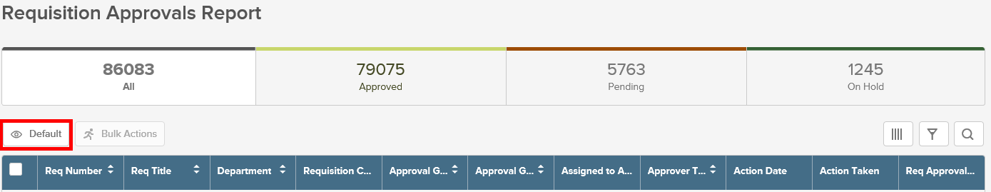
Figure 5

After selecting the “Default” button, users will have the option to either create a new view or continue using the view selected as the Default View. See Figure 6.

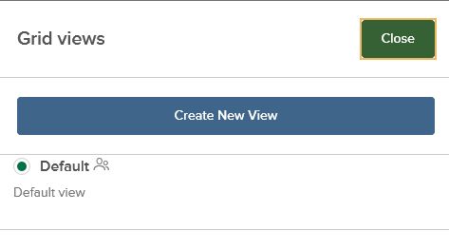
Figure 6

If the user opts to create a new view, they will be prompted to name their view. Within the “Grid View Editor,” users have the option to make the new view their default view or make the view public. Once the user is done creating the report view, they must hit the “Save” button in the upper right-hand corner of the screen. See Figure 7.

Figure 7

4. Scheduling Automated Reports and Emails

Users can also schedule exports of their reports through the “Schedule Export” option located in the “Grid View Editor.”

To start scheduling automated reports, the user must select “On” in the “Schedule Export” option.

Once “On” is selected, users will have the ability to specify the export type (CSV, Excel, or PDF), as well as the export frequency and additional criteria for repetition. The user must then save the selected settings by clicking the “Save” button in the upper right-hand corner of the screen. Please note that filling out the export information will send the report to the NEOGOV account of the user accessing the report once the report is finished.

See Figure 8 for more details.

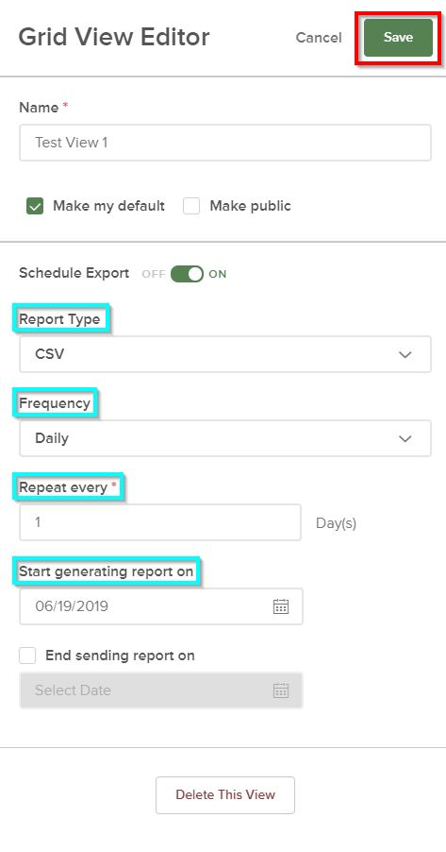
Figure 8
5. Exporting the Data

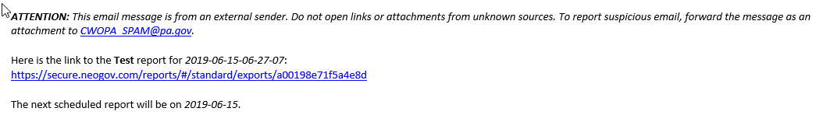
After the user schedules automated reports and emails (see 4. Scheduling Automated Reports and Emails for further instruction), the user will receive an email with the link to the scheduled report as shown in Figure 9.
Figure 9

Additionally, the user can access this report in NEOGOV by navigating to the “My Exports” tab under the “Standard Reports” section.
Navigation: Insight > Reports > Standard > My Exports

See Figure 10 for more details.

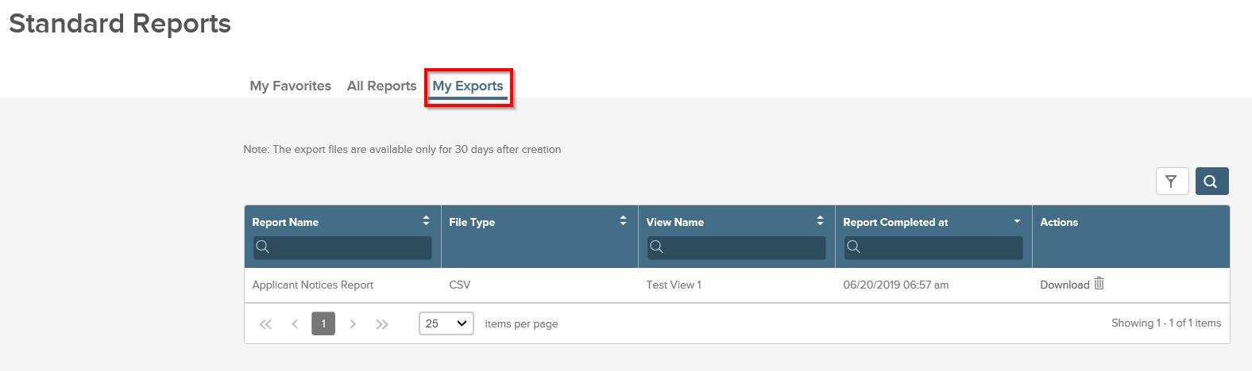
Figure 10

Once the user has navigated to the “My Exports” tab, a list of recent exports and scheduled reports will appear. These reports are displayed by name, file type, view name, and date completed. To export any report into a separate file, click on the “Download” button listed under “Actions”. See Figure 11.

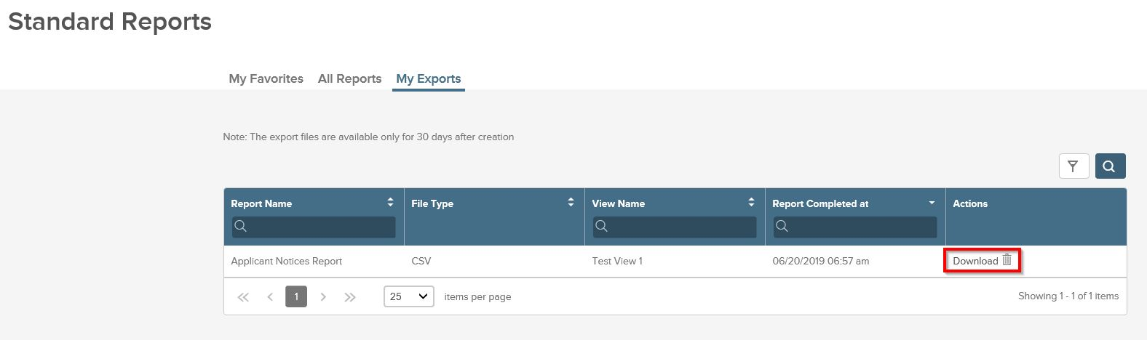
Figure 11

Please note that the export files are only available to be exported for 30 days after their original creation date.

