This Alert includes information related to the following:

- Updating information on IT0006 (Address), Subtype 1 (Permanent residence)
- IT0207 (Residence tax)
- Changing information on IT0006 (Address), Subtype 1 (Permanent residence) during a PA40 Separation action

This Personnel Administration (PA) Alert is being issued to notify you of several issues related to the permanent address on IT0006 (Address).

P.O. Box Listed as Permanent Address
In a review of permanent addresses, it was discovered that there are employees who have a P.O. Box listed as their permanent address. Because the employee’s residence tax is based on where they reside, the municipality selected on IT0207 (Residence Tax) may be incorrect. During this review, the following was discovered:

- Employees converted from IPPS with a P.O. Box
- P.O. Box exists because no other address is available
- P.O. Box plus street address with house number – In most cases, the street address and number could not be verified by USPS
- Update to permanent address made by employees via ESS

The tax area on IT0207 (Residence Tax) is associated with the permanent address data indicated on IT0006. Therefore, this should be consistent with where the employee is physically resides.

Employees should be reminded that when updating address information via ESS, a P.O. Box should not be entered unless there is no street address that is accepted by the USPS. If a P.O. Box is necessary, it is imperative that the zip code is accurately reflected for taxing purposes.

When provided by the employee, the address should be verified to ensure it is compliant with the United State Post Office. This can be verified using the link provided below:

http://zip4.usps.com/zip4/welcome.jsp

It is important that if a P.O. Box and a street number and street address is available, that the P.O. Box be listed on Address line 2. Below is an example of an employee who has both a street address and P.O. Box.

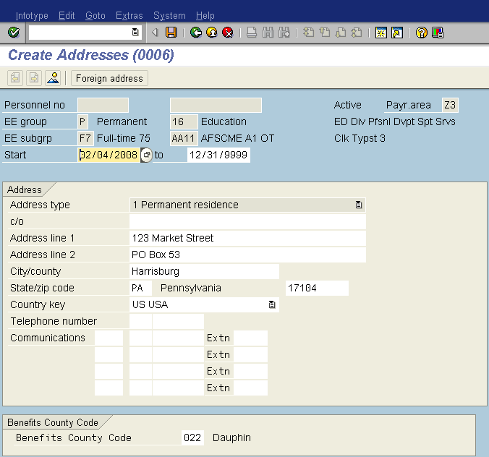
Enter first line of street address (i.e. number and street name)
If needed, enter second line for additional address information (i.e. apartment number, box number, etc.)
Enter city (i.e. Harrisburg). Do not abbreviate.
Enter zip code. This is what determines what selection is presented on IT0207 (Residence Tax)

Also, it is important that the city name be spelled out. Abbreviation of city name is not compliant with the USPS. Therefore, may cause a problem with delivery such as pay statement or W-2 Form.

Agencies will be provided with a list of employees who have a P.O. Box listed as their permanent address. These lists should be verified and corrected no later than Friday, February 29, 2008.

Undeliverable pay statements
Several pay statements have been returned to BCPO which indicate they are undeliverable. Some of the reasons why the pay statements return are:

- Address not valid with USPS
- Address undeliverable
- Missing a unit or apartment building number
- P.O. Box was closed

Treasury uses the address listed on IT0006, Subtype 5 (Mailing address) first when mailing pay statements. If no mailing address is available, the permanent address is used.

It is important that employees be reminded that if a change occurs with their address, they should make the necessary updates via ESS or submit a request to their agency HR Office to have it corrected.

Permanent Address for Separation
Personnel Alert 2006-8, distributed 12/21/06, notified agency users that the BPP and Action Guide for the PA40 Separation action were updated. These documents address the changing of the permanent address during the separation action. The Permanent Address should not be changed during this action.

If the employee has provided a new address upon separation, the address change should ONLY be made to the Mailing Address and NOT the Permanent Address. Changing the permanent address on IT0006 will result in negative taxable gross's and a termination error in processing.

When processing a separation action always refer to the Separation BPP (http://www.ies.state.pa.us/hr/lib/hr/BH0027_PA_PA40_Separations.doc) and the Separation Action Guide (http://www.ies.state.pa.us/hr/lib/hr/SEPARATION.doc)

If you have any questions, please submit an HR Help Desk Ticket in the Personnel Administration category.

