Please distribute this alert to any users within your agency who are responsible for personnel administration.

ServiceNow September 2021 Migration – HR Staff Services

- Information regarding services for HR staff that are migrating to ServiceNow in September 2021.

Effective September 1, 2021, the following services for HR staff will transition to the “AskHR” section of the new Employee Resource Center and ServiceNow platform:

- HR Report Request: Requests for ad hoc or routine HR reports. PLEASE NOTE: Effective September 1, 2021, requests should no longer be submitted via email to the Enterprise Systems and Data Analytics Office. All report requests should be submitted via AskHR to ensure proper tracking, prioritization, and metrics. The Enterprise Systems and Data Analytics Office will still satisfy any reporting requests received prior to the transition.

- HR Application Support: Requests to troubleshoot HR application errors, issues, bugs and defects. PLEASE NOTE: Effective September 1, 2021, the “HR Application Support” category will be removed from the HR/Pay Help Desk application and all new requests should be submitted via AskHR. The Enterprise Systems and Data Analytics Office will continue to troubleshoot and resolve any pending HR/Pay Help Desk tickets that were submitted prior to the transition.

- Applicant e-OPF Review: Requests for access to an employee’s e-OPF for a hiring manager.

- HRSC-Agency Services Inquiry: Submit a question to HRSC-Agency Services.

- Resignation Contact Former Agency Request: Requests for the approval of a RCFA separation.

Employee Resource Center > AskHR > HR Systems
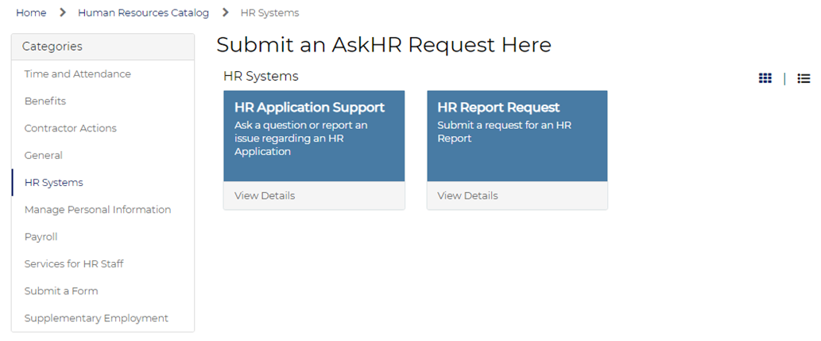

Employee Resource Center > AskHR > Services for HR Staff
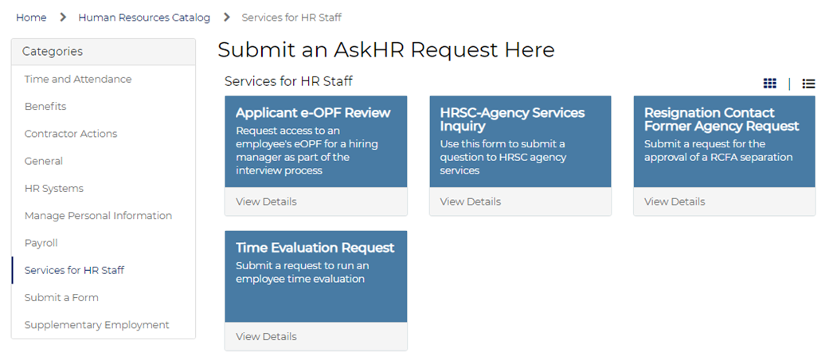

Questions?
If you have any questions regarding ServiceNow September 2021 Migration – HR Staff Services, please submit an HR help desk ticket in the personnel administration category. You may also call the HR Service Center at 877.242.6007 or email RA-HRSC@pa.gov.

