Please distribute this alert to any users within your agency who are responsible for personnel administration.

Addition of Probationary Period End Date Field in Employee Locator Reports

- Information regarding the addition of a probationary period end date field within Employee Locator Reports.

Effective Monday, May 24, 2021, the following Employer Locator Reports will include a new field “Prob Period End Date”:

- Employee Locator (SAP Transaction: Y_DC1_32000406)
- Agency Employee Locator (SAP Transaction: Y_DC1_32000458)
- Local Government Employee Locator Report (SAP Transaction: Y_DC6_14000624)
- Local Government Employee Locator Web Application

The “Prob Period End Date” field will display the end date of the probationary period in MM/DD/YYYY format when the employee has an active Infotype 0019 (Monitoring of Tasks) Subtype 01 (End of Prob Period) record in SAP. If there is no active IT0019 record in SAP, the field will be blank. Furthermore, this field will only be included within the current employment data record and will not display within any of the employment history records.

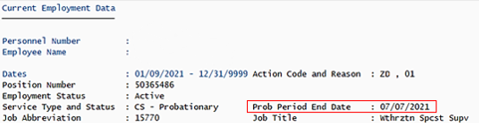

In conjunction with the addition of the probationary period end date field, both the confidential indicator and contract type fields will be relocated on the Employee Locator and Agency Employee Locator Reports. Please refer to the below examples that show the new probationary end date field and updated placement as applicable for the confidential indicator and contract type fields.

COPA employee with active IT0019, STy01 record
Employee Locator and Agency Employee Locator Reports
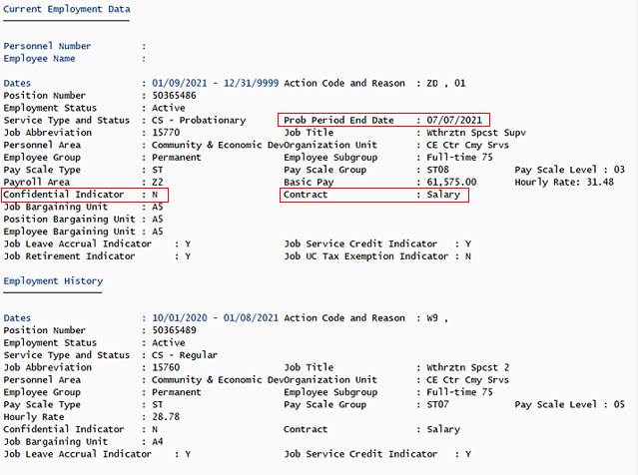

COPA employee without active IT0019, STy01 record
Employee Locator and Agency Employee Locator Reports
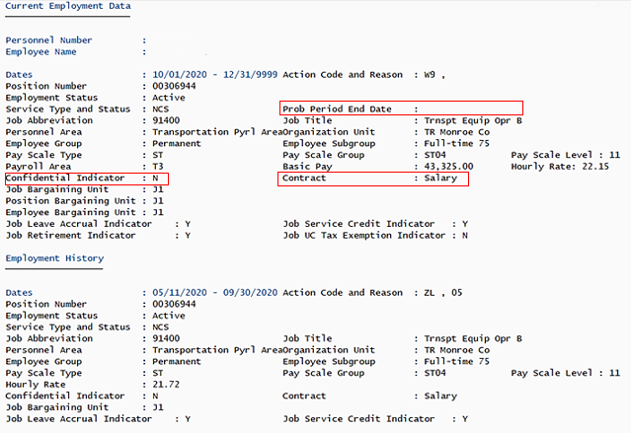

LG employee with active IT0019, STy01 record
Local Government Employee Locator Report
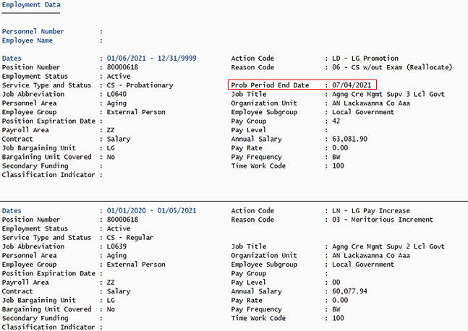

LG employee without active IT0019, STy01 record
Local Government Employee Locator Report
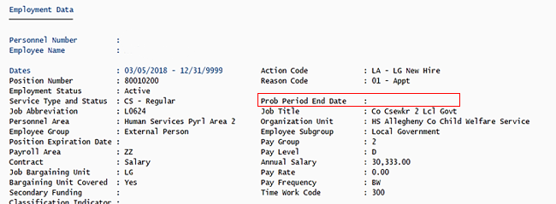

LG employee with active IT0019, STy01 record
Local Government Employee Locator Web Application
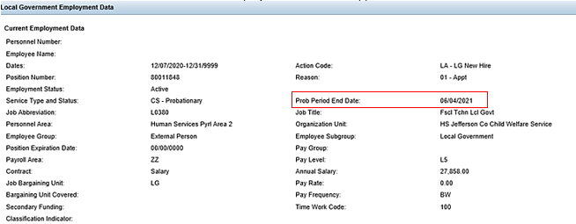

LG employee without active IT0019, STy01 record
Local Government Employee Locator Web Application
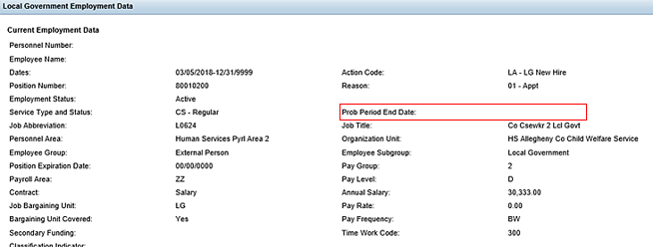

Questions?
If you have any questions regarding Addition of Probationary Period End Date Field in Employee Locator Reports, please submit an HR help desk ticket in the personnel administration category. You may also call the HR Service Center, Agency Services & Operations Division at 877.242.6007.

