Please distribute this alert to any users within your agency who are responsible for personnel administration.

USPS Address Validation and Standardization

- Information regarding a new US Postal Service address validation service for employee addresses entered in SAP and Employee Self-Service (ESS).

Effective Monday, March 29, 2021, employee addresses entered on IT0006 (Addresses) during PA30/PA40 transactions and via the “Address and Phone Numbers” service in Employee Self-Service (ESS) will prompt an address verification through the US Postal Service database. This new service is part of an effort to help validate and standardize addresses to ensure accurate information is sent to benefit providers and mailed correspondence is distributed to valid home and mailing addresses.

When a user selects the ‘enter’ key/button or ‘save’ button after creating or updating an address on IT0006 in SAP, an “Address Validation” pop-up box will present to the user and display the “Original Address” (i.e. address entered in SAP) and the “USPS Validated Address”.

In ESS, the user will receive this pop-up box after selecting the ‘continue’ button or pressing the ‘enter’ key when creating or updating an address.

The user should review the addresses to ensure the correct information is being presented. It is recommended the user choose the USPS validated address when available and correct by selecting the “Use USPS Validated Address” button.

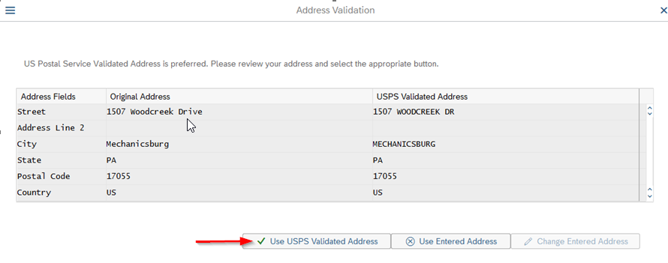

Please note that in most cases, USPS validated addresses will have some distinct characteristics that include:
- All alpha characters will be in uppercase
- Postal Code (Zip Code) will contain all 9 digits
- Street suffixes such as street, road, avenue, drive, boulevard, lane, etc. will be abbreviated
- Secondary units such as apartment, suite, floor, room, etc. will be abbreviated
- Directionals such as North, East, Southwest, Northwest, etc. will be abbreviated
- Punctuation such as periods, commas, apostrophes, colons, etc. will be removed

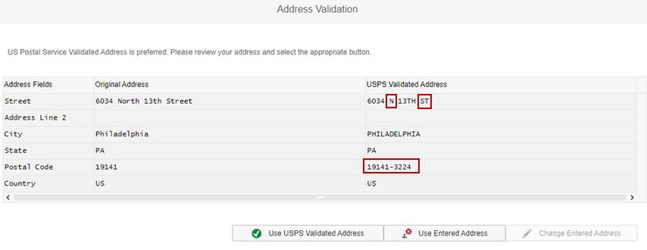

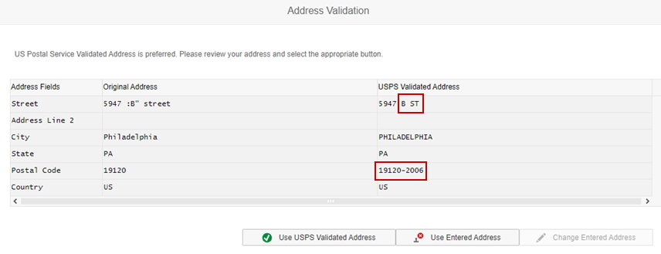

In some cases, the USPS validated address might not be available if the address cannot be found in the database or the verification service is unavailable. In these situations, the user should confirm the accuracy of the “Original Address” and then proceed by selecting the “Use Entered Address” button if the address is correct, or the “Change Entered Address” button to correct the address and reinitiate the verification.

The more common errors a user may experience are as follows:

- USPS Service Unavailable: In these situations, the user will receive the error message “USPS Web Service validation currently unavailable. Please confirm your entry and select the “Use Entered Address” button to continue.” As stated in the error message, the user should review the accuracy of the address and then select the “Use Entered Address” button to continue if the address was entered correctly.

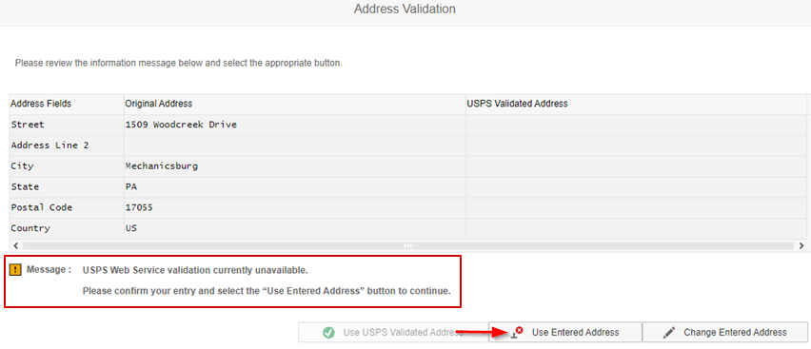

- Invalid Special Characters: In these situations, the user will receive the error message “USPS Web Service error has occurred. Special characters: & # % are problematic and should not be used.” The user should select the “Change Entered Address” button and remove the invalid special characters to reinitiate the address verification.

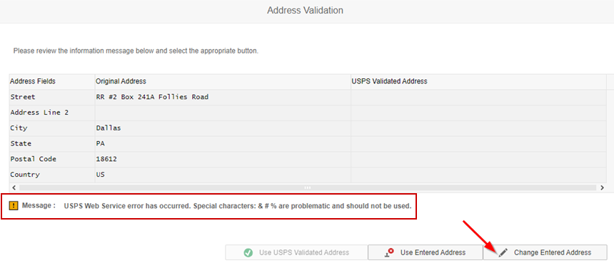
- Address Not Found: In these situations, the user will receive the error message “US Postal Service Address Not Found. Please confirm your address is accurate”. As stated in the error message, the user should confirm the accuracy of the address. If correct, the user should select the “Use Entered Address” button to continue. If the address contains a typo, the user should select the “Change Entered Address” button and update the address to reinitiate the address verification.

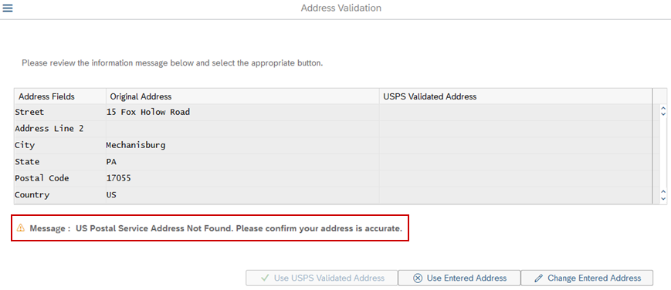

Questions?
If you have any questions regarding USPS Address Validation and Standardization, please submit an HR help desk ticket in the personnel administration category. You may also call the HR Service Center, Agency Services & Operations Division at 877.242.6007.

