Please distribute this alert to all users within your agency who are responsible for personnel administration and organization management.

Agency Name Change – Parole Board

- Information regarding a change to the agency name for Business Area 25 and Personnel Area 25.

Effective October 26, 2020, the agency name for Business Area 25 and Personnel Area 25 will change in SAP and LSO from “Probation & Parole” to “Parole Board”.

This change is in accordance with Executive Board Resolution OR-20-015 which authorized the renaming of the agency on September 3, 2020 from “Pennsylvania Board of Probation and Parole” to “Pennsylvania Parole Board”.

Position - IT1008 (Account Assignment Features)
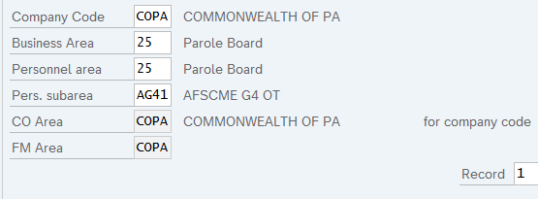

Employee - IT0001 (Organizational Assignment)
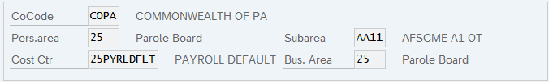

In addition, all organizations (0025****) under Business Area 25 will be updated to a new agency abbreviation “PB”.

Organization – IT1000 (Object)
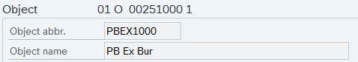

An updated organizational assignment record will be subsequently created on positions and employees to coincide with the agency name and abbreviation changes. Employees currently in Business Area 25 and Personnel Area 25 will also receive the following transaction on IT0000 (Actions):

Action Type: ZI (Employment Condition Change)
Action Reason: 12 (EBA Org Title Change)

The organization, position and employee updates will process the week of 10/26/2020 to 10/30/2020 and will be retroactively effective 09/03/2020, the date the name change was approved by the Executive Board.

Further impacts of the agency name change are being assessed and updates will occur as needed. Information regarding the agency name change in NEOGOV can be found in TA Alert 2020-11 (Agency Name Change – Parole Board).

Questions?
If you have any questions regarding the agency name change for the Pennsylvania Parole Board, please submit an HR help desk ticket in the Personnel Administration category.

