Please distribute this alert to all users within your agency who are responsible for personnel administration.

Personal Email Address

- Information regarding personal email address in Employee Self-Service (ESS) and SAP.

Effective Monday, October 26, 2020, a new ESS service “Email Addresses” will be available to all active Commonwealth employees. The new service enables employees to provide and maintain a personal email address for employment-related communications.

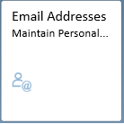

The collection and use of personal email addresses by the Commonwealth are only for employment-related purposes. The following message will display to employees when using the service:

The Commonwealth, through ESS, collects “personal information,” which is used for employment-related purposes only. Personal information collected through ESS includes information such as employees’ names, addresses, telephone numbers, email addresses, banking information, as well as information related to dependents. Employment-related purposes include, but are not limited to, onboarding, changes to employee benefits, pay notifications, and emergency contact. All personal information supplied to the Commonwealth by employees is subject to use and protection in conformance with applicable Federal and State laws, as well as any applicable Commonwealth policies and management directives.

Employee Self-Service (ESS)
The “Email Addresses” service allows employees to keep one active personal email address and provides the ability to create, edit and delete entries in order to properly maintain personal email address records.

Employees will not be required to provide an effective date when processing changes. The system will automatically use the current date to apply the updates. Additional information and instructions for using the service can be found by accessing the following link:

Employee Self-Service (ESS): Maintain Personal Email Address Instructions

SAP
The personal email address provided by the employee via ESS will be stored on Infotype 0105 (Communication) under Subtype 0030 (Personal Email Address). Any additions, changes, or deletions of the personal email address in ESS will dynamically update the corresponding SAP record.

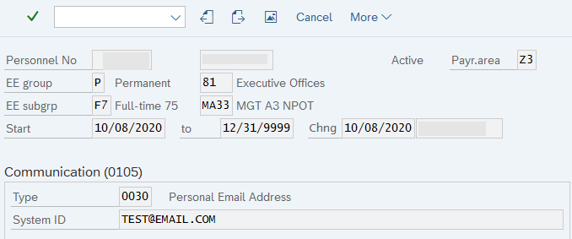

Changes to the personal email address in ESS will automatically delimit the previous record and create an entry for the new email address.

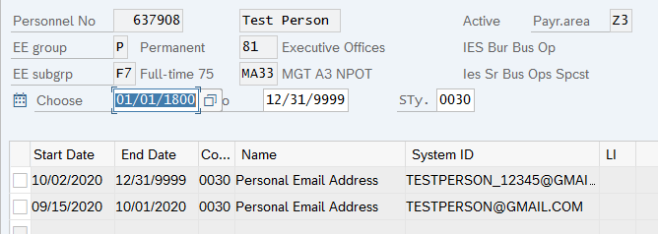

Deletions of the personal email address in ESS will not delete the corresponding SAP record. The SAP entry will be delimited the day prior to the date the deletion was processed. For example, if the employee deleted the record in ESS on 10/02/2020, the SAP entry would be delimited on 10/01/2020.

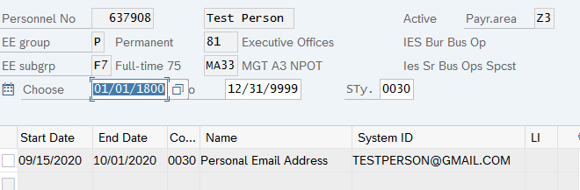
SAP Reports
The following SAP reports have been enhanced to include personal email address:

- Employee Contact Information Report (ZH_ECONTACT): A new column “Personal Email Address” will display after the “Telephone Numbers(s)” column.

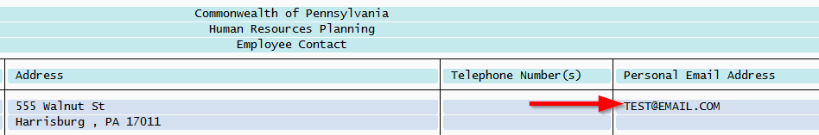

- HR PA Emp Contact Information Report (Y_DC6_14000171): A new column “Personal Email Address” will display after “Communications4” column.

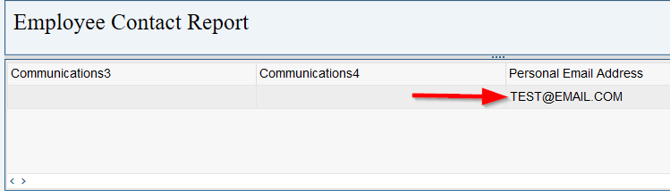

Notice to Employees
A mass communication announcing the new service will be sent to all employees in the future.

Questions?
If you have any questions regarding Personal Email Address, please submit an HR help desk ticket in the Personnel Administration category.

