Please distribute this alert to any users within your agency who are responsible for submitting ‘Fill a Vacant Position’ (Hires and Rehires) E-PARs.

New Certified Veteran field in E-PAR (Hire actions)

- Information regarding a new certified veteran field in E-PAR.

Effective Monday, January 14, 2019, a new “Is this employee a Certified Veteran Applicant?” field will appear on all ‘Fill a Vacant Position’ hire actions in E-PAR. The new field will consist of a Yes/No dropdown selection and will be optional at the requester level but required at the HR Office level prior to submission to the HR Service Center. Selecting ‘Yes’ will indicate the employee has been certified as a US military veteran (or in a minority of cases, a spouse of a certified US military veteran) within NEOGOV during the candidate application process. This information should be obtained from the ‘Vet Indicator’ column on the applicable referral list in NEOGOV.

Please note that the field does not indicate the hire was selected with veterans’ preference having been applied, but only that the hire was certified as a qualifying veteran.

This information will be used to update a new Military Services infotype in SAP planned for the spring and to enable enterprise reporting on certified veteran hires and employees:
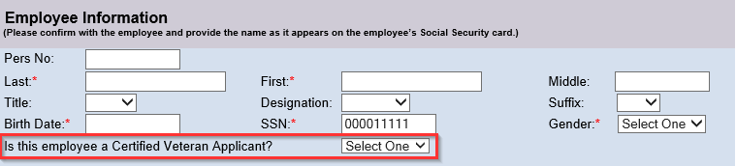

Questions?
If you have any questions regarding the New Certified Veteran field in E-PAR (Hire actions), please contact the HR Service Center at 866.377.2672 or submit an HR help desk ticket under the Personnel Administration category.

