Please distribute this alert to any users within your agency who are responsible for personnel administration.

Fair Share and Initiation Fee Changes

- Information regarding changes to the fair share process and collection of fees.

In accordance with the Supreme Court of the United States’ decision in Janus v. AFSCME, fair share and initiation fees have been stopped for all non-member union employees, effective close of business 06/26/2018.

Fair Share Fee Records
Infotype 0057 (Membership Fees) records will continue to exist for non-member union employees. This process has not changed. All non-member union employees must have an active Infotype 0057 and those records must still be created for employees during hire and new duty assignment transactions.

Effective 07/09/2018, all wage types previously associated with fair share have been renamed to “Non-Member” to coincide with the stoppage of fees. The text change to “Non-Member” does not impact PSTA (L1) and AFSCME District Council 33 (54) as there are no fair share wages types due to all employees being union members.

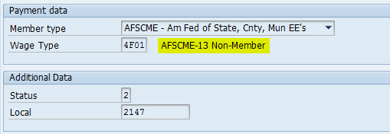

Initiation Fee Records
For unions that levy initiation fees, employees will now only be required to pay those fees when enrolled as a union member.

Initiation fee records on Infotype 0014 (Recurring Payments/Deductions) and Infotype 0015 (Additional Payments) will no longer generate during hire and new duty assignment transactions when an employee is placed into a non-member status on Infotype 0057.

Effective 07/23/2018, SAP enhancements will automatically create Initiation Fee records for applicable employees when enrolled as a union member on Infotype 0057. This system change only affects membership enrollments performed directly on Infotype 0057. Initiation fee records already generate when membership enrollments occur as part of a hire or new duty assignment transaction. The HR Service Center will be provided processing instructions for the system change.

Fair Share and Initiation Fee Reimbursements
Final Fair Share and Initiation Fee deductions for employees occurred on the following dates:
- Pay Area Z1/Z2/T2 – Pay Date 06/29/2018
- Pay Area Z3/T3 – Pay Date 07/06/2018

The Bureau of Commonwealth Payroll Operations is refunding all fair share and initiation fees that have not yet been remitted to the unions with the exception of ALES (K5) and UGSOA (R1, R2). Additionally, PSTA (L1) and AFSCME District Council 33 (54) are unaffected by these changes, as all employees are union members.

Employees, including some separated employees, will receive refunds as applicable according to the following schedule:

Pay Areas | Pay Date(s) Refunded | Pay Date of Refund
Z1/Z2/T2 | 06/01/2018 | 07/27/2018
 | 06/15/2018
 | 06/29/2018
Z3/T3 | 06/08/2018 | 07/20/2018
 | 06/22/2018
 | 07/06/2018

Employees who receive refunds will see a negative amount under the deductions section on their remuneration statement. Refunds will appear as follows:

- Fair Share Fee Refund Example:

- Fair Share and Initiation Fee Refund Example:
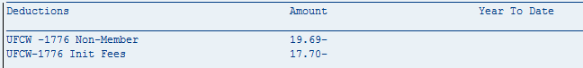

Questions?
If you have any questions regarding Fair Share and Initiation Fee Changes, please submit an HR help desk ticket in the personnel administration category.

