Please distribute this alert to any users within your agency who are responsible for talent management.

Fair Chance Hiring Exemptions

- Information regarding new task indicators for jobs and positions exempt from the Fair Chance Hiring Policy.

In order to track and report on jobs and positions exempt from the Fair Chance Hiring Policy, two new job/position tasks have been created in SAP:

Task Abbreviation | Task Name | Task ID
FCH-Policy | Fair Chance Hiring-Policy Exemption | 50537525
FCH-Stat | Fair Chance Hiring-Statutory Exemption | 50537526

The tasks are assigned at either the job or position level and are applied to the Relationships Infotype (IT1001). If all positions for an agency specific job are exempt from the policy, the task can be added at the job level and will not need to be maintained at the position level. Otherwise, the task should be added to the specific position that qualifies for the exemption.

Agencies had previously submitted exemption requests to the Governor’s Policy Office for review/approval and provided exemption spreadsheets to the HR Systems & Applications Division to mass load into SAP. The mass program has been run to load the tasks on all jobs and positions that were approved through that process. (Note: The data collected for the mass load identified qualification ID’s 50532209 (Statutory) and 50533726 (Policy) however, the above task ID’s are what was used to mass load SAP and are the ID’s that should be used going forward.) HR Delivery Center Managers will be provided with reports of all current exemptions for their agencies in the near future.

Human Resource Offices should continue to consult with their Office of Chief Counsel and receive approval from the Governor’s Policy Office on all future exemption requests. Once approval is obtained from the Governor’s Policy Office, Agencies should submit an E-PAR to have the task added in SAP:

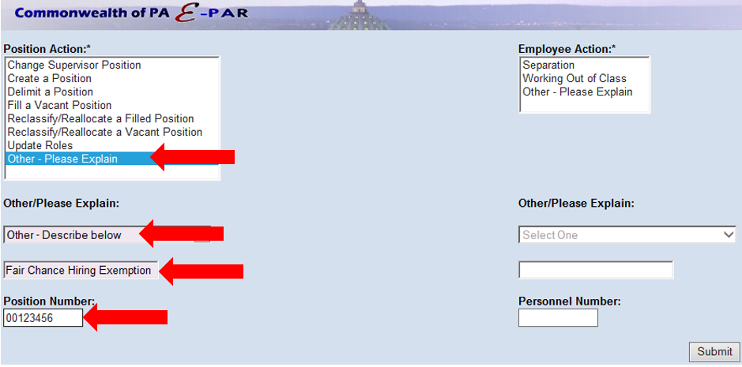

Agencies should also submit E-PARs to remove the task in situations where the exemption is no longer applicable. For example, a position is currently exempt, but has been reclassified to a job that is not eligible for the exemption or to a job that is already exempt.

All requests sent to the HR Service Center to add or remove the task indicator should include the following information:
- Position Number(s)
- Effective Date: Date exemption should be added or removed
- Exemption Type: Policy or Statutory
- Task ID: 50537525 (Policy) or 50537526 (Statutory)

Further information will be provided to human resource offices when the Fair Chance Exemption indicator is available in NEOGOV.

Questions?
If you have any questions regarding Fair Chance Hiring Exemptions, please submit an HR help desk ticket in the personnel administration category.

