Please distribute this alert to any users within your agency who are responsible for supplementary employment and processing SAP transactions.

New Infotype in SAP for Supplementary Employment

- Information regarding a new infotype in SAP for supplementary employment

In support of OneHR Project 2 – Supplementary Employment, a new infotype has been created in SAP to capture supplementary employment request information. The new infotype, IT0329, Supplementary Employment, will be available in SAP on Monday, 03/27/2017.

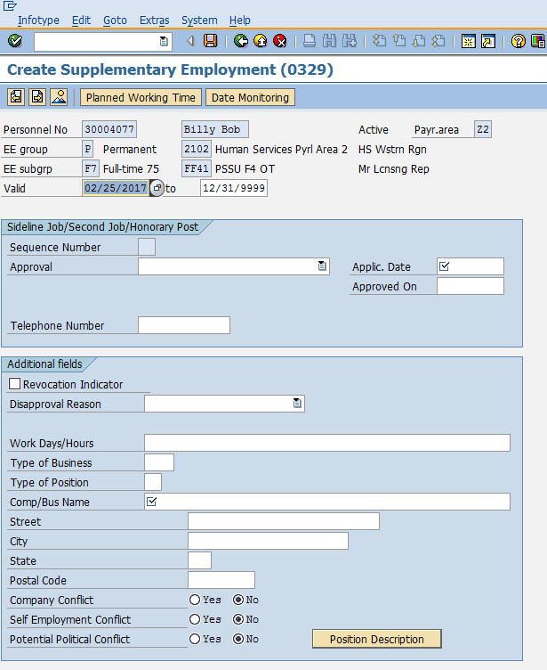

The infotype will be presented during new hire, rehire, dual hire, and return from furlough actions. If an active IT0329 exists for an employee, it will also be presented during promotion, demotion, reassignment, downward reclassification, and separation actions.

IT0329 has been added to the Logged Changes in Infotype report.

IT0329 can be reported on through SAP Ad-Hoc reporting. A standard report for IT0329 is being built and will be available soon. If there is a need for a report of IT0329 data before the standard report is available, please submit a Help Desk Ticket in the reporting category. Once the standard report is available, agencies will have the ability to generate their own supplementary employment reports.

The Position Description box that is showing on IT0329 has no built-in functionality and will be removed from the infotype in the near future.

Questions?
If you have any questions regarding the New Infotype in SAP for Supplementary Employment, please submit an HR help desk ticket in the personnel administration category. You may also call the HR Service Center, Agency Services & Operations Division at 877.242.6007.

