***Please distribute this alert to any users within your agency who are responsible for personnel administration.***

**Electronic Official Personnel File**

* Information regarding e-OPF Manual Purge and e-OPF ‘Do Not Purge’ indicator

e-OPF Manual Purge

Effective June 26, 2016, the ability to manually purge an e-OPF document will be available. Purging is a new method for removing an e-OPF document.

Distinction between Delete and Purge:

**Delete** – removes a document immediately from an e-OPF due to it being filed erroneously or it not belonging in the e-OPF. Employees are not notified when a document is deleted.

**Purge** – marks a document for later removal from an e-OPF in accordance with the OPF retention schedule while giving the employee a window of opportunity to save a copy within ESS. Purge functionality will not be permitted for uncertified documents. Employees must be notified when a purge is initiated. A document marked for purging is not considered part of the Official Personnel File.

The manual purge function will be accessible via PA20/PA30. HR employees who are assigned one or more of the following OPF update roles will have the ability to purge related e-OPF documents:

* + YPC>HR_OPF_UPDATE_COPA – purge documents other than confidential, restricted, and HRSC only
  + YPC>HR_OPF_UPDATE_CONF_COPA – purge confidential documents
  + YPC>HR_OPF_UPDATE_RESTRCT_COPA – purge restricted documents
  + YPC>HRSC_OPF_UPDATE_COPA – purge HRSC (benefits) documents

The “Purge” button will appear between the Certify and Delete buttons and a “Purge After” column will be added between Effective Date and CRM No. in the Services for Object Window on PA20/PA30:

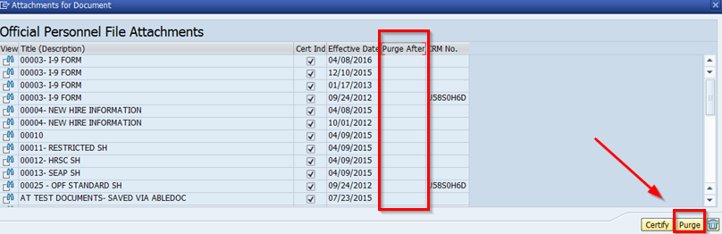

Users will be prevented from purging the following:

* + Documents with a “permanent” retention value in the [e-OPF Required Document List](http://www.hrm.oa.pa.gov/Pages/e-opf.aspx#.VWX_YfPD-Uk)
  + Documents for separated employees
  + Documents for employees with an “e-OPF Do Not Purge” indicator on IT0002
  + Documents that have not been certified

When a document is manually purged, a “Purge After” date equivalent to the current date plus six months will appear in “Purge After” column of the Services for Object window. In addition, a “To Be Purged After” column in the Official Personnel File service of ESS will be populated with the same date. Employees will have until this date to print and/or save the document prior to its permanent removal:

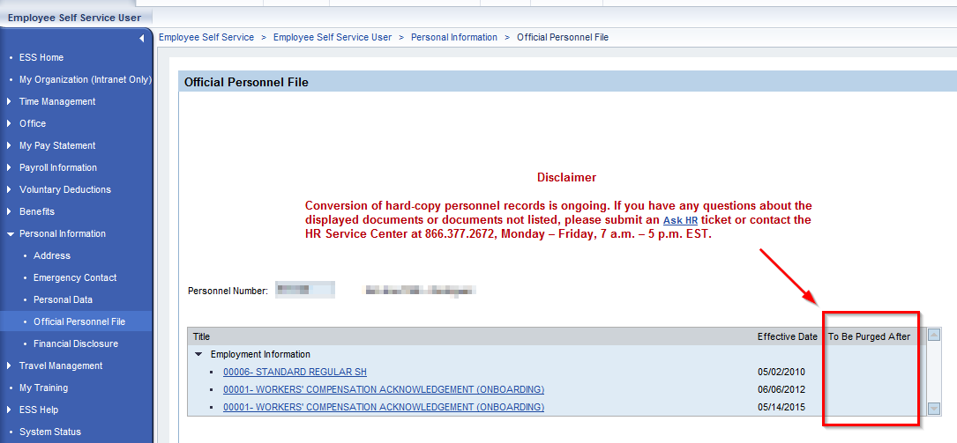

Automated notifications to inform employees of purged documents are still under development. Until this functionality is available, e-OPF coordinators must continue to notify employees prior to a document being purged, in accordance with Management Directive 505.18, 7.b.(1).

Until automated notifications are in place, e-OPF coordinators may use the following message to notify employees when a document has been purged:

Please log into the ESS Portal via [www.myworkplace.state.pa.us](http://www.myworkplace.state.pa.us) and view your Official Personnel File under the Personal Information category in the left navigation bar. Review any documents that have been set to be purged. If you would like to keep a copy, print and/or save the documents before the “To Be Purged After” date.

e-OPF “Do Not Purge” Indicator

An “e-OPF Do Not Purge” Indicator will be added to IT0002 (non-public information). When checked, the indicator will prevent the manual or automatic purging of any documents from an employee’s e-OPF. The indicator is intended for employees currently under investigation or involved in potential litigation:

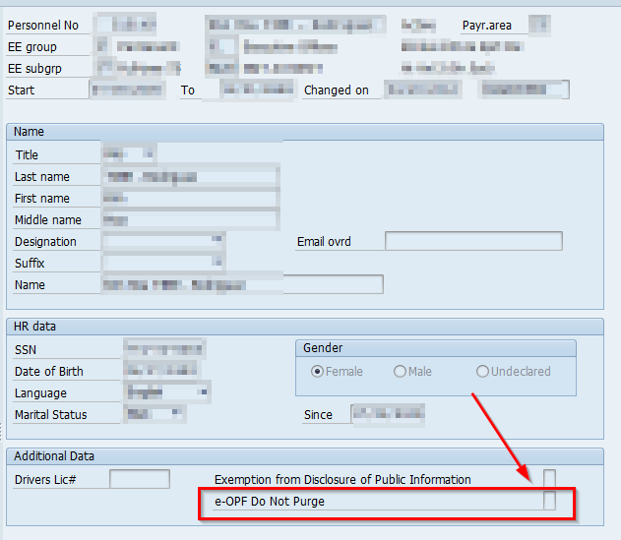

Agency human resources office staff may request that the indicator be added or removed by submitting an “Other – Please Explain” [E-PAR](http://oaiss.state.pa.us/par) as depicted below:

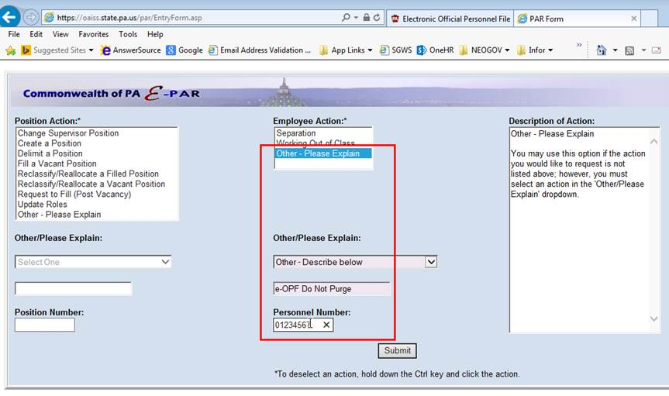

Please stay tuned for a future alert regarding automated purging functionality to be implemented at a later date.

**Questions?**   
If you have any questions regarding the e-OPF Manual Purge or e-OPF Do Not Purge Indicator process, please submit an [**HR help desk ticket**](http://oaiss.state.pa.us/HR-Pay_Help_Desk/) in the Abledoc/e-OPF category. You may also call the HR Service Center, Business Information & Support Division at 877.242.6007, Option 4.