Please distribute this alert to any users within your agency who are responsible for processing human resource transactions in SAP.

SAP Upgrade for the Relationships Infotype (IT1001) on the Position, Organization, and Job

- Information regarding an SAP upgrade for the Relationships Infotype (IT1001) on the position, organization, and job.

This alert is to provide notification that an SAP enhancement will allow users to apply filters to the relationships infotype (IT1001) within the following transactions:

- PO13 – Maintain Position
- PO13D - Display Position
- PO10 – Maintain Organizational Unit
- PO10D – Display Organizational Unit
- PO03 – Maintain Job
- PO03D – Display Job

Below is a screen shot of where the filter is visible on the relationships infotype within the applicable transactions.

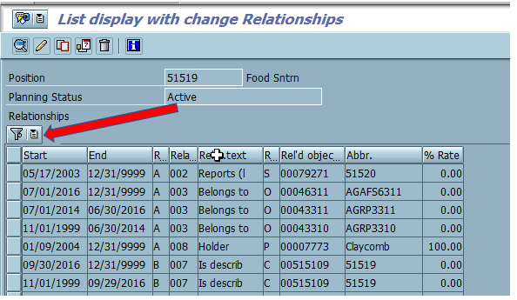

To apply filters on the relationships infotype, the user must select “Set Filter” from the drop-down menu as shown below.

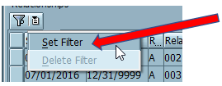

Once the “Set Filter” has been selected, a pop-up box will appear in SAP and the user will be prompted to enter filter criteria. After the filter criteria has been input, the user should select the “Green Check” icon.

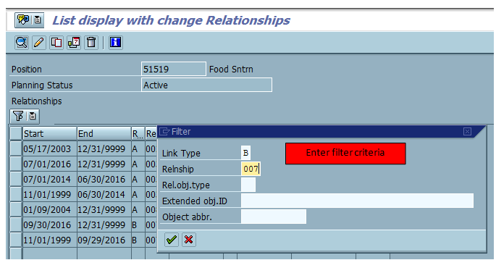

The relationships that meet the filter criteria will appear after the “Green Check” icon is selected.

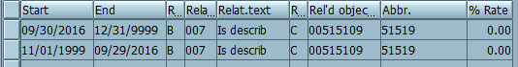

To remove the filter, the user will need to select the filter tab again and select “Delete Filter” from the drop-down menu as shown below.

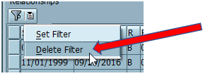

Questions?
If you have any questions regarding SAP Upgrade for the Relationships Infotype (IT1001) on the Position, Organization, and Job, please submit an HR help desk ticket in the organizational management (Org Mgmt) category.

