Please distribute this alert to any users within your agency who are responsible for Timecard approval in WFT.

Kronos Free Text for Comments (DMVA, DHS and PGCB Only).

- Information regarding a new comment in Kronos Workforce Timekeeper for free text only.
A new comment has been created in the Kronos Workforce Timekeeper (WFT) system which will allow Kronos users to access the free text field to enter comments related to absences or voluntary overtime. If an employee is working in a higher-class position or a mandated overtime assignment, users should continue to select the appropriate OC reason codes from the drop down.

The new comment, labeled “Comment Only” is only visible in Kronos WFT. Just like the current comments in WFT, the new comment can be added to punches via the timecard and on absences through the schedule or request modules. This comment will not pass through the interface into CATS; only free text will pass to CATS. Like free text added with other Kronos comments today, this will appear as short text in CATS and will be passed to the appropriate infotype. Effective immediately, please use “Comment Only” to add free text alone to an absence or a voluntary overtime punch.

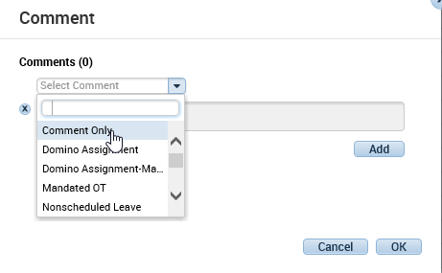

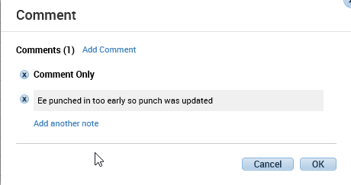

Questions?
Field time advisors should direct any questions related to this alert to their Central Agency Time Advisor. Central Agency Time Advisors may submit questions via an HR help desk ticket in the time category or call the HR Service Center, Time Services team at 877.242.6007, Option 2.

