***Please distribute this alert to any users within your agency who are responsible for benefit enrollments.***

**Updated Text for “SE” Dependent Reason Code on Infotype 0167 (Health Plans)**

* Information regarding updated text for the “SE” Dependent Reason Code on Infotype 0167 (Health Plans).

Effective January 1, 2020, the six-month waiting period for supplemental benefits and exclusion from prescription and dependent buy up costs was changed to a 90-day waiting period. Text has been updated for the “SE” dependent reason code on Infotype 0167 (Health Plans) to reflect the change in policy.

When adding a dependent onto coverage through the HRBEN0001 (Benefit Enrollment) transaction in SAP, the user is prompted to update the “DC” (Default Code) that automatically generates on Infotype 0167 (Health Plans) after the enrollment is processed. The update to the dependent change reason code must be made by the user via a PA30 (Maintain) transaction to ensure the enrollment is passed to PEBTF on the daily file. For users adding a dependent onto coverage due to the employee reaching the 90-day threshold of commonwealth service, the “SE” dependent change reason code should be utilized.

For dependent enrollments that are processed due to the employee reaching the waiting period threshold **prior to 1/1/2020**, the “SE” dependent reason code text will remain as “Add – 1st 6 months Employment” in SAP as shown below.

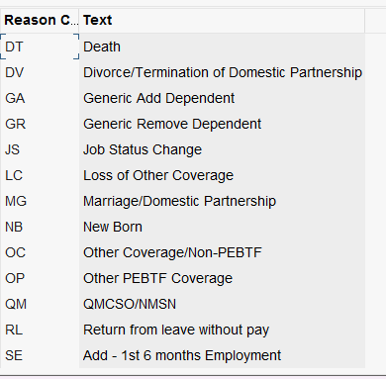

For dependent enrollments that are processed due to the employee reaching the waiting period threshold **on or after 1/1/2020**, the “SE” dependent reason code text will be appear as “Add – 1st 90 days of employment” in SAP as shown below.

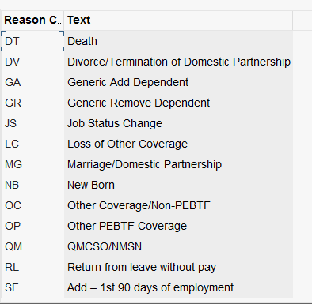

**Questions?**   
If you have any questions regarding Updated Text for “SE” Dependent Reason Code on Infotype 0167 (Health Plans), please submit an [**HR help desk ticket**](http://oaiss.state.pa.us/HR-Pay_Help_Desk/) in the benefits category.

Any policy-related should be sent to the Bureau of Employee Benefits and Services email account at [RA-BENHELP@pa.gov](mailto:RA-BENHELP@pa.gov).