***Please distribute this alert to any users within your agency who are responsible for transactions and benefit enrollments.***

**Employee Contribution Surcharge**

* Information regarding the Employee Contribution Surcharge

On May 17, 2016, the Equal Employment Opportunity Commission (EEOC) issued final regulations on wellness plans. The regulations provide guidance on waivers and state that waivers cannot exceed a specific threshold. For the Pennsylvania Employee’s Benefit Trust Fund (PEBTF) Get Healthy program, the waiver cannot exceed 30% of the annual premium for the single coverage of the lowest cost plan. When calculated, this amount equals $62.19 bi-weekly for calendar year 2017.

Due to this ruling, **commonwealth employees enrolled in benefits not participating in the Get Healthy Wellness Screening will incur an Employee Contribution Surcharge**. This deduction is a pre-tax flat dollar amount which will be incurred by the employee in addition to the Employee Pre-Tax Medical Hospital Percentage currently being deducted from an employee’s pay if enrolled in benefits.

Effective January 1, 2017, the following unions will have the Employee Contribution Surcharge implemented:

* American Federation of State, County and Municipal Employees (AFSCME)
* Service Employees International Union (SEIU) Local 668
* Service Employees International Union (SEIU) Healthcare PA
* United Food and Commercial Workers (UFCW)
* Office and Professional Employees International Union – Healthcare Pennsylvania (OPEIU)
* PA State Education Association (PSEA)
* Correctional Institution Vocational Education Association (CIVEA)
* Federation of State Cultural and Educational Professionals (FOSCEP)

In addition, the Public Utility Commission and employees in the following management bargaining units will have the Employee Contribution Surcharge implemented effective January 1, 2017:

* 98
* 99
* A3
* A8
* B3
* C3
* F3
* G3
* H3
* J3
* K3
* K6
* M3
* M8
* N3
* P3
* R3
* Z3
* A5
* B5
* S5
* W3
* J3

*\*Please note: As contracts are ratified, the Employee Contribution Surcharge will be implemented pending contract language.*

The Employer Contribution Surcharge rates for 2017 are as follows:

* PEBTF benefit enrollment - $62.19
* Bronze Plan benefit enrollment - $55.89

Employees who are in a union or bargaining unit who is having the Employee Contribution Surcharge implemented effective 01/01/2017 and is in pay area Z1/T1/Z2 will incur the Employee Contribution Surcharge for pay date 01/27/2017. Employees in pay areas Z3/T3 will incur the Employee Contribution surcharge for pay date 01/20/2017.

**PEBTF Pay Statement**

Below is a screen shot of how the Employee Contribution Surcharge will appear on the remuneration statement for an employee enrolled in PEBTF benefits. The Employee Contribution Surcharge will appear under the “Deductions” section of the remuneration statement. The text on the remuneration statement will appear as “EE Contribution Surcharge”.

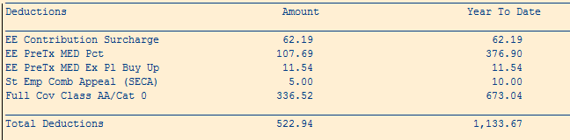

**Bronze Plan Pay Statement**

Below is a screen show of how the Employee Contribution Surcharge will appear on the remuneration statement under the “Deductions” section for an employee enrolled in the Bronze Plan who did not participate in the Wellness Screening. The text on the remuneration statement will still appear as “EE Contribution Surcharge”, however, the surcharge amount will be $55.89 for Bronze Plan enrollment.

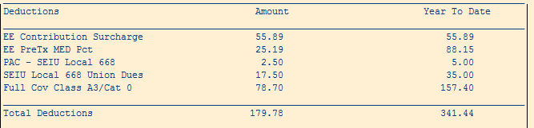

**Partial or No Surcharge on Pay Statement**

There may be cases in which the employee may not see the full Employee Contribution Surcharge (EE Contribution Surcharge) or no surcharge amount on their remuneration statement. These cases occur when the employee’s benefit costs (i.e. Employee Contribution Surcharge, Employee Pre-Tax Medical Hospital Percentage, Medical Buy Up cost, Dependent Buy-Up cost, and Prescription Buy-up Cost) exceed the benefit plan premium. In these cases (due to the EEOC ruling), the employee may have an adjustment to their Employee Contribution Surcharge and/or Employee Pre-Tax Medical Hospital Percentage. This adjustment would appear on the employee’s remuneration statement under the “Deductions” section.

In Scenario #1 (shown below), the employee’s benefit costs exceed the benefit premium amount. On the remuneration statement, the employee does not see an Employee Contribution Surcharge Amount in the “Deductions” section due to the employee not having a year-to-date amount for the Employee Contribution Surcharge.

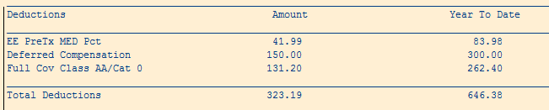

In Scenario #2 (shown below), the employees’ benefit costs exceed the benefit premium amounts as well. In this case, the Employee Pre-Tax Medical Hospital Percentage is being adjusted in addition to the Employee Contribution Surcharge amount. If the Employee Pre-Tax Medical Hospital Percentage is adjusted, an “EE PreTx M/H Adj”Amount will appear on the employee’s remuneration statement.

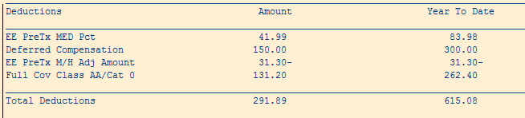

To confirm an adjustment has been made to the Employee Contribution Surcharge or the Employee Pre-Tax Medical Hospital Percentage, the user can review the infotype 0015 (Additional Payments). These adjustments will have negative sign at the end of the amount to indicate that the employee is being reimbursed that amount. The following new wage types were created for Employee Contribution Surcharge adjustments:

* 6E6Y – EE Contribution Surcharge (Bronze Plan)
* 6E6Z – EE Contribution Surcharge (PEBTF )

If an adjustment is made for the Employee Pre-Tax Hospital Percentage, the user will see a wage type 6E75 on the infotype 0015 (Additional Payments). The “EE PreTx MED Pct” amount listed on the remuneration statement would be the final employee contribution pretax amount deducted after the adjustment is made for that pay period. In addition, if there is an adjustment made for the Employee Contribution Surcharge, the amount listed on the remuneration statement would be the **final** Employee Contribution Surcharge amount deducted. Please note: There may be no Employee Contribution Surcharge Amount taken due to the adjustment that is made. If this is the case, the dollar amount will appear as blank if the employee has a year-to-date amount on their remuneration statement.

Below are screen shots to show the adjustments will appear on the infotype 0015 (Additional Payments).

Bronze Plan adjustment

cid:image001.png@01D256C4.79A5E660

PEBTF benefits adjustment



Employee Pre-Tax Hospital Percentage adjustment



**Questions?**   
If you have any questions regarding the Employee Contribution Surcharge, please submit an [**HR help desk ticket**](http://oaiss.state.pa.us/HR-Pay_Help_Desk/) in the benefits category. You may also call the HR Service Center, Agency Services & Operations Division at 877.242.6007.