Please distribute this alert to any users within your agency who are responsible for processing deferred compensation sick and annual leave deferral transactions.

Deferred Compensation Sick and Annual Leave Deferrals

- Information regarding deferred compensation sick and annual leave deferrals

Commonwealth employees who participate in the deferred compensation program have the option of placing either a portion or all of their leave payout into deferred compensation. The amount varies depending on the employee’s age. The current deferred compensation limits for 2014 are shown below.

    - Under age 50 – $17,500

    - Age 50 and above (age 50 catch-up) - $5,500
When combined with the normal contribution of $17,500, an employee over age 50 can defer a total of $23,000 ($17,500 + $5,500 = $23,000).

    - Special Catch-up (must be within three years of retirement age) - $35,000

The deferred compensation payroll election “Sick and Annual Leave Deduction” section of the Paycheck Contribution and Election form should be completed by the employee if their intent is to defer a portion if not all of their leave balance which is shown below.

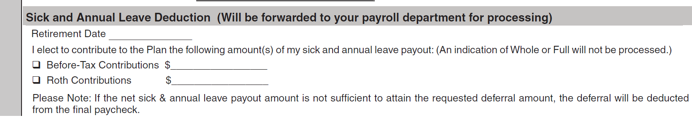
The following guidelines have been established by Great West for users to determine if the Paycheck Contribution and Election form is valid and should be processed accordingly as leave deferral.
- The employee electing to defer their leave must have had at least one deferred compensation deduction prior to the pay period their leave is deferred.
- The form must be signed by the employee.
- The form must be date stamped one month prior to the leave being paid (i.e. the employee is retiring in June 2014, the form must be date stamped by Great West by May 2014).
- The form is only valid for six months after it is signed and received.

Agencies not served by the HR Service Center should follow the above guidelines when determining if a deferral form is valid and should be processed accordingly.

All deferred compensation leave sick and annual leave deferrals must be processed in the form of a dollar amount. Percentages cannot be utilized for deferred comp sick and annual leave deferrals.

Questions?
If you have any questions regarding deferred comp sick and annual leave deferrals, please submit an HR help desk ticket in the benefits category. You may also call the HR Service Center, Agency Services & Operations Division at 877.242.6007.

